Hi Engineer,

When we use the DRV11873, there are about 5 or so, and the chip is damaged. The specific situation is:  
1. About the motor: 12V power supply liquid bearing motor, when the motor speed is 3000 r/ min, the current is about 200 mA during normal operation, the specific parameters are as follows: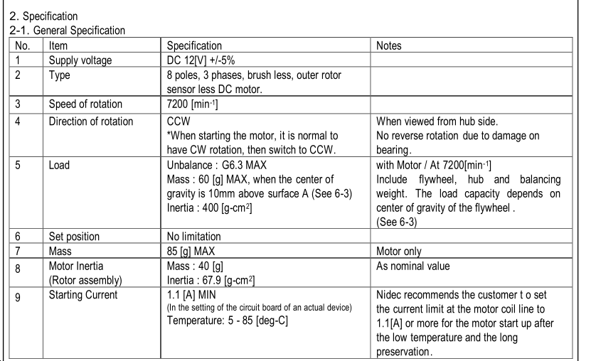

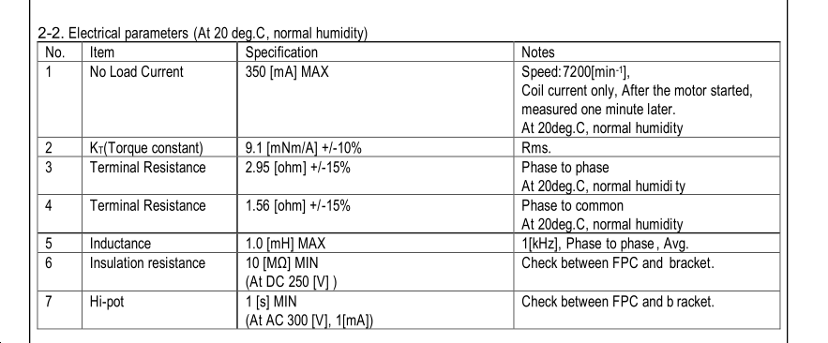

2. PWM wave related information:

• PWM waveform with stable speed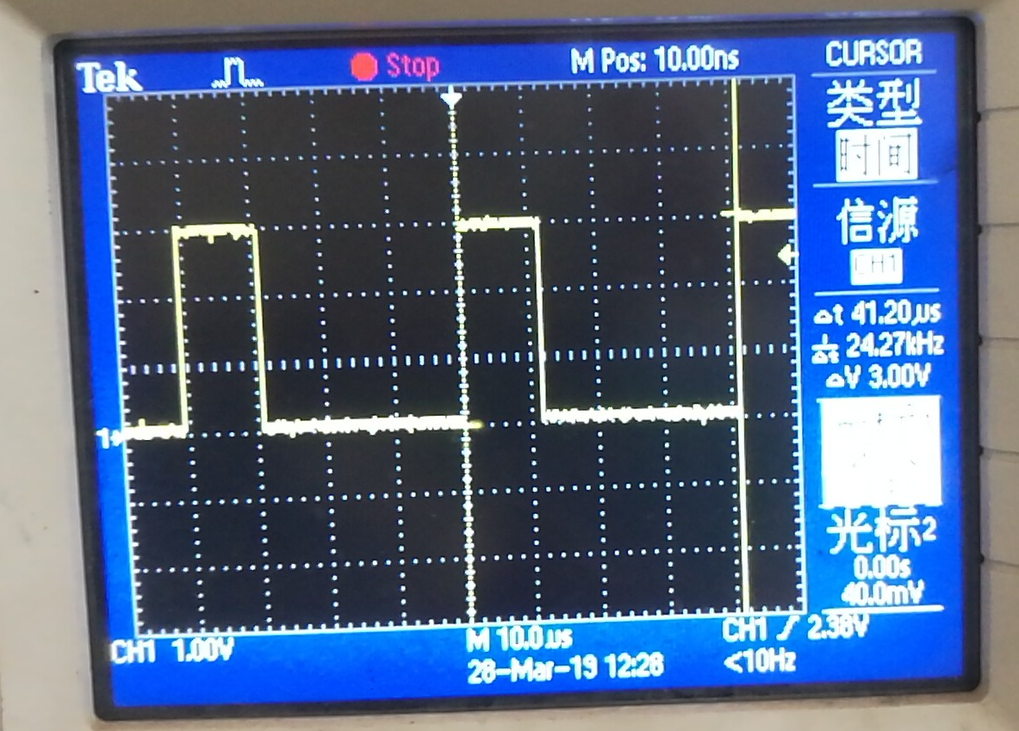

• During the startup process, the program control gradually increases the pulse width of the PWM wave and adjusts the speed to 3000 rpm;

3. When chip damage occurs, the thermal pad on the PCB has different degrees of scorch phenomenon, such as thermal breakdown, the current limiting resistor is 3.9k, the R10 10K is not soldered, open circuit; circuit schematic:

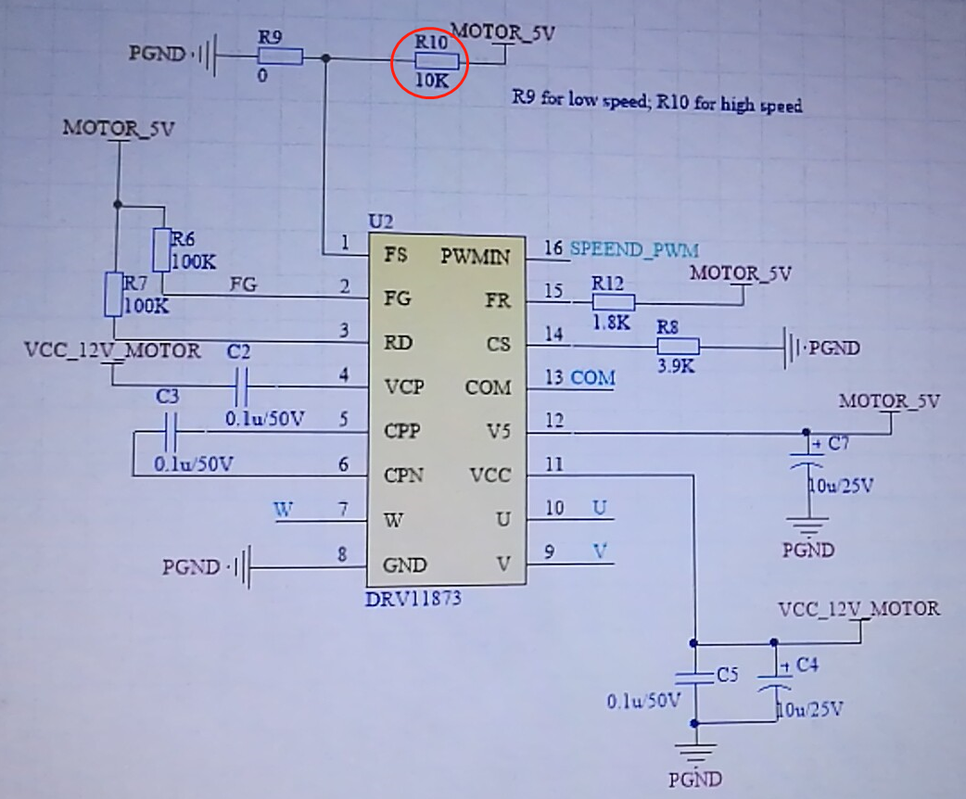

4. If the motor has a low-speed reversal, the current will generally be larger (basically around 700ma), the chip is a little hot, before the motor just started, the motor has been low-speed reversal, so we have done in the program After processing, once the low speed reversal occurs, the driver's PWM is stopped and then restarted;