* Problem description:
  + PCB has different degrees of scorch phenomenon, such as thermal breakdown
  + 5 chips or so damaged
  + the heat sink pads on the pcb are burned out, and the above several vias are broken

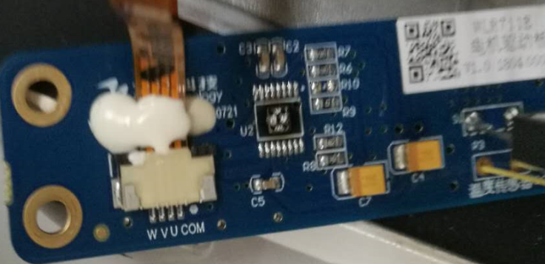

* Sometimes on startup, motor spins in the wrong direction at low speed (200Hz)
  + current will be larger (700mA), and the chip gets hot, so as of now, motor is commanded to restart when there is low speed reversal
  + now it will reverse for up to 10 seconds in normal use, the program will shut down the motor
  + When the reversal occurs, the chip is a little hot, but it runs for several hours at 80 high temperatures,
* Condition at which the problem happened:
  + Not clear on this
* Settings of DRV11873
  + FS is high = High speed mode
  + CS resistor = 3.9k. I_limit(A) = 6600 / RCS, so I_limit(A) = 1.7A
    - DRV11873 max current capability = up to 1.5-A continuous and 2-A peak.
  + Direction is fixed
* About the motor:
  + 12V, 200mA during normal operation
  + Motor is spinning at 3000 rpm = 200Hz

motor load will not change during the whole process

* Schematic:
  + 