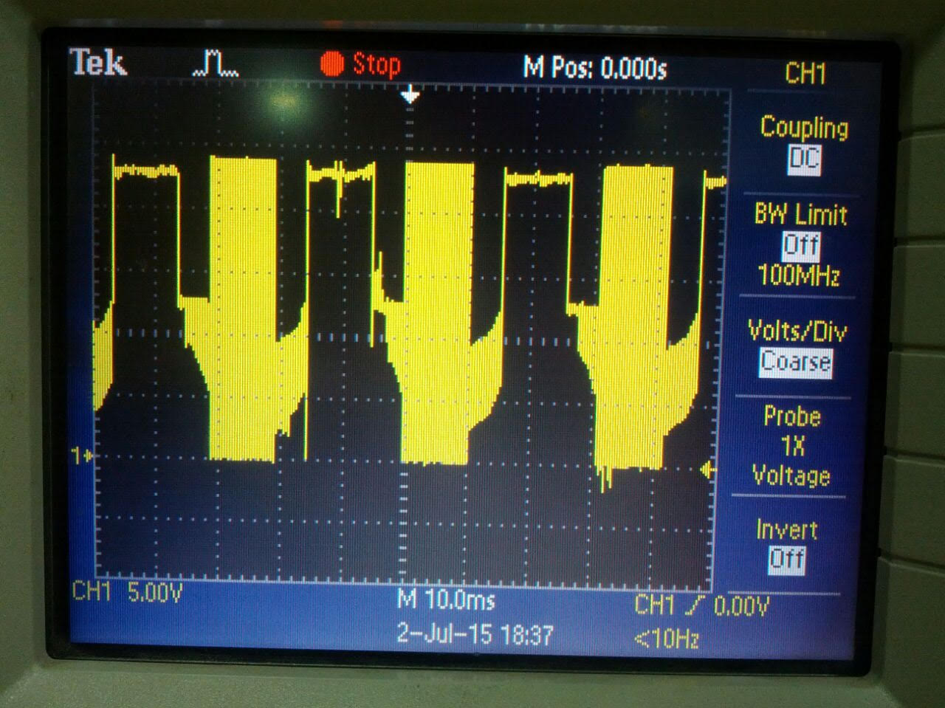

**GHSA_Wrt_GND**

**Point 1 is the “0”**

**Each division is 5 V**

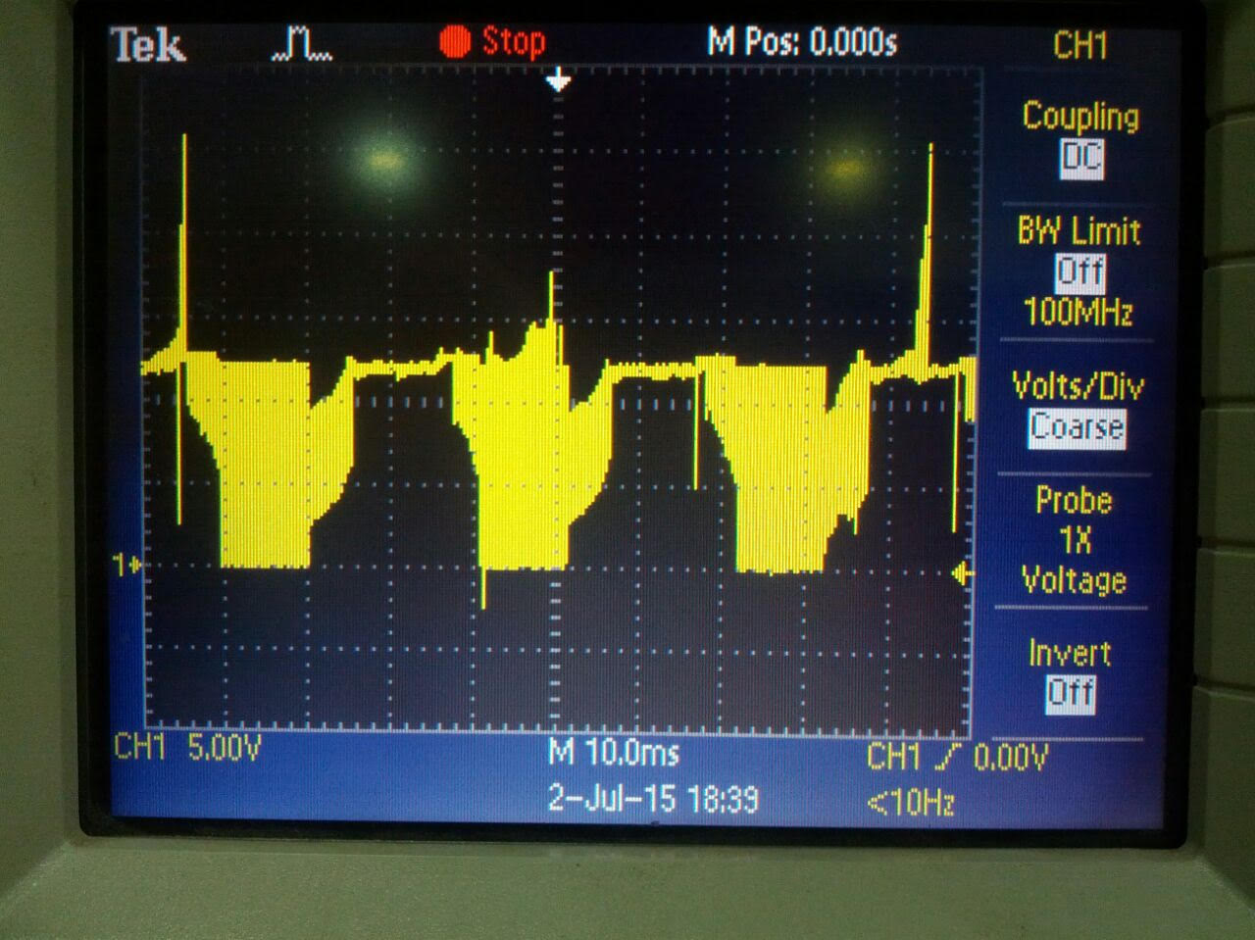

**SHSA_Wrt_GND**

**Point 1 is the “0”**

**Each division is 5 V**

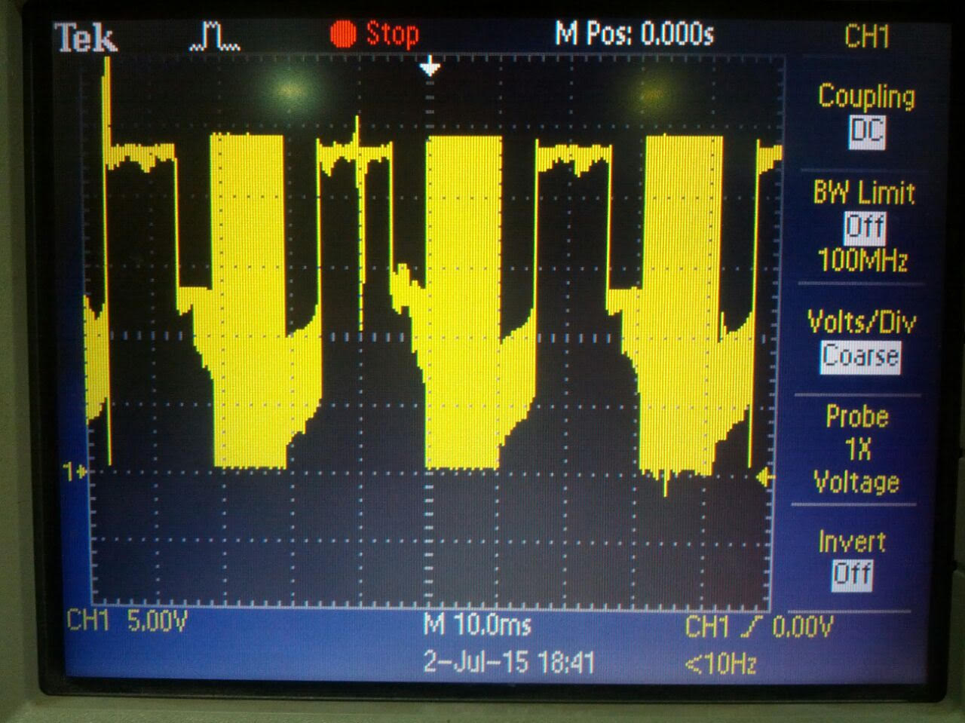

**GHSA_Wrt_SHSA**

**Point 1 is the “0”**

**Each division is 5 V**