DRV8301 SPI Waveforms

1. Control Register 1 Configuration

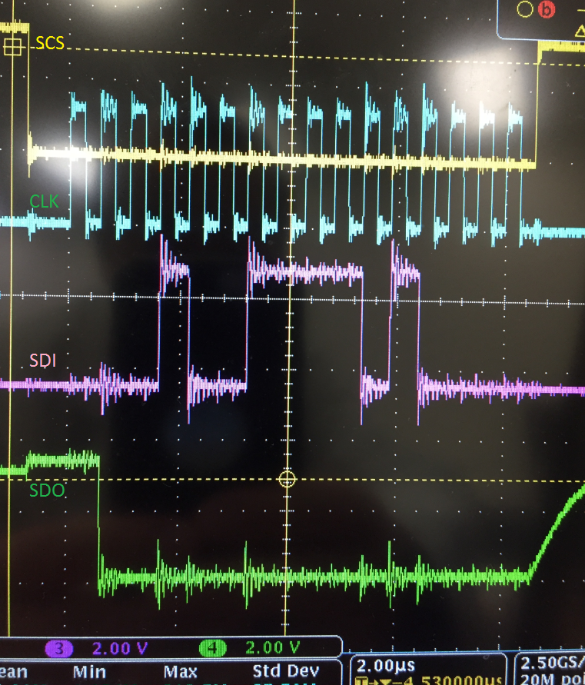

1. Control Register 2 Configuration

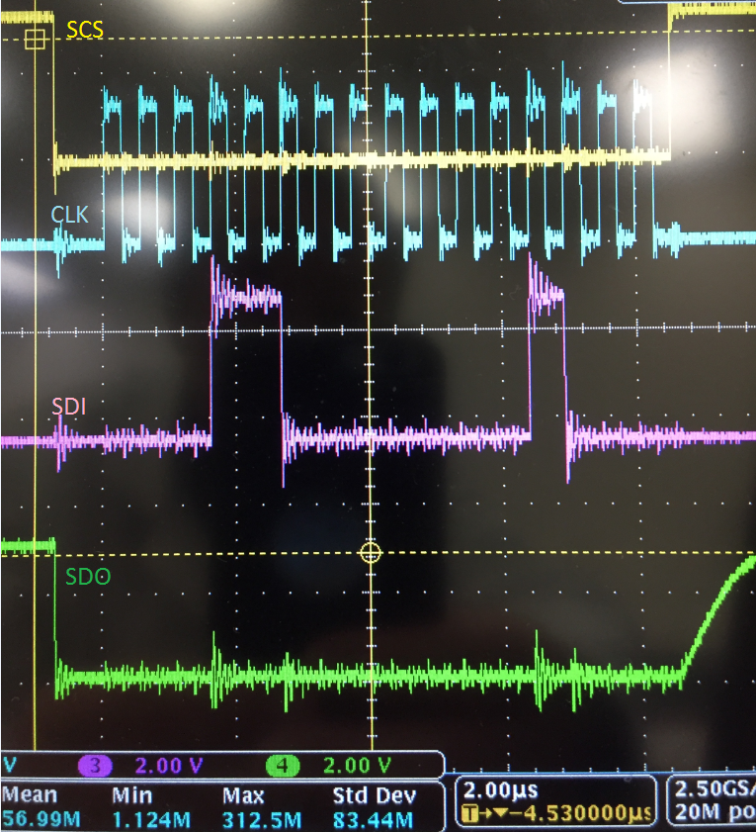

1. Reading Status 1 and Status 2 Registers

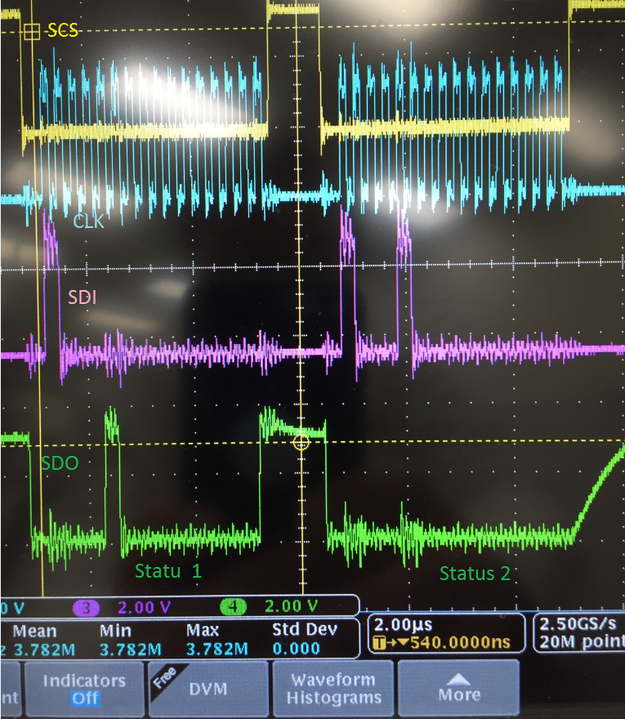

1. F28069M SPIA Register Values

