DRV8423 EVM test problem points
1. Use resistive load (cement resistance 510Ω as shown below) to test, when input PWM signal to PWM_A=100% or PWM_B=100%,
OUT_A or OUT_B is no output normally: such as item 5&6.
If the input is lower than 100%, it is normal, such as items 1~4.
Why does my input turn to 100% and it becomes noise?
2. Use the motor attached - the operation is normal (but 100% has noise, as shown in Figure 7.8.)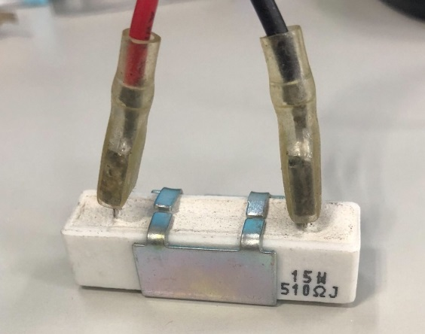( cement resistance 510Ω)
- Standby waveform:
CH1:PWM_A =0V ; CH2:PWM_B =0V ; CH3:OUT_A=0V ; CH4: OUT_B=0V
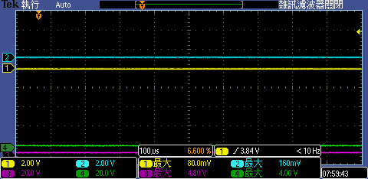
- PWM_A=70% waveform:
CH1:PWM_A =70% ; CH2:PWM_B =0V ; CH3:OUT_A=70% ; CH4: OUT_B=0V
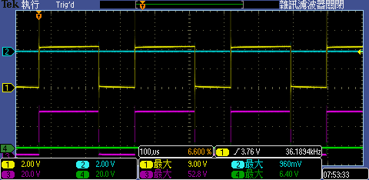

- PWM_B=90% waveform:
CH1:PWM_A =0V ; CH2:PWM_B =90% ; CH3:OUT_A=0V ; CH4: OUT_B=90%
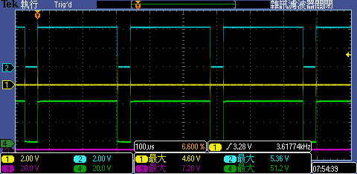
- PWM_A=70% waveform:
CH1:PWM_A =70% ; CH2:PWM_B =0V ; CH3:OUT_A=70% ; CH4: OUT_B=0V
- PWM_A=100% waveform:
CH1:PWM_A =100% (noise); CH2:PWM_B =0V ; CH3:OUT_A=(雜訊); CH4: OUT_B=0V abnormal
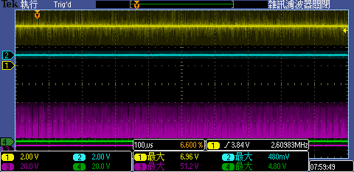

- PWM_B=100% waveform:
CH1:PWM_A =0V; CH2:PWM_B =100% (noise) ; CH3: OUT_A=0V(雜訊); CH4: OUT_B=(noise) abnormal
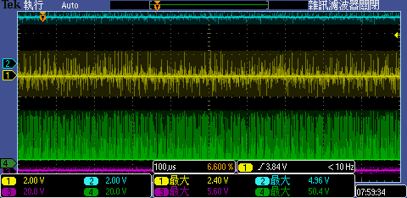

use motor load PWM_A=100% 或 PWM_B=100% Works fine, but noisy。
- CH1:PWM_A =100%; CH2:PWM_B =0V ; CH3:OUT_A=正轉;CH4: OUT_B=0V (noise)
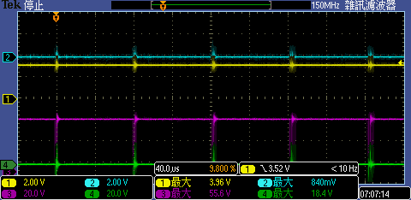
- CH1:PWM_A =0V; CH2:PWM_B =100%; CH3:OUT_A=0V (noise); CH4:OUT_B= reverse
