tSCLK minimum period = 100 ns. The measured value is 500 ns. OK

tSCLKH minimum high time = 50 ns. The measured value is 244 ns. OK

tSCLKL minimum low time = 50 ns. The measured value is 136 ns. OK

tH_SDI Minimum, SDI input data hold time = 25 ns. The signal’s logic level is retained for more than 25 ns. OK

tSU_SDI Minimum SDI input data setup time = 25 ns. The signal’s logic level is retained for more than 25 ns. OK

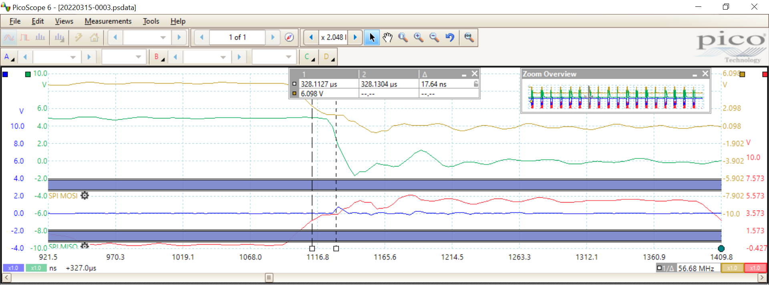

tD_SDO Maximum SDO output data delay time = 30 ns. The measured value is 18 ns. OK

tH_nSCS Minimum nSCS input hold time = 25 ns. The measured value is 1100 ns. OK

tSU_nSCS Minimum nSCS input setup time = 25 ns. The measured value is 1300 ns. OK

tHI_nSCS Minimum nSCS high time = 450 ns. The measured nSCS high time is more than 450 ns. OK

tEN_nSCS Maximum enable delay time = 50 ns. The measured value is 15 ns. OK

tDIS_nSCS Maximum enable delay time = 50 ns. SDO remains active for more than 50 ns. TBD if this is an issue

tDIS_nSCS The measured disable delay is 2000 ns. TBD if this is an issue