- Motor Parameters:
Manufacturer: Leadshine

Model: 57CM31

Holding Torque: 3.1N·m

Rated Current: 5A

Phase Resistance: 0.26 Ω

Phase Inductance: 1.18mH

Detent Torque: 100mN·m

Rotor Inertia: 570g·cm²

- Drive Hardware: VM supply voltage, ISEN sense resistance value, VREF reference voltage

- VM Supply Voltage: 24V
ISEN Sampling Resistance: 0.08Ω
VREF Reference: 2.75V

Schematic design is shown in the figure below:
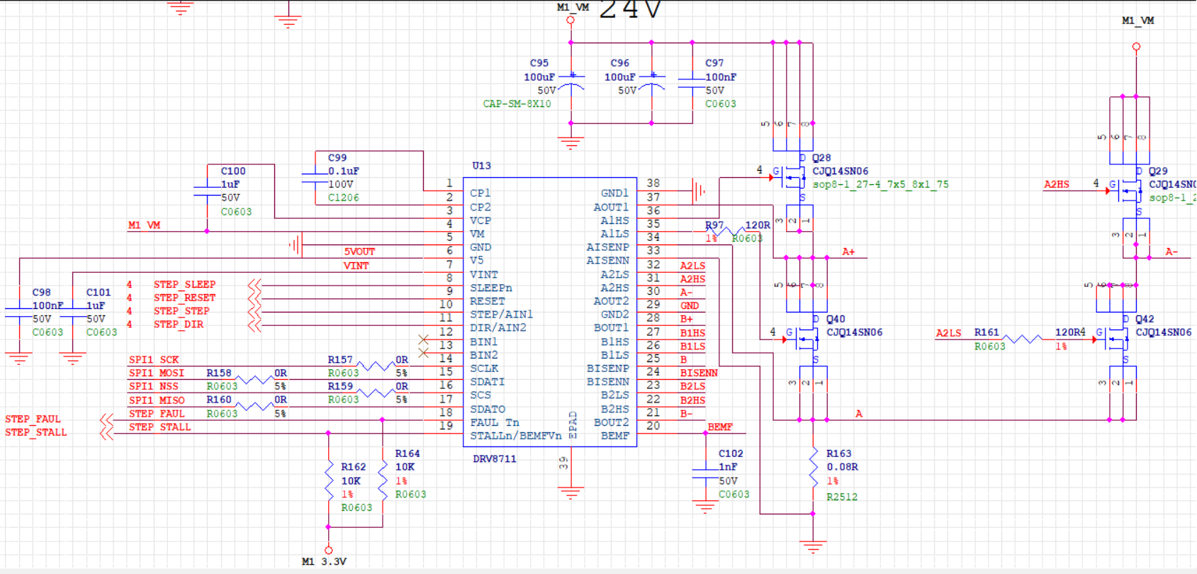

- Current Configuration: Microstep level, current setting, decay mode, TOFF/TBLANK parameters
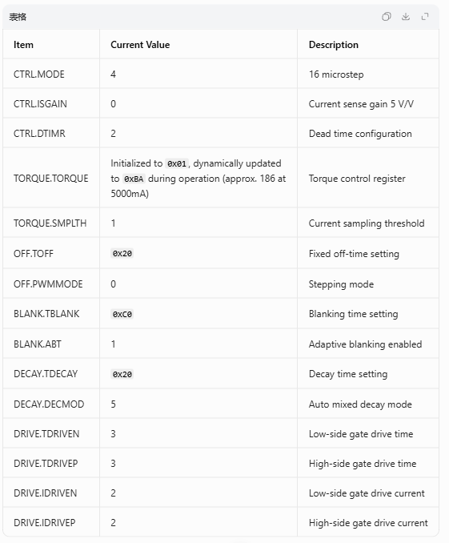

- Operating Conditions:
With acceleration/deceleration control implemented, the maximum loaded speed is approximately 380 rpm. When the same motor is operated under the same load with the motor manufacturer’s driver, it can achieve over 1000 rpm.Questions: Are the above DRV8711 design and parameter configuration correct? How can the motor be controlled to reach speeds above 1000 rpm?

