**DRV8825 IC FAILURE DETAILS**

**Dear Team,**

1. We are giving pulse to drive the motor. This signal is given to Step pin of DRV8825.
2. DIR pin is connected to IO pin of the controller (LPC1768FBD100).
3. M2 pin ground connected.
4. M1, M0 pins – controlled by Controller (pin output 0 or 1).
5. ENBL pin - controlled by Controller (pin output 0 or 1).
6. SLEEP, RESET – GIVEN 3.3V supply
7. AVref, BVref connected to below network

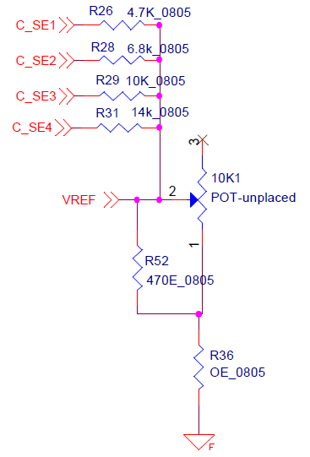

1. C_SE1, C_SE2, C_SE3, C_SE4 signal are given from controller IO pins (0 &1 output)
2. VREF connected to AVref & BVref
3. 10K1 POT is not soldered in PCB it is unplaced.
4. We are connecting the DRV8825 Driver board to our mother board through one connector

**We are facing below problems**

1. **DRV8825 IC over heat – Taking more current**

Under this condition motor Running is OK. But my controller is getting more disturbed and LCD Display totally collapsed. This problem comes when switch on the machine (or can say when power up the mother board)

1. **Motor Not Running –**

Under this Condition motor only not running. Other functions on my machine are OK working good. I am unable to read pulse output on the winding output (A1 A2 B1 B2). This problem comes after switch ON and setting the machine to run mode.

1. We are facing this problem on multiple numbers of boards. Over 300 nos 96 failures are found.
2. When Replacing IC on driver boards – Few Boards getting OK, Few giving the same above failure no **2.**
3. If once the Board getting OK & works good then it is not failure again.