We are interfacing STM32F4 (MCU) with DRV8842PWPR

Motor:
AE200: 24VDC, Ampere Draw Max,
1.38Amps Average, Peak Starting Current 9A for 3.22ms

HBRIDGE Setting:
VREF: 1V
ISENSE: 0.1Ohms
ICHOPPING CURRENT: 2A(1/(5*0.1)
ICURRENT SETTING :(I4:I0)=11111
Sleep,Reset,IN1, IN2 ,I[4:0] controlled from MCU.

Power Supply:
The HBRIDGE is supplied by 24V Supply from board.

Schematic:
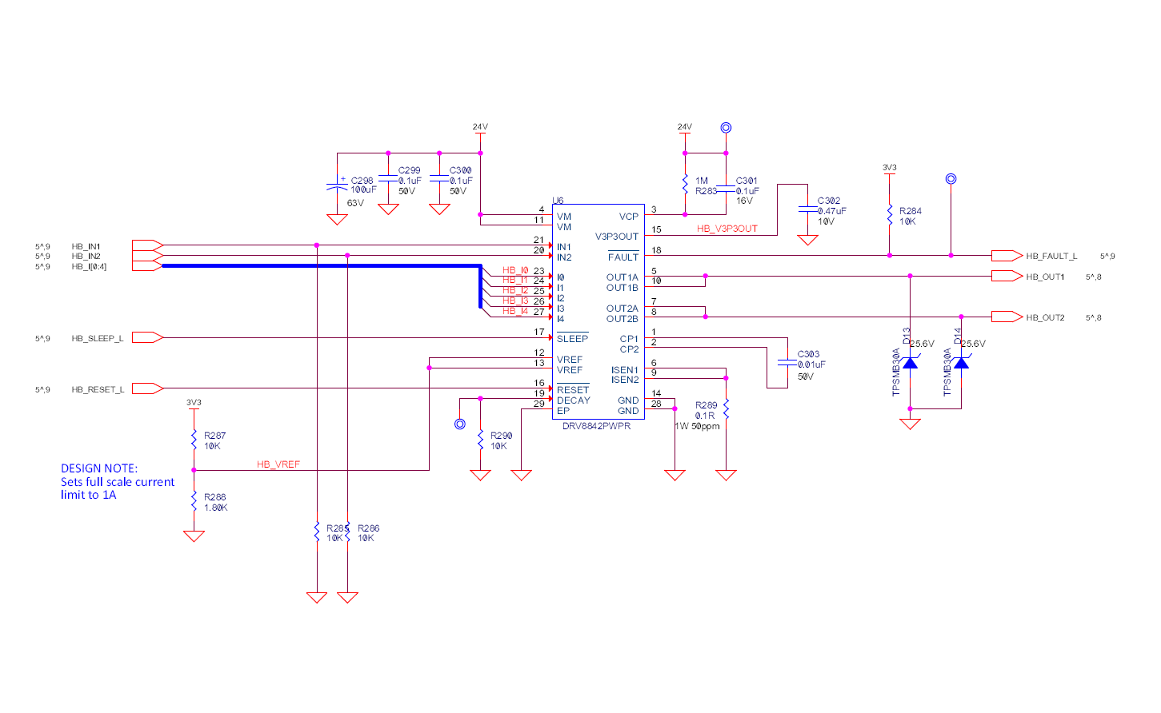
EVM Schematic:
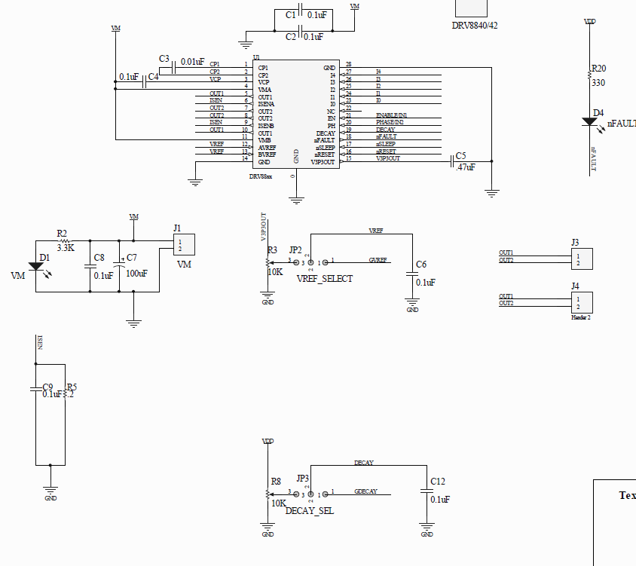
Board Layout:
Bottom Layer:
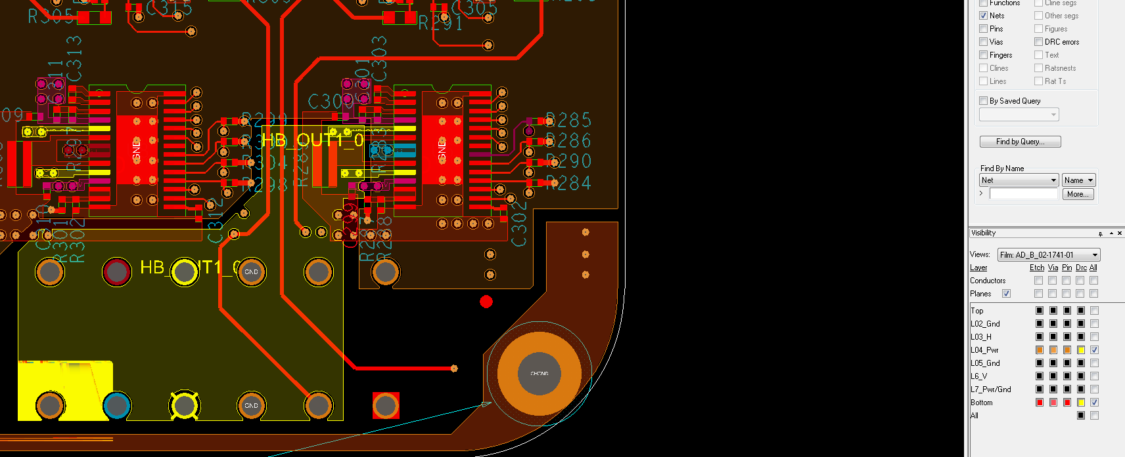

Top Layer:
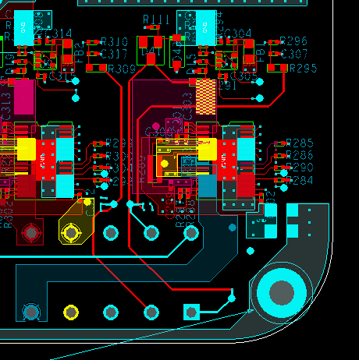

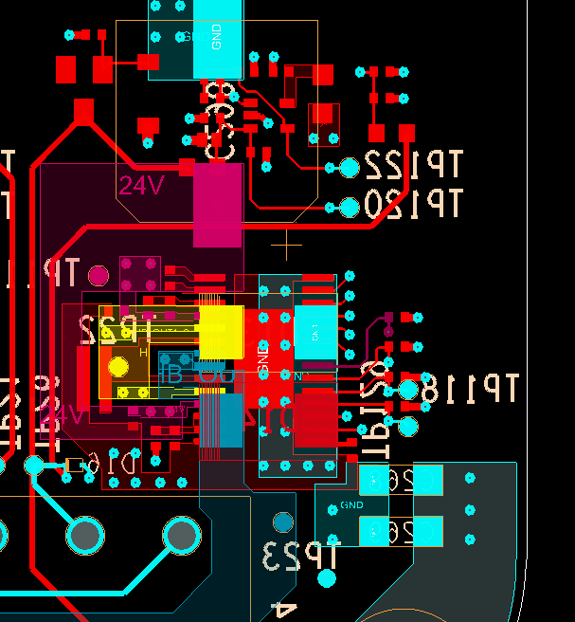
Issue:
The DRV8842 doesn’t drive the motor consistently and triggers the fault when OUT2 or OUT1 gives 24V at times.

The DRV8842 EVM works perfect with the motor and the one on my board doesn’t.
The schematics is pretty much similar with the EVM.

Normal Working when not driving motor:
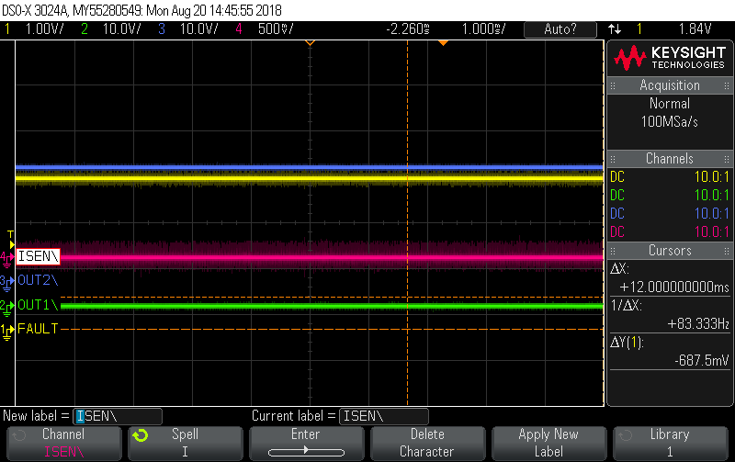
Case 1(Fault Trigged):

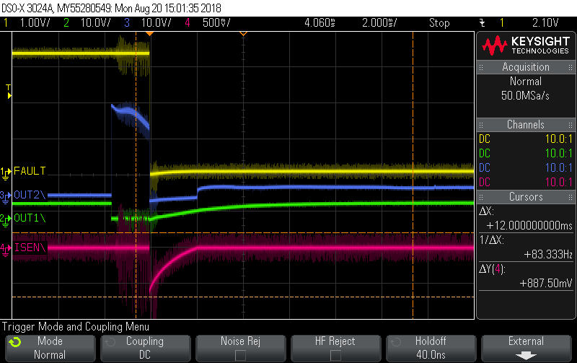
But the above doesn’t happen in the EVM.
Is it because of the starting current of 9A for 3ms which is causing this?

Case2:
The HBRIDGE is not responding to the commands on IN1 & IN2 on OUT1 & OUT2.

Hint:
- I powered the EVM with my board’s 24V and the board works fine thought the 24V dips to 16V when starting the motor for 12ms.
- I have a bulk of 100uF 63V aluminum similar to EVm on board.
- I have the same sense resistor value of EVM (0.1Ohms as per EVM BOM)

Can I send the HBRIDGE to TI for RMA and dechiping it for analyzing?

Questions:
- What is the OCP response time and the Isense Response time (is ISENSE 3.7us?)
- How to limit the inrush current of the Motor if HBRIDGE doesn’t do it?
- Why the H Bridge allows to rise the current and doesn’t go to PWM mode when exceeding the chopping current?
- Why the EVM behaves the correct way?

