IAR WORKBENCH ISSUE
I am trying to use the following device: eZ430-F2013.
When following the manual of the device, it fails at the step when I want to flash a program to it.
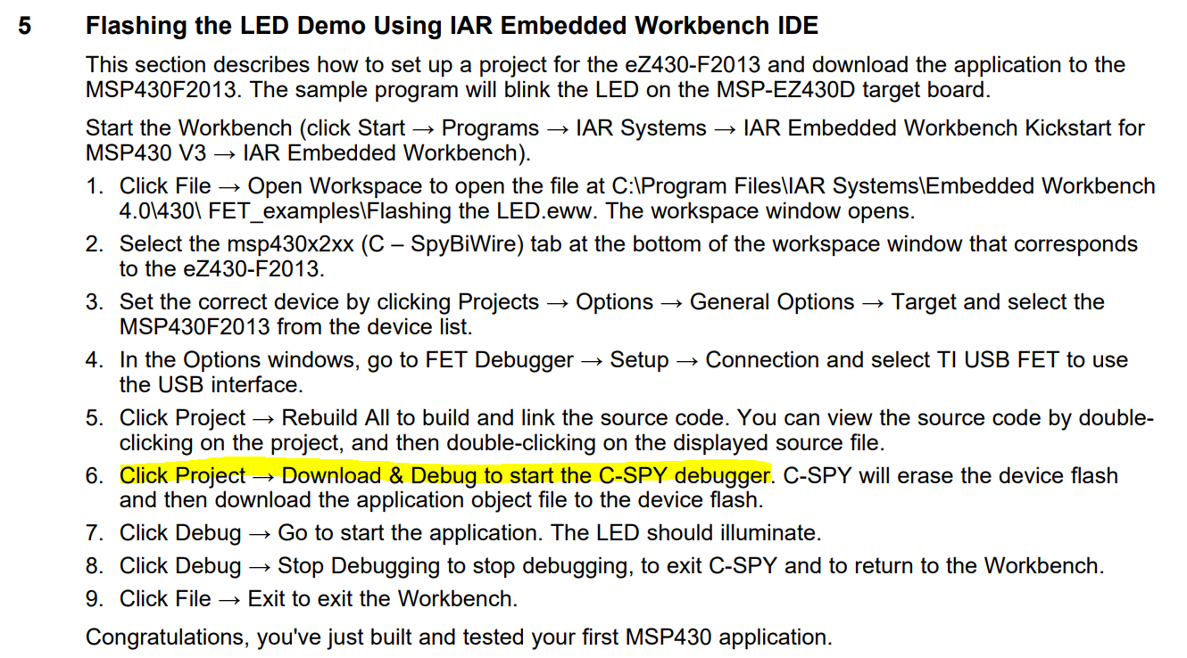
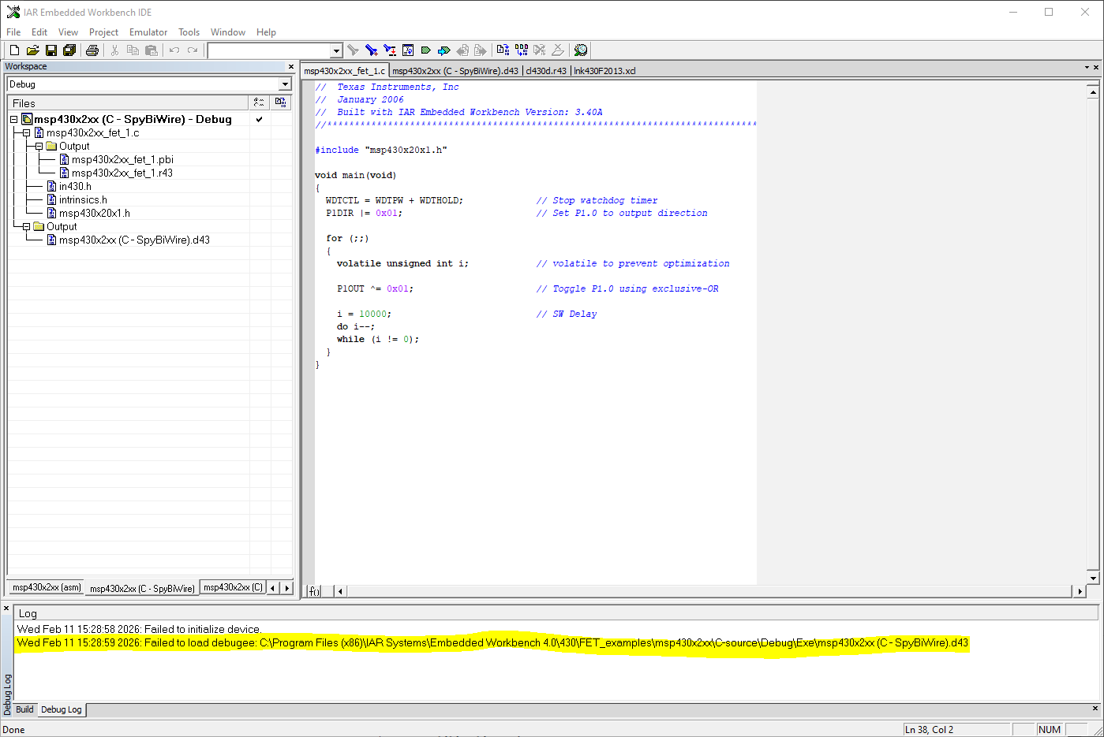
When I try to use the drivers in the specified path, it won’t recognize them and tells me that it already has the best drivers and won’t update.

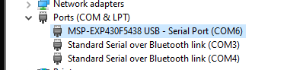
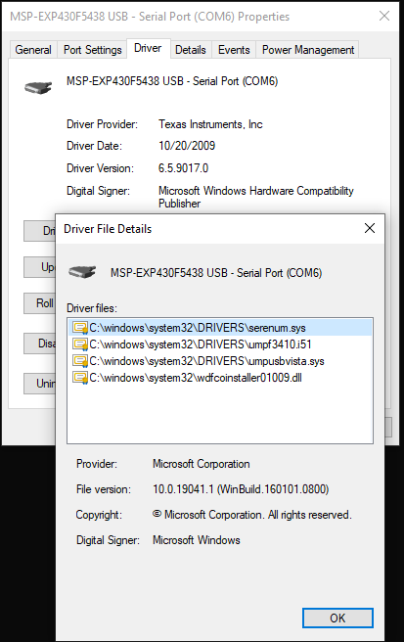
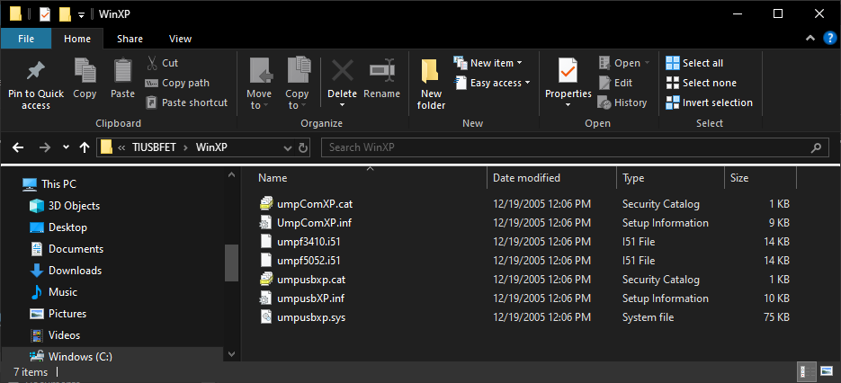
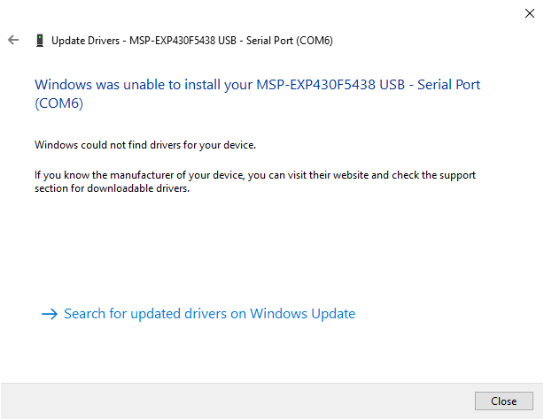

Update
I now have another issue. I don’t see it in device manager anymore and the LED on the target board won’t light up anymore… This happened after the IAR embedded workbench version 8.10 “updated” it because it wouldn’t recognize the device. Now it just doesn’t show at all. Did it burn the usb stick or did it just change the settings and if it’s the latter, how do I go back to something that works? Thanks

