1）200rpm Motor phase current waveform
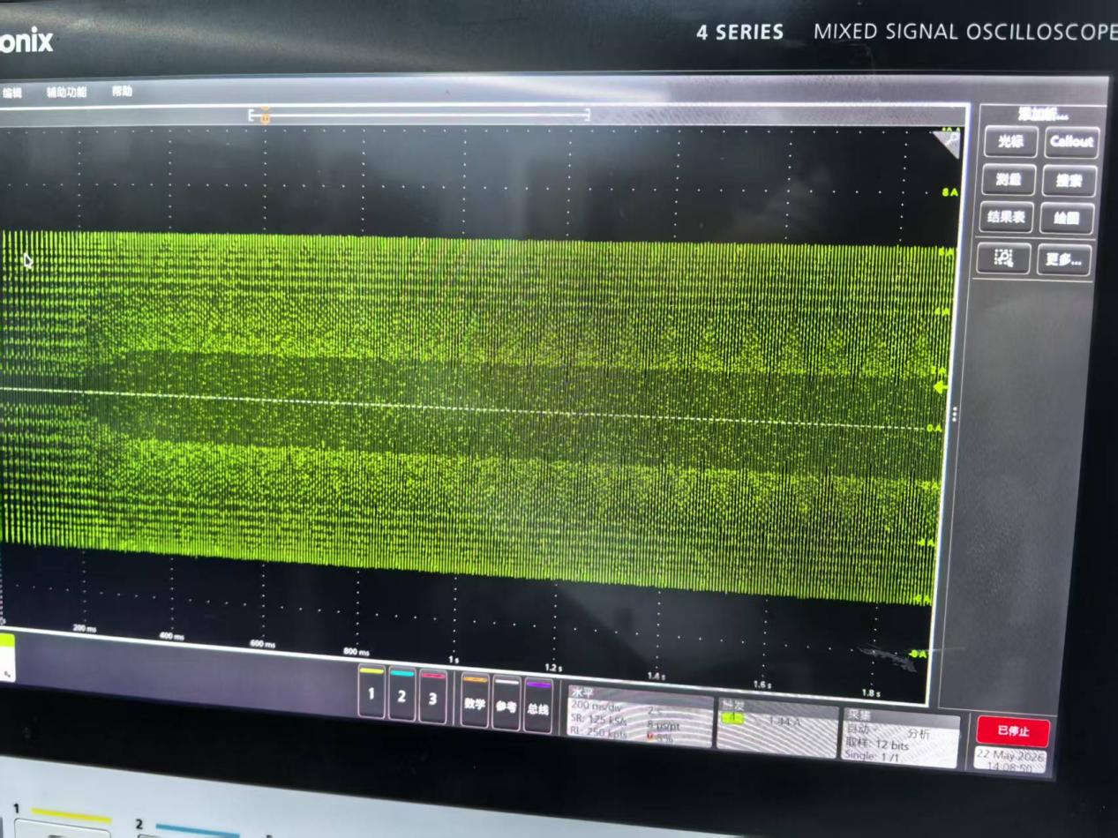

2）300rpm Motor phase current waveform
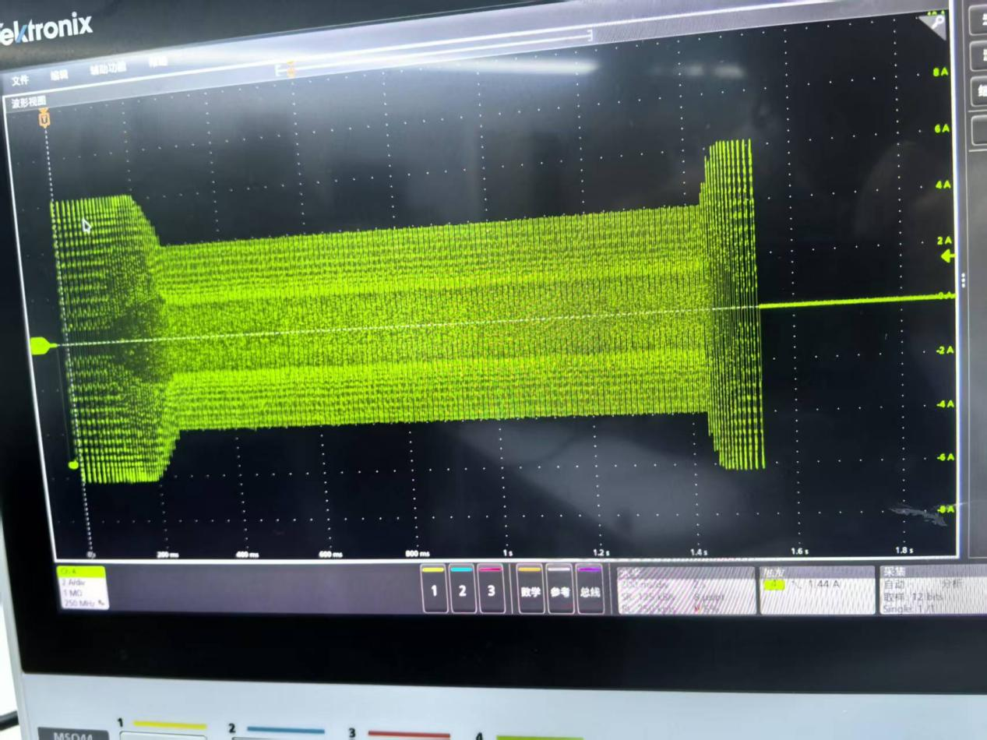
3）600rpm Motor phase current waveform
