We have captured voltage waveforms across both resistor with external trigger mode, using trigger source as step pin.

**½ step with 8 number of steps,**

First 8 steps (motor movement observed)

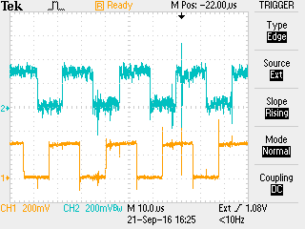

Next 8 steps (motor movement observed)

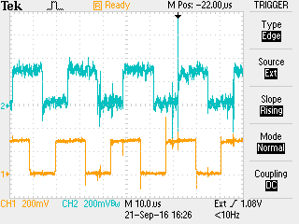

Next 8 steps (zoomed in) (motor movement observed)

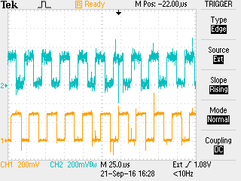

Now main problem is when we are trying half step with 1 number of step.

First single half step (motor movement observed)

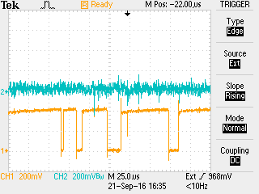

Second single half step (we couldn’t see any motor movement)

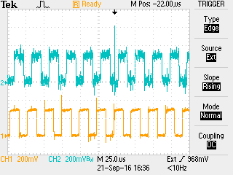

Third single half step (motor movement observed)

