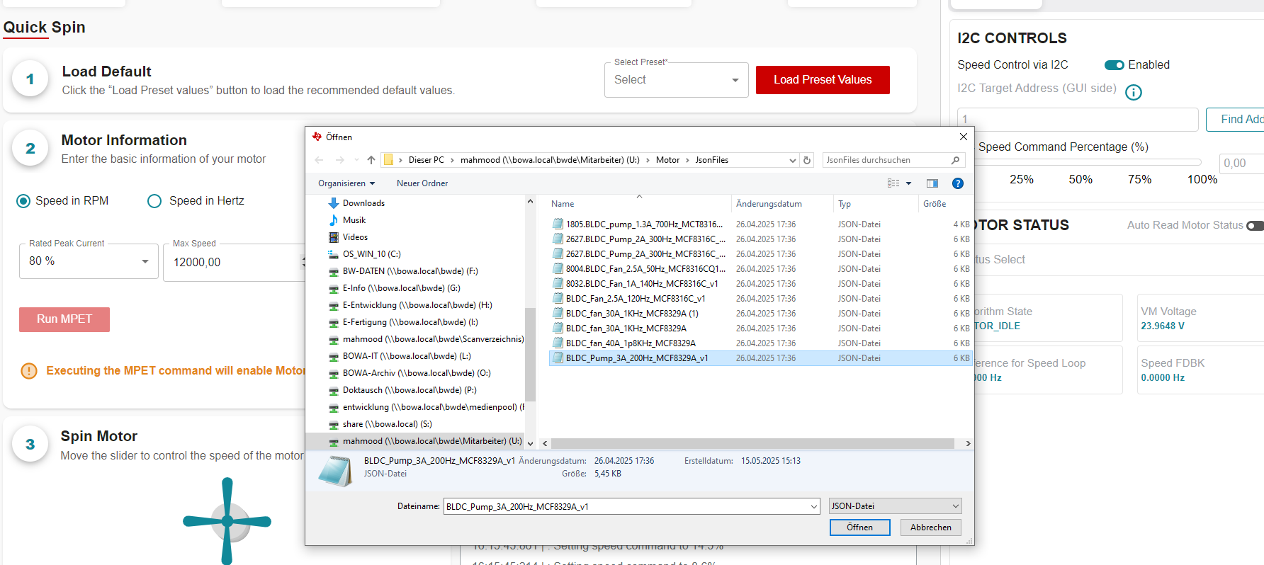

Loading the json file. Pressing the Load Preset Values

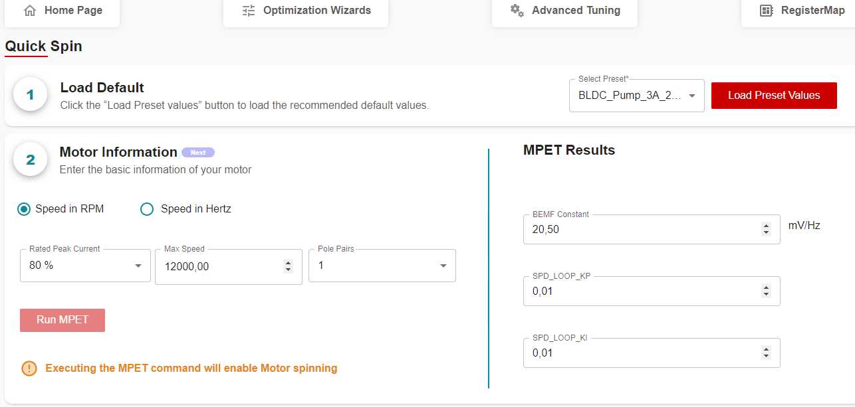

Preset Values are loaded.

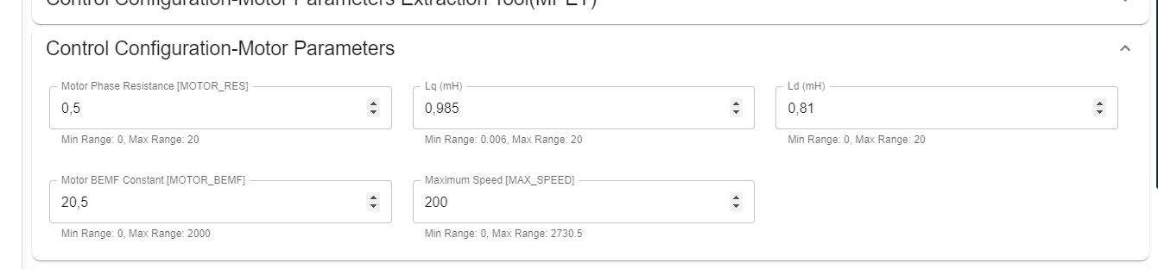

Entered the values of resistance and inductance.

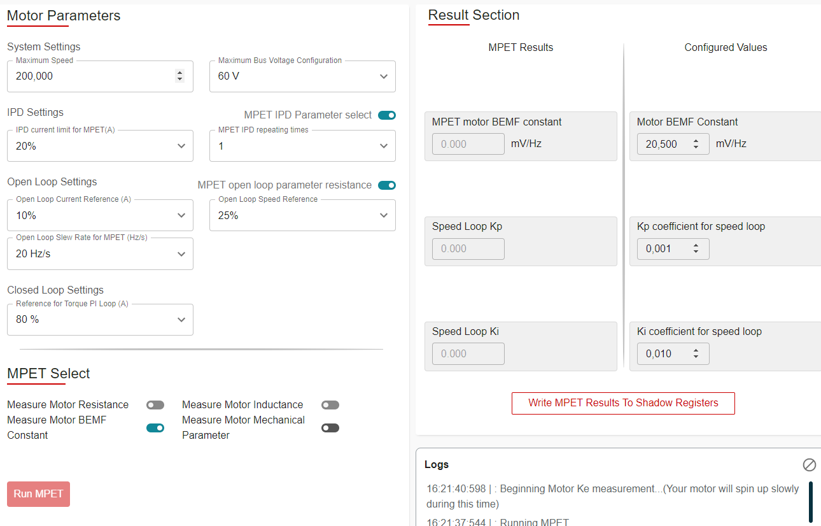

MPET Running

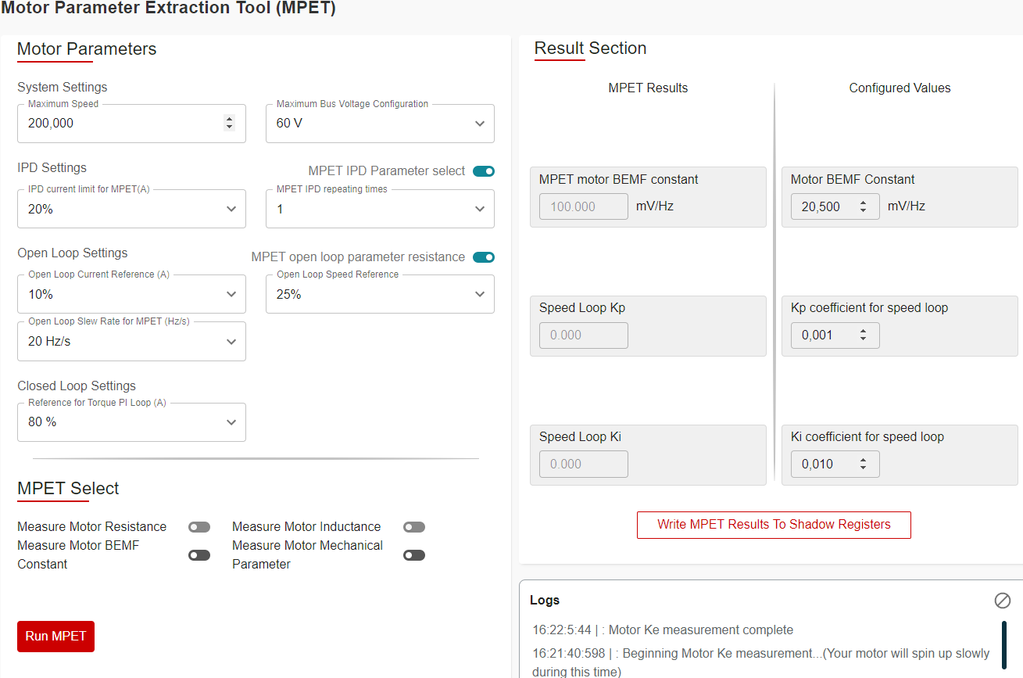

MPET found the value of BEMF constant.

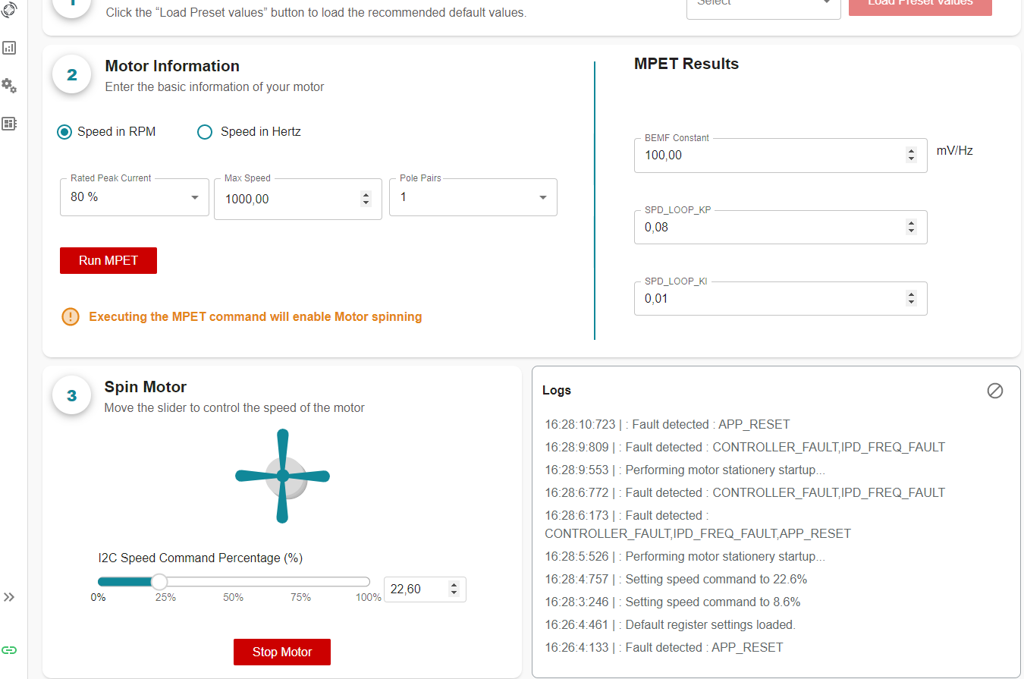

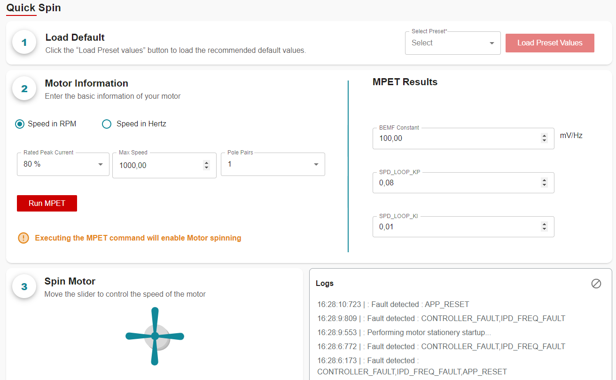

Trying to run motor with the backemf constant. Motor giving fault.