1. **FAULT+PWM+VM+V MOT**

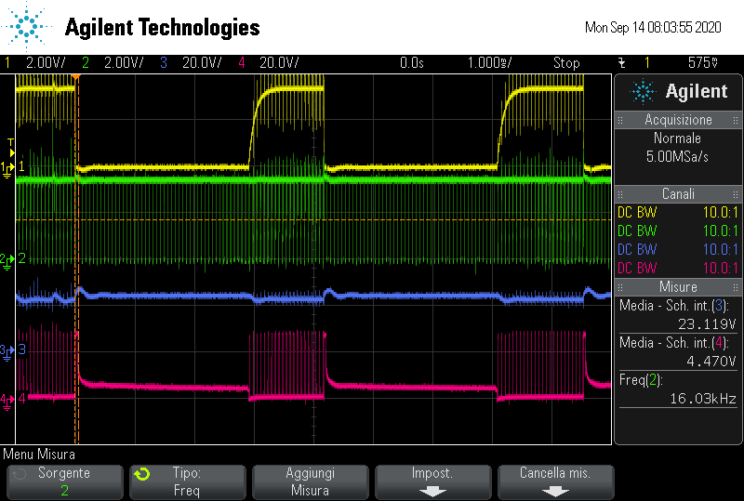

Yellow=_FAULT-Green=PWM -Blu=VM-Pink=V mot (negative pole)

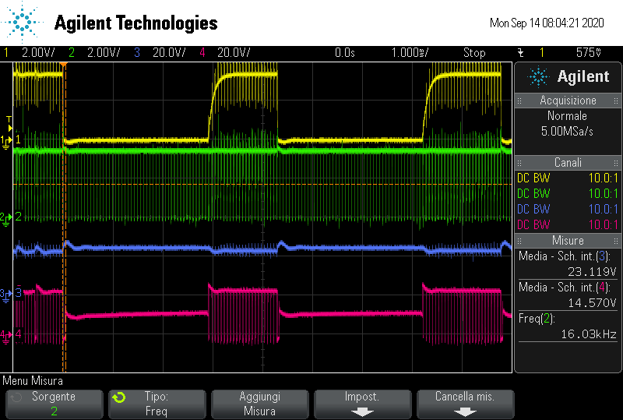

Yellow=_FAULT-Green=PWM -Blu=VM-Pink=V mot (poitive pole)

1. **FAULT+SENSOUT**

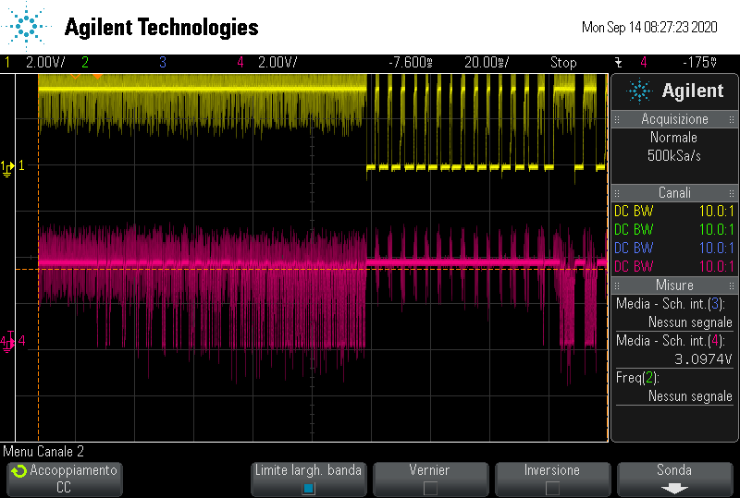

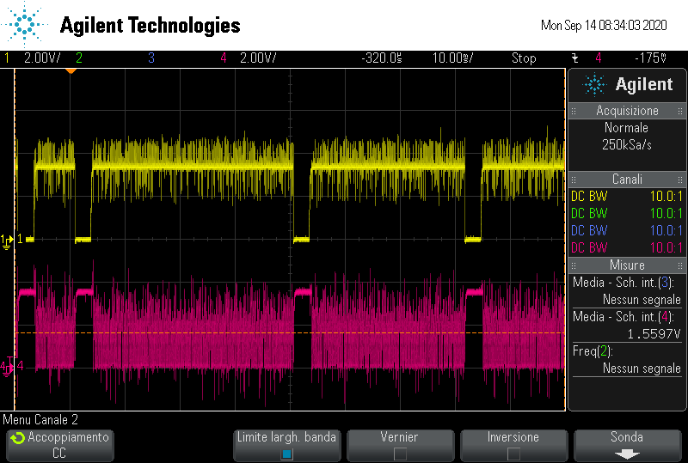

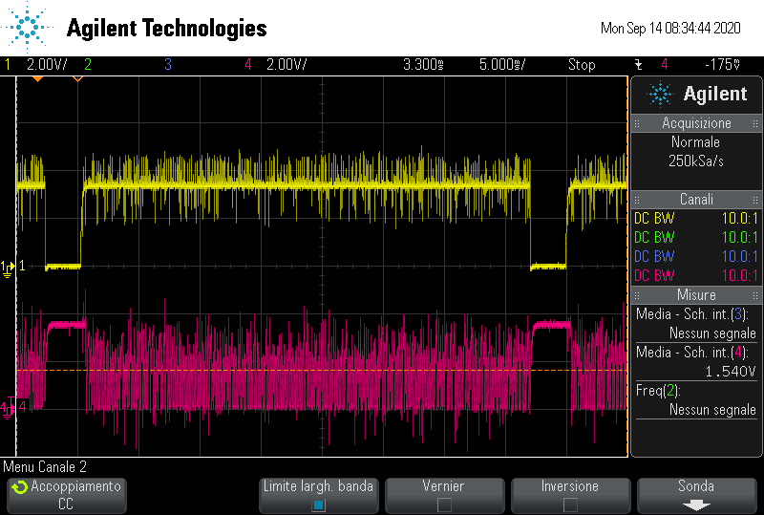

Yellow=_FAULT- Pink=SENSOUT