Schematic recommendations:
The schematic looked fine overall one area of concern I wanted to bring up was the sense resistor R7, it seems like all the current goes through this path to your current sense circuit. I just wanted to make sure that you were aware of this to ensure that your sense circuit was rated to handle all the current coming through this path.
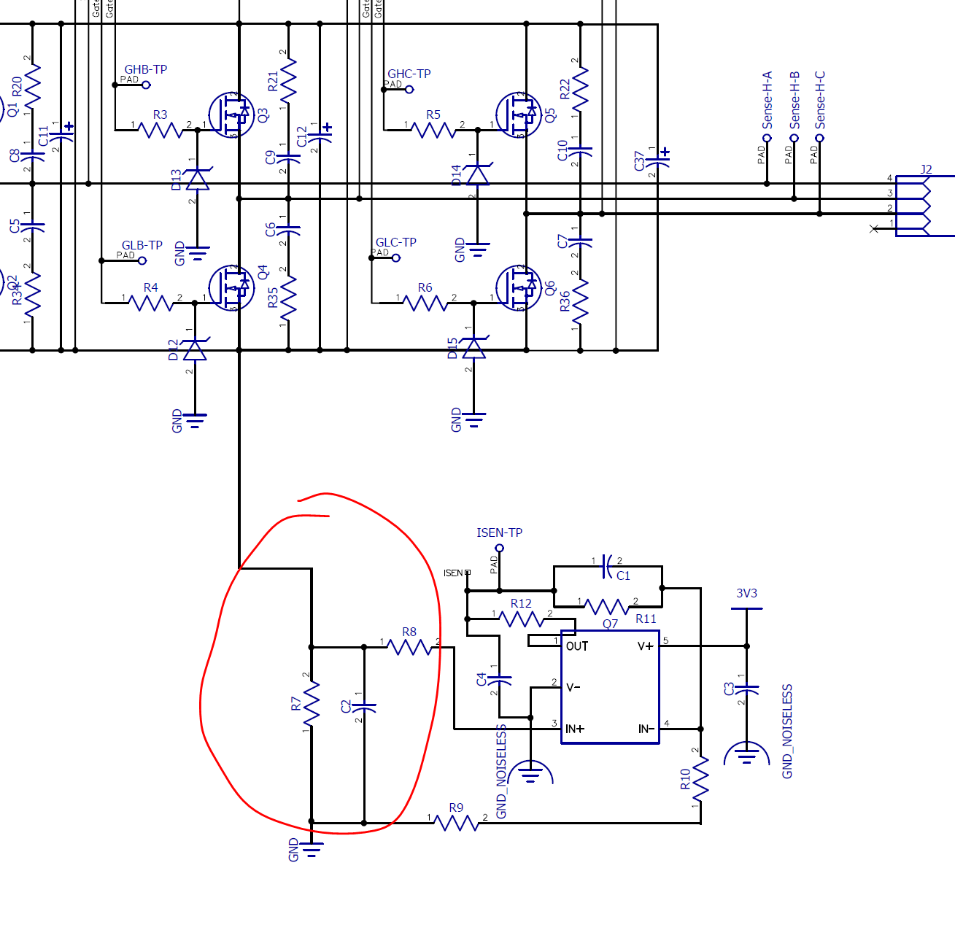

Layout recommendations:
We believe that it would be necessary to restructure the connections to VM and VDRAIN. VM path is somewhat narrow for the current requirements, we usually recommend using large copper planes and wide traces to support these requirements, a good rule of thumb to use for trace width is 10mil/1A.
Having narrow traces for VM, VDRAIN, VCP, and CPH/CPL can add inductance to the system, and all of these should be wide enough to support the current needed by your system. Some areas of concern can be found below:
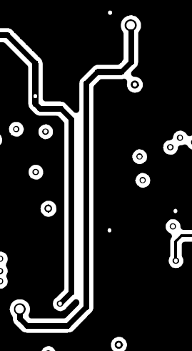

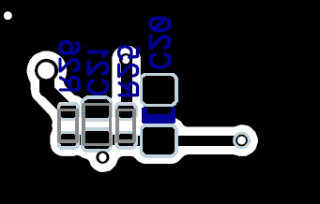
We typically recommend using surface mount over through hole FETs, the long leads in through hole FETs typically add additional unwanted inductance. Usually we also recommend to move these FETs as close to each other as possible, you want to minimize the length between of the trace between the source of the high side and drain of the low side MOSFET will reduce parasitic inductance. Moving Sense-H-X should allow you to get FETs closer together.

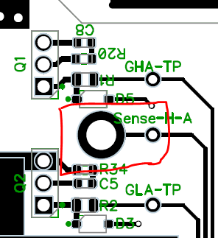
Also note that there is no copper pours in the below of the PCB, adding a polygon pour in this area might be useful for carrying the high current signals or dissipate current back to GND. Additionally the thicker traces would be recommended for the GHx and GLx paths.
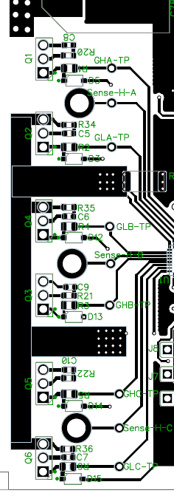

One last note would be to add stitching between board layers to ground and power. This helps reduce current loops to ground as well as ensuring low impedance between the layers/planes. You can take a look at our EVM layout files as an example.

