# Recommended External components:

* VM,C_FLY,VCP,VREF,CBK,LBK seems good
* There are no voltage ratings on the components in your schematic. It is a good rule of thumb to use a component rated for 1.5 to 2 times the voltage that the component will be operated at.

# Specific review

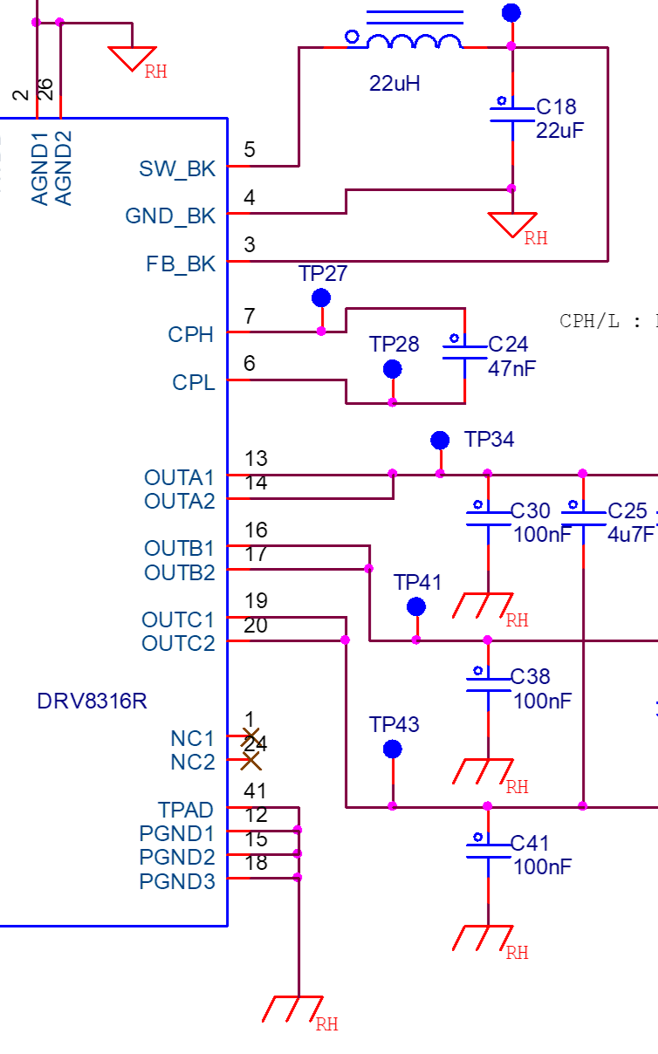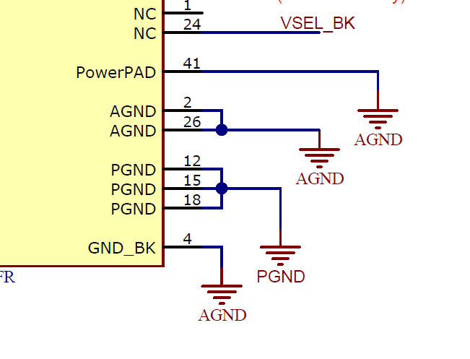

* AGND should be connected to thermal pad, not PGND, see EVM
  + Also, please review this layout app note if you intend to use a split GND: <https://www.ti.com/lit/an/slva959a/slva959a.pdf>

→ Reply : Thank you, I will modify the schematic

* Couldn’t find where you tie the AGND and PGND nets together. How are they connected? Are they both the same net since they are both labeled RH (even though the symbol is different)?

→ Reply : It’s different. ( = PGND , =AGND )



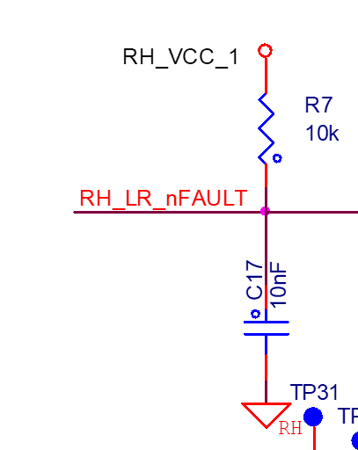

* Not sure why cap is needed on nFAULT, this will slow down rise time nFAULT which means the MCU detects nFAULT slower than what it actually is.
  + In addition, capacitors are used to clean up signals but nFAULT does not switch with a frequency, it will have one rising or falling edge.
  + At least DNP the cap and if there truly is spiking or ringing on the one rising or falling edge, then its more indicative or very poor GND’ing.

→ Reply : I will delete C17, I was confused with the reset circuit.

* The recommended value for R7 is 5.1k, but 10k would probably fine as well.

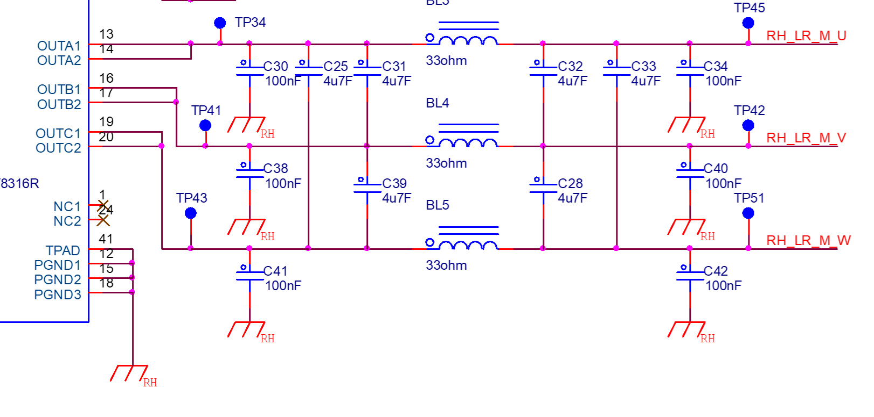

* It seems like this is supposed to be differential and common mode filtering on the output, with the intention to help with EMI
  + However, these capacitors divert motor current between the phase. The phase voltages will be PWM waveforms with a frequency and capacitors turn into resistors when there is frequency.
  + If you see voltage coupling and losses as motor current is diverted away from the motor, this filter section will be the reason.
  + In addition, if you see damage with phase shorts to GND or VM this filter will also be the reason. These capacitors increase coupling and will make the voltage spiking and layout worse adding inductance in the line.

→ Reply : I will operate the motor referring to your opinion.

* Are the BLx components inductors? Or are they ferrite beads? The symbol looks like an inductor but the units are in ohms.

→ Reply : Changed from ferrite bead to inductor.



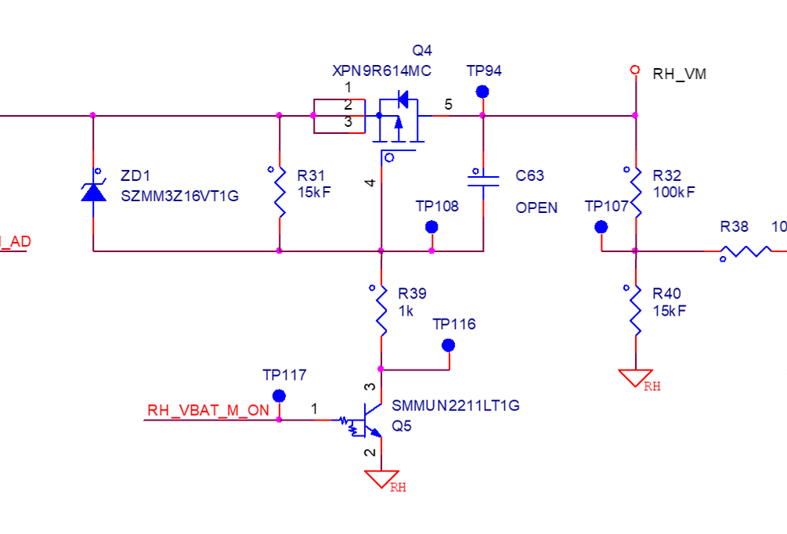

* In regards to the high side cut off switch, feel free to review app note on Cut-Off Switch in High-Current Motor-Drive Applications <https://www.ti.com/lit/an/slva991a/slva991a.pdf>

→ Reply : In slva991a documents, Our schematic has a similar PMOS Cut-off switch method.

* R31, R32, R40, and some others are labeled in units of F instead of ohms. Just want to confirm that these are resistors

→ Reply : Its resistor, and F-mark means the tolerance rating.

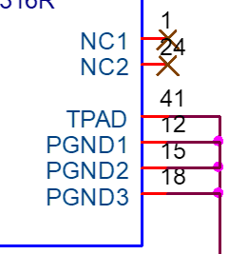

* Feel free to connect the NC pins to AGND for better thermal performance

→ Reply : Thank you, I will modify the schematic

# modifed Schematic



Change from BEAD to Inductor

Delete CAP

Change from AVDD(3.3V) to VCC1(5V).

Add Voltage sense & protection

