- Connect PC/laptop to USB2ANY | 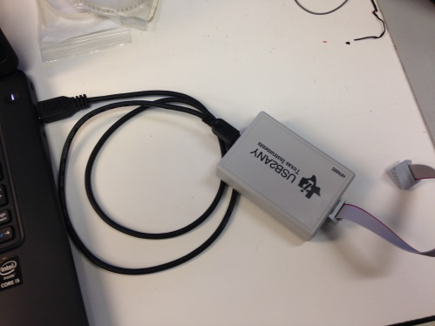
- Launch GUI | 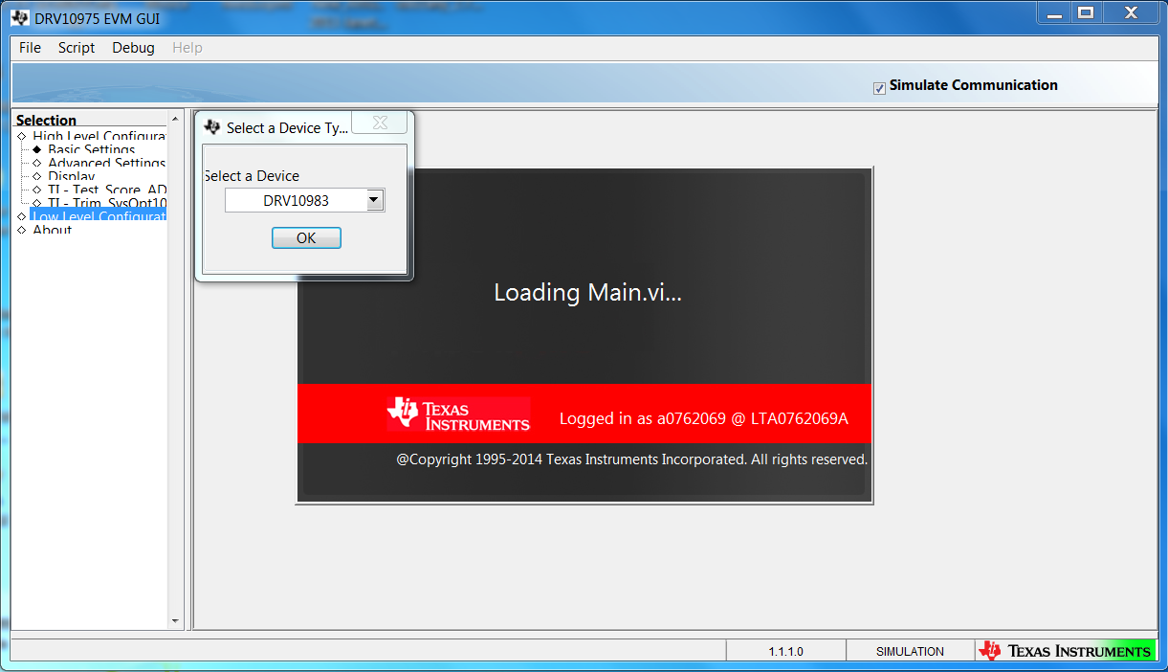
- Click “OK”  Notes: If didn’t see this screen, please jump to step 7 | 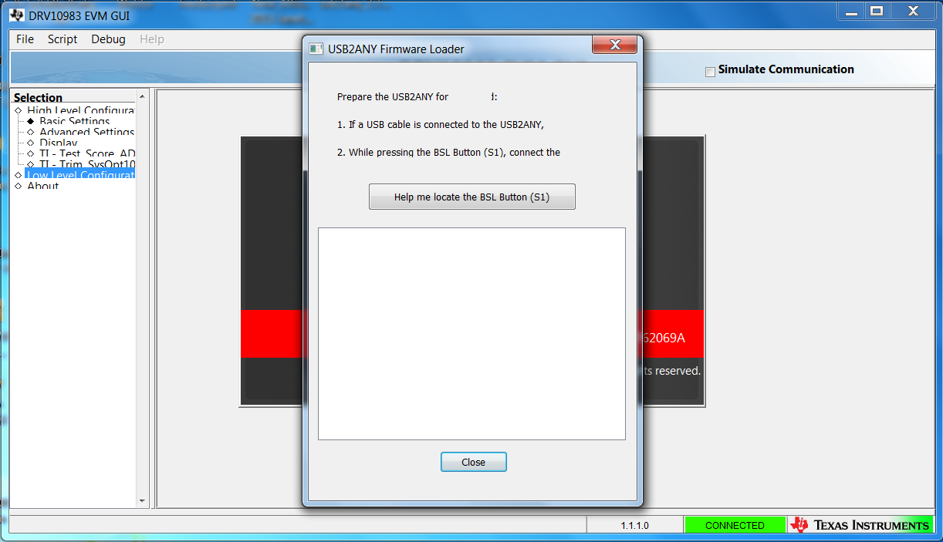
- Click “Help me locate the BSL Button(S1)” to know S1 location | 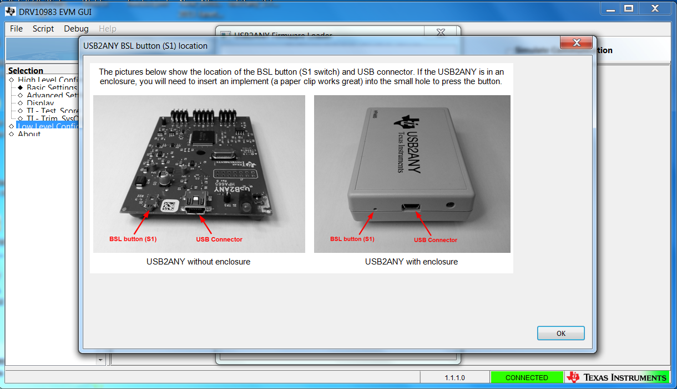
- Disconnect USB Connector | 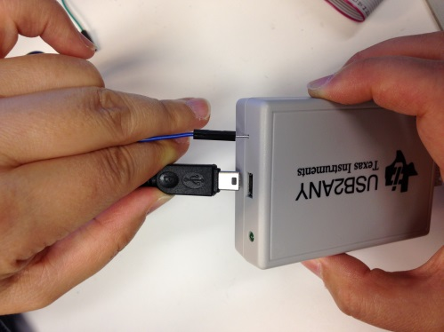
- Push S1 and Connect USB Connector together | 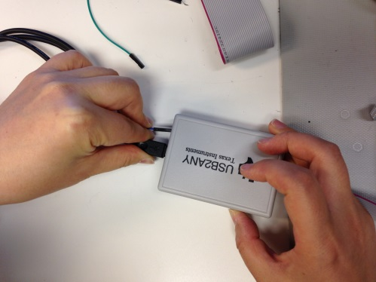
- After Step 6 -> screen will show and ready for updating firmware. | 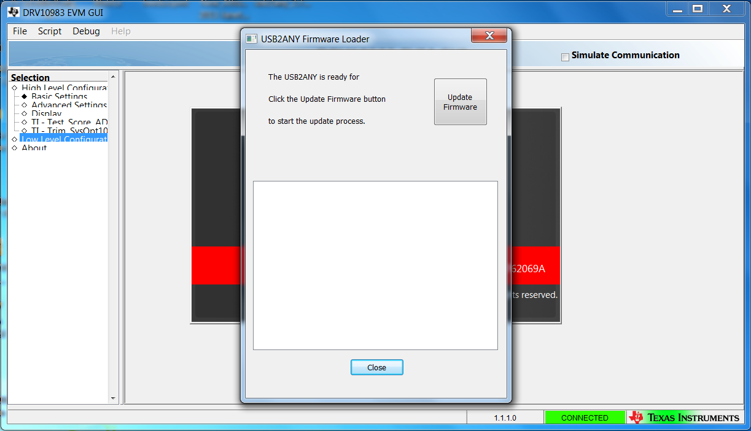
- Click Update firmware to update firmware | 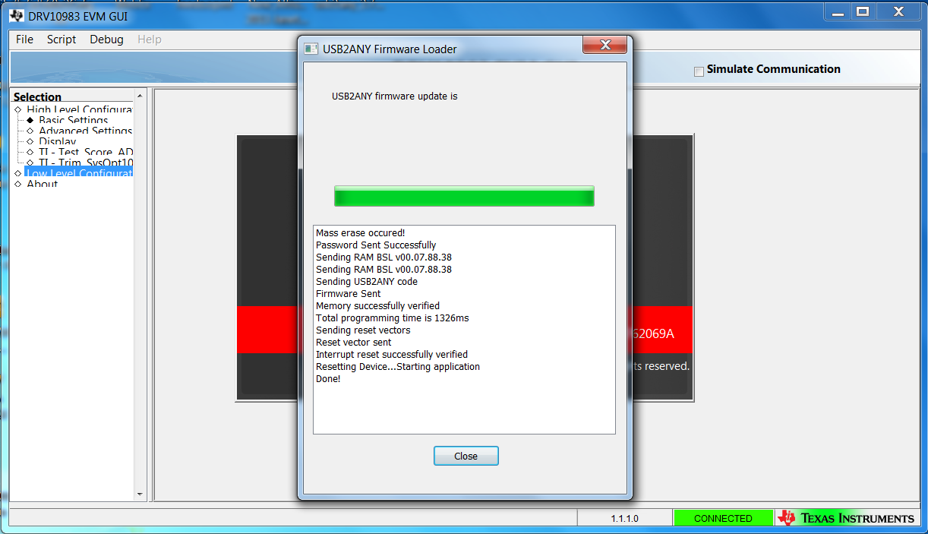
- After updating firmware Click close. USB2ANY is ready work with DRV10983EVM. | 