1. 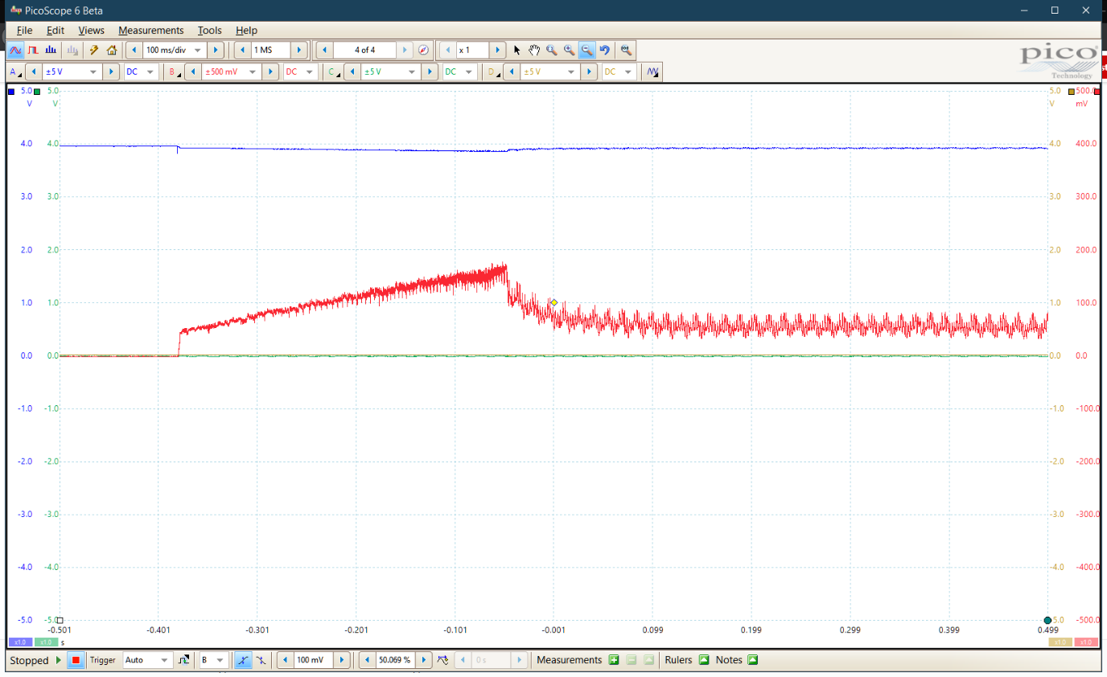VILIM (red) across RISEN (0.91 Ohm) for a normal motor start, FAULTn (blue) still HIGH (Vcc 4V)

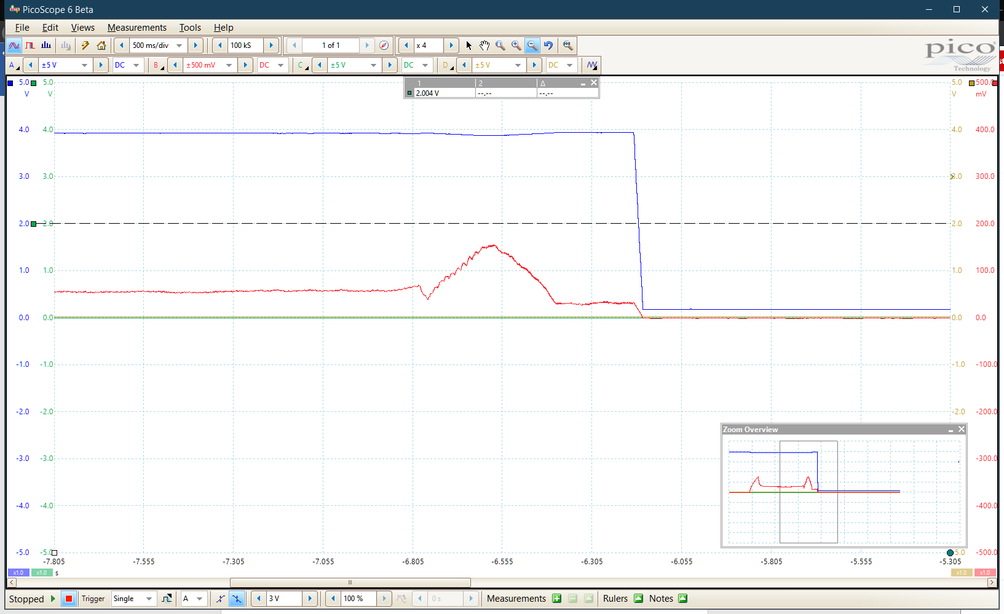

1. Mechanical stall applied. FAULTn asserts and stays asserted after BRAKE applied.