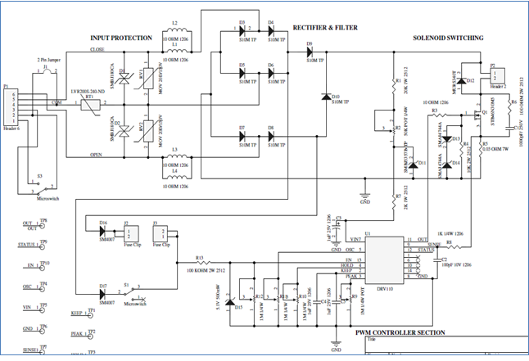
Figure 1: Schematic of DC Control Board
Red Marking componets are related to EN pin.

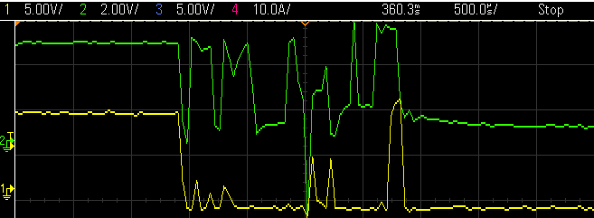

Figure 2: EN & OUT pin behavior after Break the High pulse to EN pin (Green – EN & Yello – OUT)

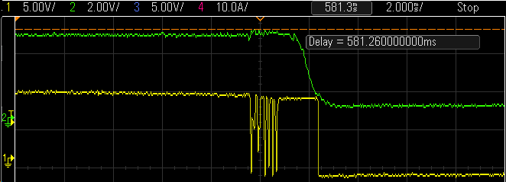

Figure 3: EN & OUT pin behavior after 2.2 nf Cap between R13 to gnd

