CD4051 test Wave

Two PCS CD4051， one is normal, the other is imnormal. Both of the two chips are testing the same borad. The power supply VDD is 8V. VSS and VEE connect GND. The input signal frequency is 58.1k and the amplitude is 3V, the offset 4V.

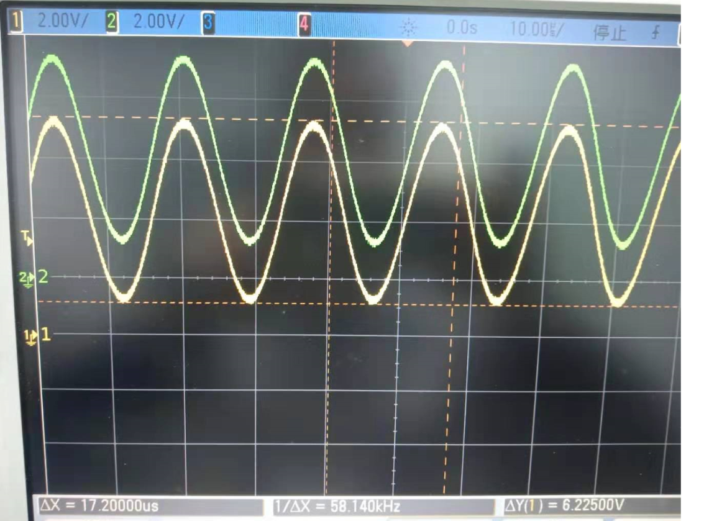

Figure Normal Chip

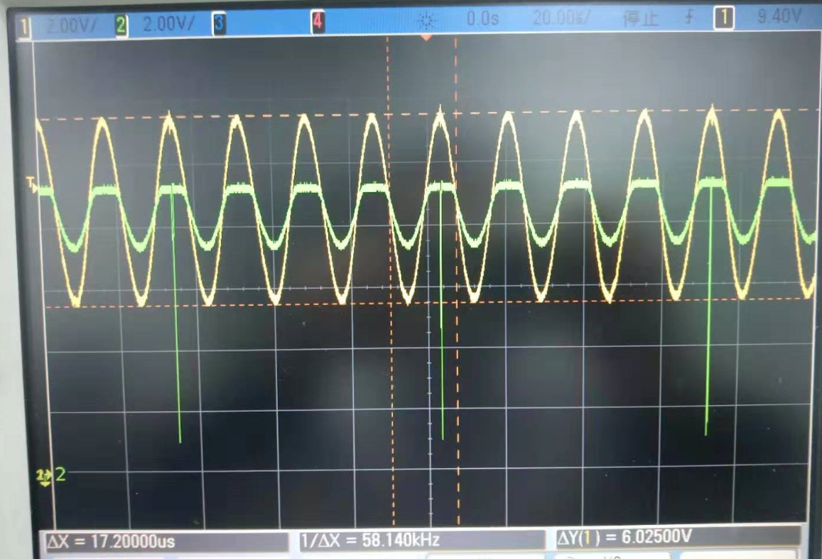

Figure NG Chip

Please see above NG chip test scope wave. The yellow is input signal. It is abnormal. The offset should be 4V, but it change to 8V. and the peak voltage is lager than the power supply 8V. It is difficult to understand。