Currently my power supply is 5V.

1. What is the parameter mentioned in Figure 1, specifically, the manual is the resistance of the input signal, and what its function is.

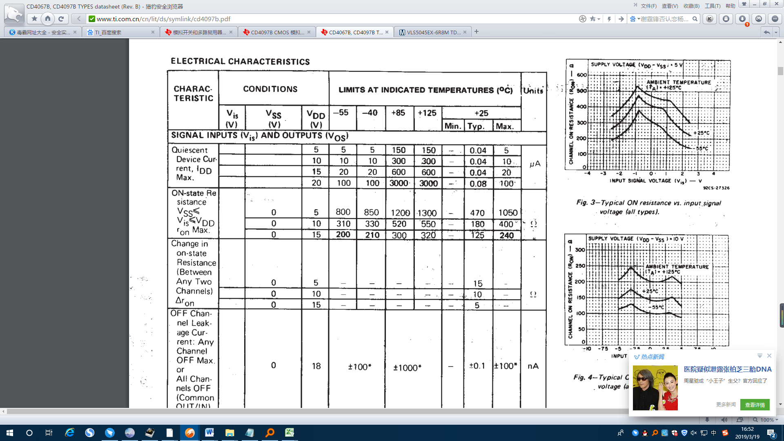

Figure 1

2. The parameters mentioned in Figure 2 are the on-resistance of the channel in the on-state of the switch. According to the manual, the power supply of my system is 5V, and the on-resistance should be 15Ω. Is it correct?



Figure 2

3. If I want to know the maximum output current of a single channel in operation, the system power supply is 5V, how to calculate the maximum current for different input voltages, can I pass Pd=I\*I\*Ron, Ron is the on-resistance, Pd of a single channel How much.

4. The Pd given in Figure 3 is 500mW, which refers to the overall Pd of the chip. What is the parameter 100mW?

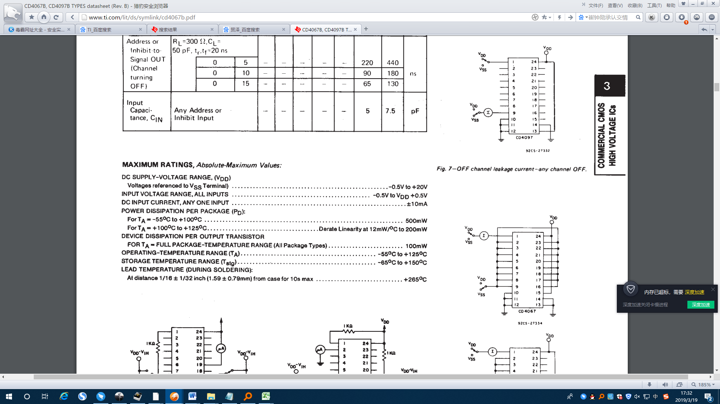

Figure 3