How to connect to LMK03228:
- Open TICSpro Application.
- Select appropriate device under “Select Device” option the top menu bar.
- Make sure board is being powered on by supplying appropriate VDD and having device connected to PC via USB cable.
- Determine if board is connected to PC correctly via TICSpro by pressing “USB communications” in toolbar and press “interface.”
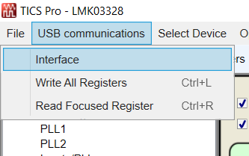
- If the board is detected it will be visible here:
- If multiple devices are connected press “identify” button to see which device is currently being communicated to.
  - On Board LED will flash if device is being communicated to successfully.
- Press “Scan i2c Bus” button to connect to device and update I2C address.
How to use the wizard to quickly create a configuration:
- Press the “Wizard’ tab button.
- Input the reference frequencies for PRIREF & SECREF
- Decide whether you need to use the doubler for the input frequencies
  - Note: Typically, one always wants to double the input frequencies to have the largest Phase Detector Frequency (PFD) possible which results in best output phase noise performance.
- Choose appropriate PLLN R Div values from the dropdown menu
- Choose appropriate PLLN Ref Sel values from the dropdown menu
- Choose appropriate PLLN M Div values from the dropdown menu

- Input all desired output frequencies into the wizard to see if all outputs can be generated from two frequency domains.
  - Note: OUT0/OUT1 are an output pair & thus their output frequencies are identical
  - Same case with OUT2/OUT3
  - OUT0/OUT1 & OUT2/OUT3 prefer using PLL2
  - OUT[7:4] prefer PLL1
- Press “Calculate” button to see if frequency solution can be implemented.
  - Note: I purposely inputted 54 MHz into OUT23 above which will result in error as 54 MHz and $\frac{200}{3} MHz$ belong to two different frequency domains and cannot be generated from a single VCO frequency.
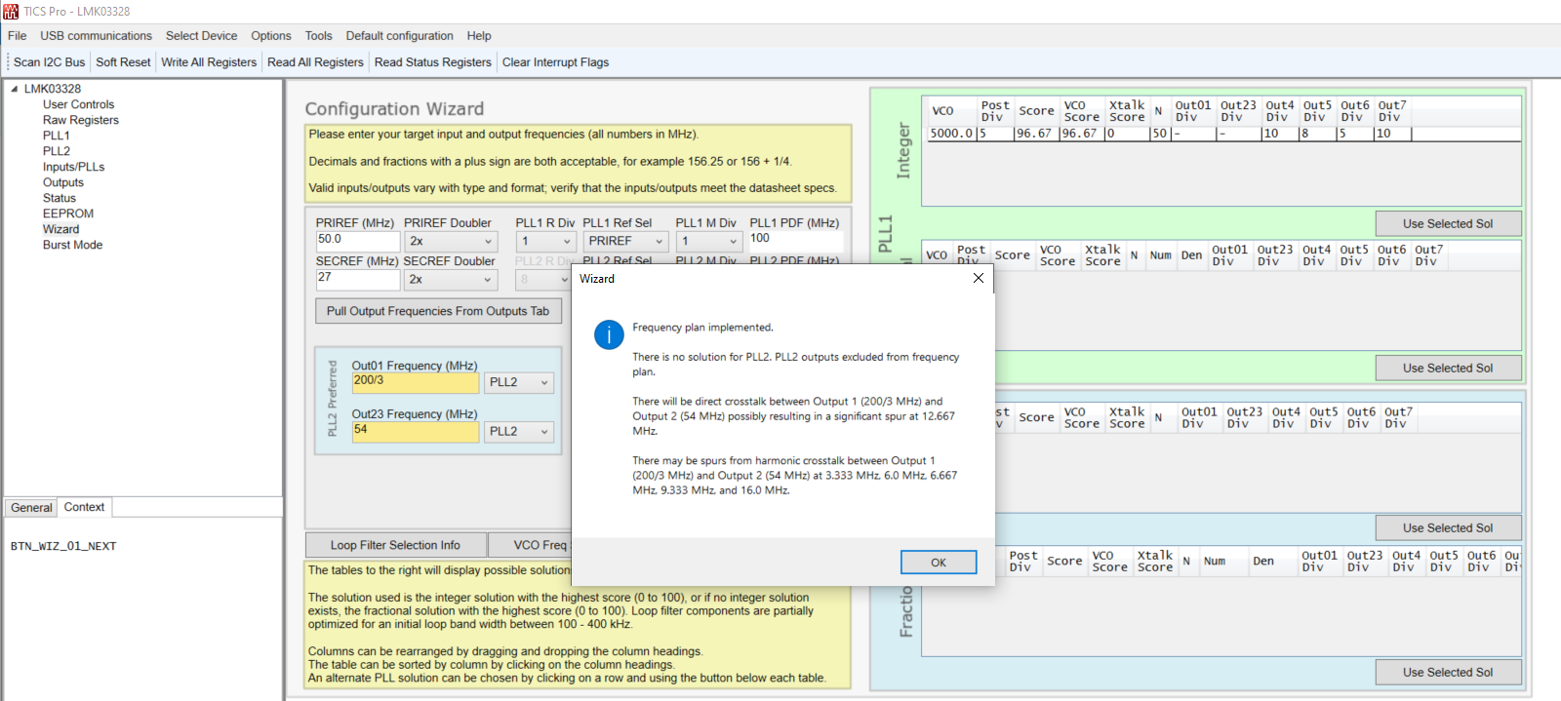
  - You will encounter an error when trying to generate a solution to a frequency plan that is impossible to create as the one I tried above where the wizard has determined there is not solution to PLL2.
- I will change OUT2/3 frequency to $\frac{200}{3}$MHz to overcome this issue and demonstrate generating a successful solution.
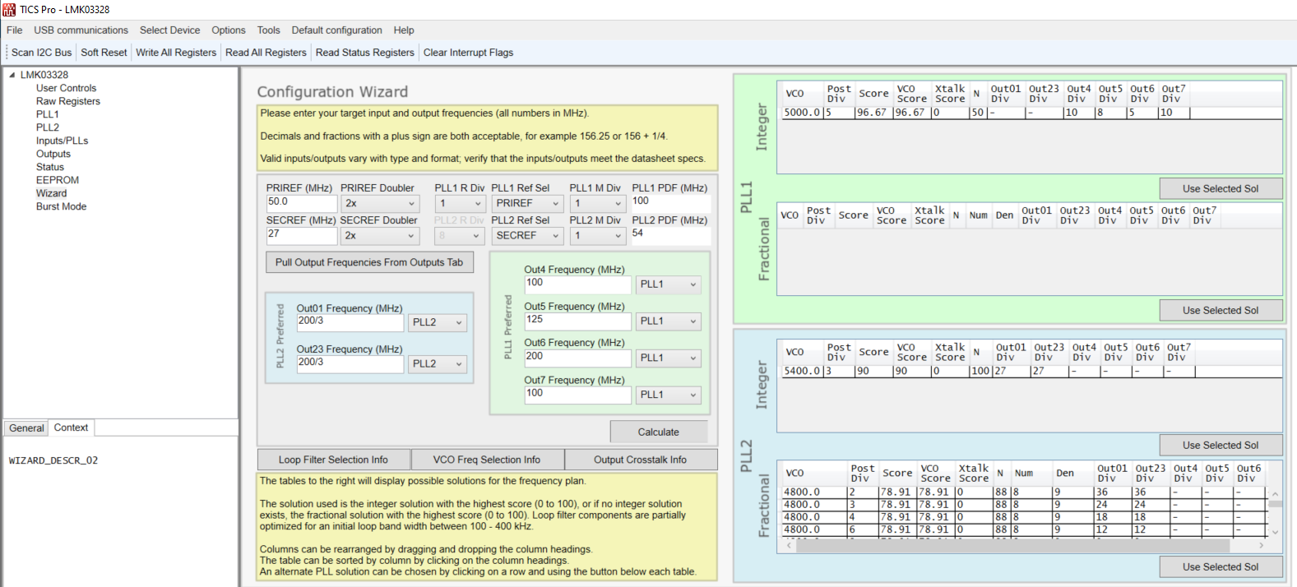
- Press “Calculate” button.
  - If successful and frequency plans can be generated you will receive the message in the image below.
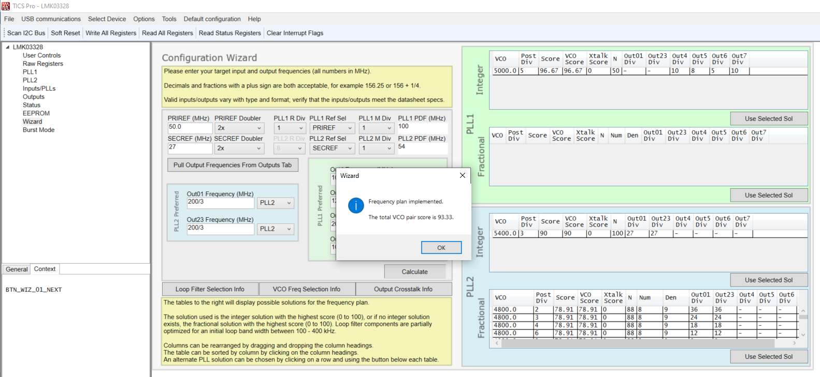
- Choose the appropriate VCO solutions.
  - In my case there is only one Integer solution for PLL1. A 5000 MHz VCO frequency can be divided down to generate 100, 125 & 200 MHz respectively.
  - For PLL2, there is one integer-based solution and various fractional solutions to generate a $\frac{200}{3}$MHz output
  - Press “Use Selected Sol Button”
- You can now go to the outputs tab and confirm you have the desired outputs which you generated in the wizard
How to save a TICS Pro configuration:
- Have your desired configuration ready.
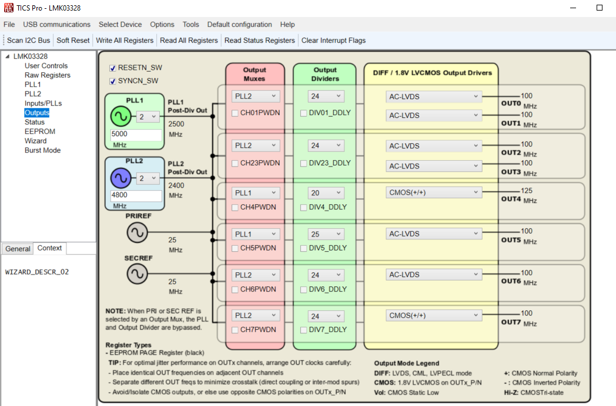
- Press “File” first and then press “save” button.
- Name the configuration and press “save” with the desired directory chosen for storage location.

How to load TICSpro (.tcs) configration:
- Open TICSro.
- Press “File” button followed by pressing “Load” button.
- Choose appropriate saved .tcs file and press “Open” button.
- Press Write all register button or “CTRL + L” to ensure configuration is loaded onto device

How to export register map:
- Have your desired configuration ready.
- Press “File” first and then press “Export Hex registers values.”
- Name the file as desired and press “save”.

How to program create an .epr (EEPROM) file:
- Assure your configuration is correct and read back all registers.
- Press “EEPROM” tab and choose an appropriate Register commit page.
- Press the “Commit Registers to SRAM PAGE/GUI Map” button.
- Press the “Export GUI Map to EEPROM File” button.
- Save the file with whatever name you like to the correct directory and press “Save” button.

Workaround on how to program EEPROM:
One needs to follow the steps listed in the page 56/57 of the datasheet. Begin by following the “Write SRAM” steps.
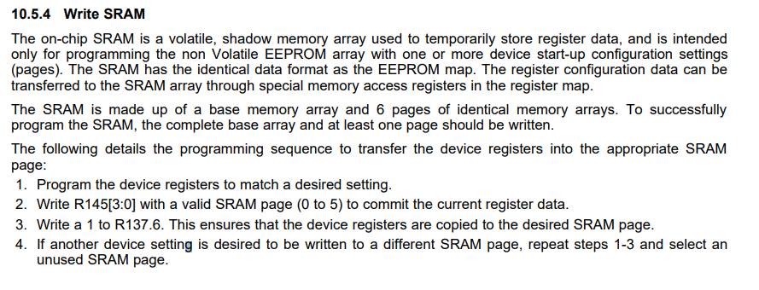
- Once your configuration is finished Press “EEPROM” tab and choose an appropriate Register commit page.
- Press the “Raw Registers” tab and write a 1 to R137.6
  - Repeat all SRAM steps above to write to different SRAM pages if necessary
Now the “Write EEPROM” section of the datasheet must be followed. +
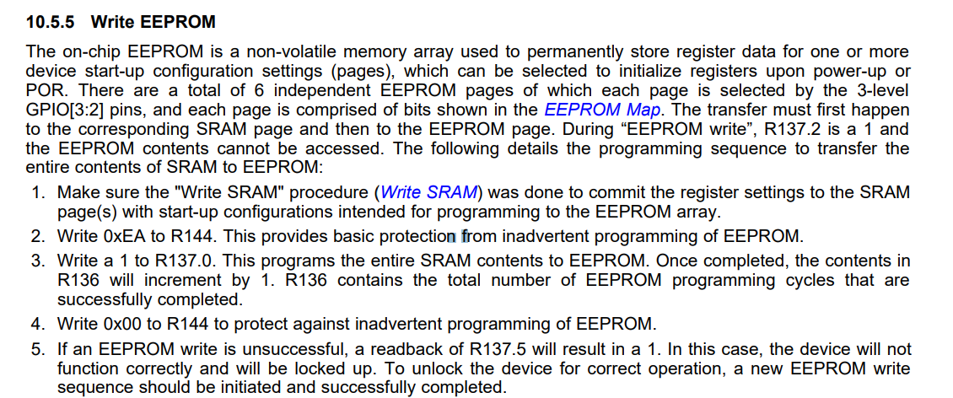
- Write 0xEA to R144
- Write a 1 to R137.0
- Write 0x00 to R144
- If EEPROM write is unsuccessful, readback of R137.5 will return a 1 and the EEPROM programming sequence must be restarted.

