Hello,

Please tell me how to input a 1PPS signal to PRIREF/SECREF and phase synchronize the output clock of OUT0-7 to the rising edge of the 1PPS signal. I Refer to "1PPS default" in default Configurations of TICSPro-SW for basic configuration.
Note: (CHx_sync_EN = 1), (PLL1_P1_sync_EN = 1).
[JB]
- We are making datasheet updates and will release next week to specify that a 1PPS input must only be applied to PRIREF_P or PRIREF_N.
- If deterministic alignment between input and output is required, then I recommend enabling the REF to OUT7 synchronization feature (refer to the DCO page in TICS Pro). The REF to OUT7 sync feature is only available on OUT7 and only OUT7 can generate a 1PPS output. Do you require more than one 1PPS output?
Q1: There are two sync events (phase synchronization method): The GPIO0/sync pin in the hardware (active low) and the sync_SW bit in the software (active high). Please tell me how to use these two.
Are the following #1 to #3 perceptions correct?
#1 If GPIO0/SYNCN pin=0 (output driver mute/divider reset) or sync_SW bit=1 (output driver mute/divider reset), will the outputs from OUT0 to OUT7 go to the state (output driver mute/divider reset)?
[JB]
- If the SYNC_MUTE register is set, R12[3] = 1, then the outputs enter a “muted” state when the SYNC is triggered. SYNC is triggered when GPIO0/SYNCN pin=0 or sync_SW bit=1.
- 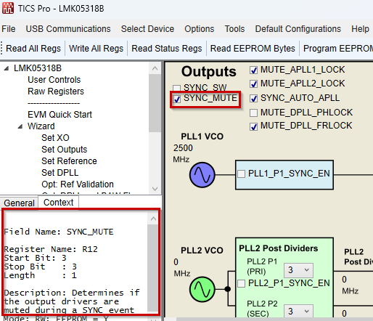
If one is (output driver mute/divider reset), is it OK to recognize that output is stopped? "
[JB]
- Yes, mute means the outputs are not present.
#2 when the GPIO0/SYNCN pin is controlled from "0" to "1" in the hardware to perform phase synchronization of the output clock and clock output, the sync_SW bit of the software must be set to sync_SW bit = 0 (normal operation).
[JB]
- Correct. If you are using the GPIO0/SYNCN pin, make sure to keep SYNC_SW bit = 0 to avoid conflict.
#3 when the software controls the sync_SW bit from "1" to "0" to perform the phase synchronization of the output clock and the clock output, the GPIO0/SYNCN pin of the hardware must be set to GPIO0/SYNCN pin = 1 (normal operation).
[JB]
- Correct. If you are using the SYNC_SW bit, GPIO0/SYNCN must be logic HIGH to avoid conflict.
Q2:
If you set the OUT7 clock as 1 PPS output, you can phase synchronize with 1 PPS input of PREREF/SECREF with zero delay by enabling ZDM (DPLL_ZDM_sync_EN bit = 1) and OUT7 divider synchronization (CH7_sync_EN bit = 1). How about the remaining OUT0 through OUT6?
[JB]
- Please see my comment at the top of the page.
- Note that in the upcoming datasheet release, the “ZDM” feature is renamed to 1PPS Reference to OUT7 synchronization feature. This is because the LMK05318B does not have “true” ZDM. True ZDM uses a closed-loop system. The LMK05318B uses an open-loop sync to achieve deterministic 1PPS IN-to-OUT7 phase and reduce the lock times.

Please tell us which is true among #1 to #3 below.
#1 Synchronization between OUT0 and OUT6 is frequency-synchronous only, and the phase is asynchronous.
[JB]
- No, both frequency and phase synchronization is still achieved for OUT0 to OUT6.
#2 Synchronization of OUT0 through OUT6 is frequency and phase synchronization, but ZDM delay is not zero.
[JB]
- Correct. The OUT0 to OUT6 follow the REF input with a small phase delta when the DPLL is locked.
#3 Synchronization of OUT0 through OUT6 can be synchronized with zero ZDM delay in frequency synchronization and phase synchronization.
[JB]
- No, only OUT7 can achieve deterministic delay (pseudo-ZDM). The delay can become zero by adjusting the phase offset register (R339 to R345) for OUT7.

Best regards,

Serizawa

