LMX2594
Output frequency: fast jump between 14G and 14.2G
The configuration of VCO is as follows: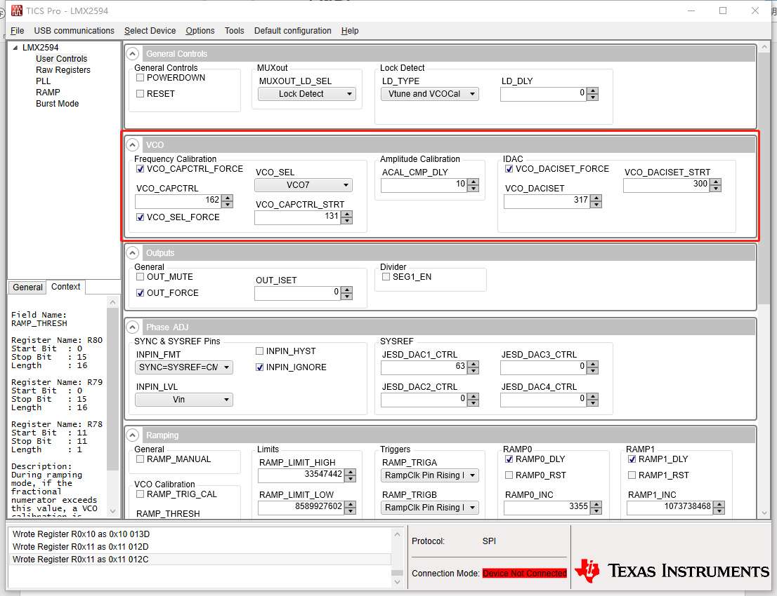
However, it is displayed on the signal source analyzer as: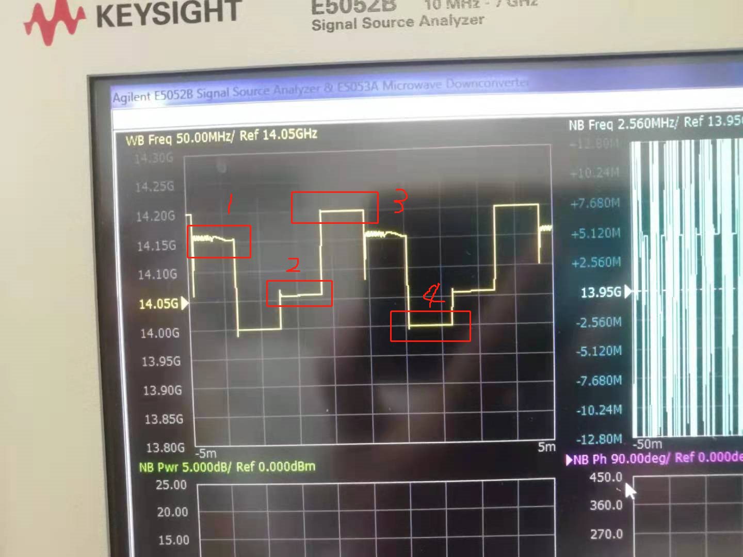
As shown in the figure: the frequency of 3 is 14.2G, and the frequency of 4 is 14G, but the frequency of 1 point and 2 points should not appear.
1 Is this output normal?
TI Response: During the VCO calibration for new frequency, it is trying to set the correct Cap code and going through some intermediate values, which show some other frequencies as in your plot also.LMX2594 doesn’t have the look up table for fast cal hence, you could see the other intermediate frequencies also.

2 If not, what is the correct configuration order?
TI Response: If you are able to see the required frequencies (14G and 14.2G), you must be following the correct sequence. Point 1 and point 2 frequencies always be there but you can Mute the LMX2594 output during the calibration and at this time output would mute in the range of ~-50 to 60dB down. After calibration, you would see the required new frequency with full output. For mute output during the cal, follow the below setting along with VCO setting, as you were following.

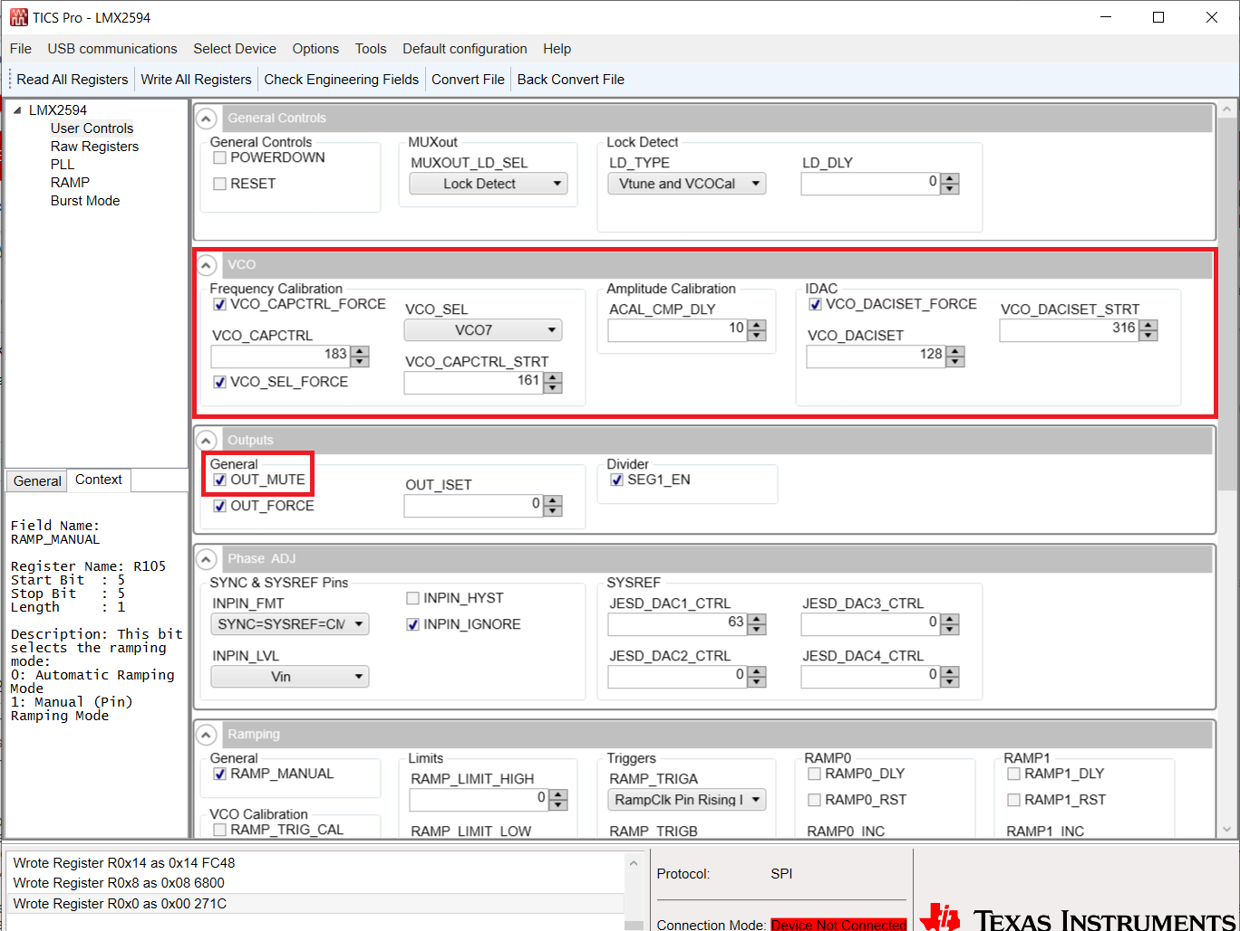

3 It is better to use TICS-Pro parameter configuration or program sample code.
TI Response: If you have limited output frequencies requirement, you could try with the program individual registers for sample codes, acts like look up table externally applied.

Thanks.

