**At 7500.2MHz VCO output**

**1st order modulator**

**Spectrum and Phase Noise**

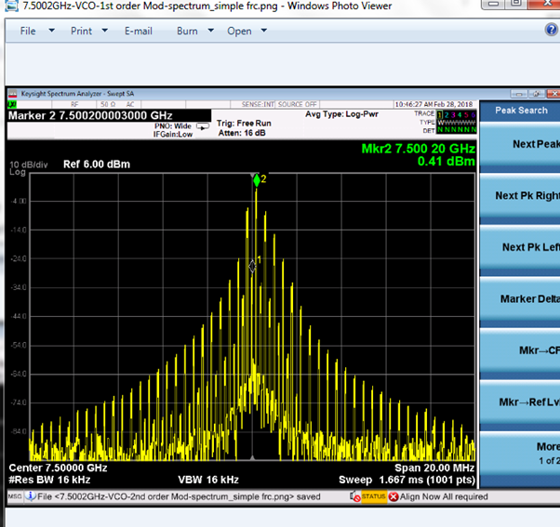

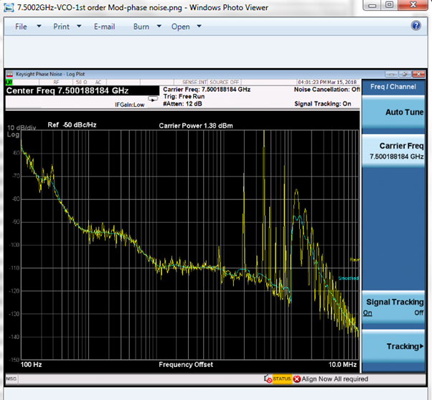

**2nd order modulator**

**Spectrum and Phase Noise**

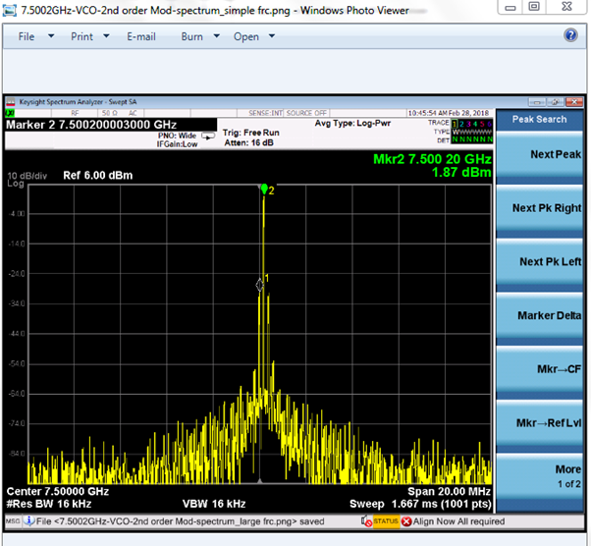

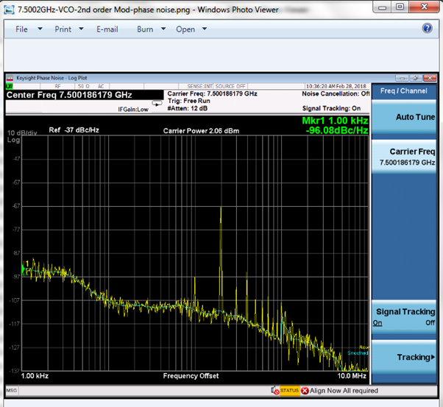

**3rd order modulator**

**Spectrum and Phase Noise**

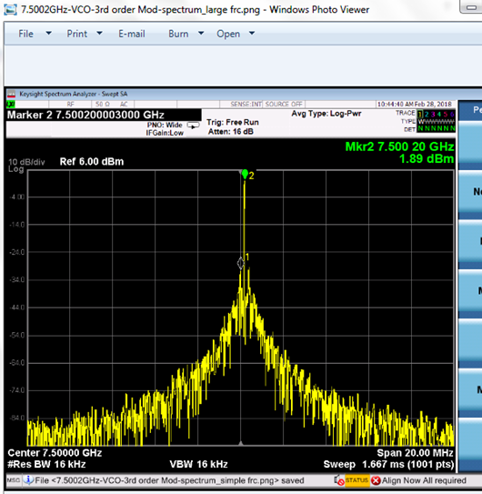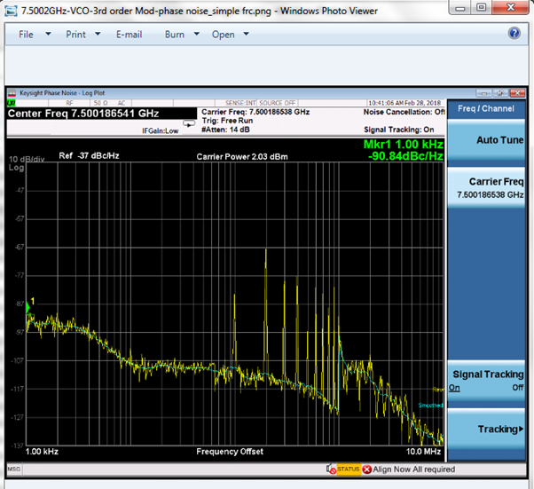

**\*Remark:**

**-1st and 3rd Order Modulators give very bad phase noise.**

**-While the 2nd order modulator gives better performance, close in spurs are still present**

**- This issue does not occur at 7500MHz or whole number frequencies where fractions are not used**

**At 7500MHz via VCO**

**1st Order Modulator**

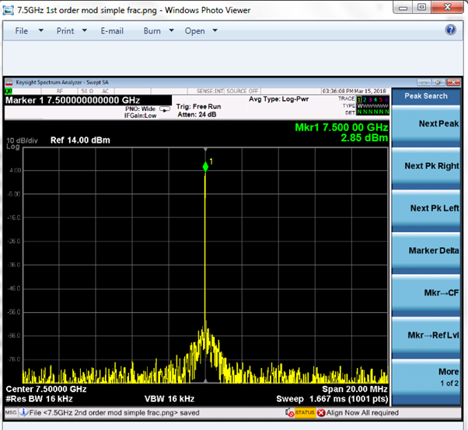

**2nd Order Modulator**

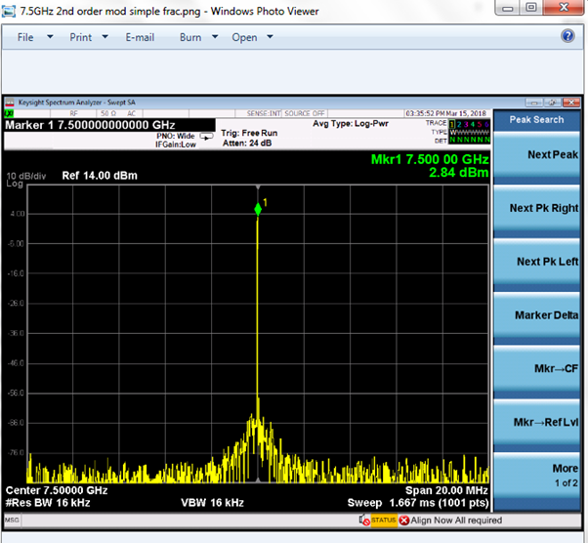

**3rd Order Modulator**

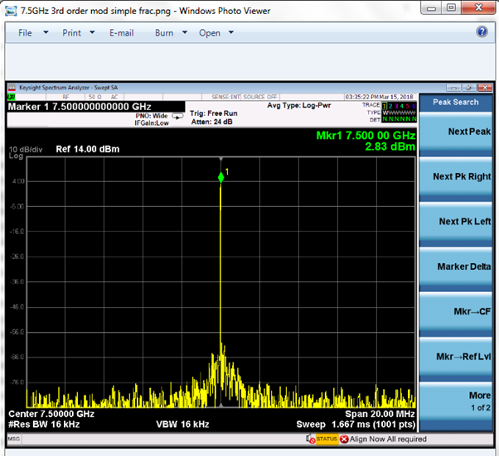

**Phase noise measurement**

