- LMC555 CIRCUIT
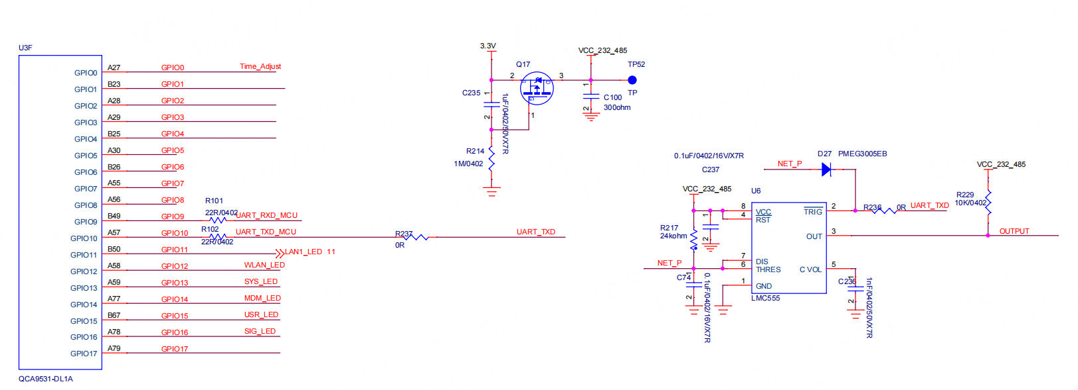
Working description
The device is powered on, U3 starts to work, and then controls UART_TXD to output high level “VH”. The “VCC_232_485”supplies power to the U6 after “ms”delay than the “VH”. Then we control the UART_TXD become pulse information, so that the U6’s output produces a delay signal.May I ask whether the above circuit will cause abnormal OUTPUT logic, and even cause damage to the LMC555 chip?
Note:
- LMC555 chip is only used for delay.
- The circuit’s GPIO10 current consumed when the U6 is not powered(see Figure 1) .
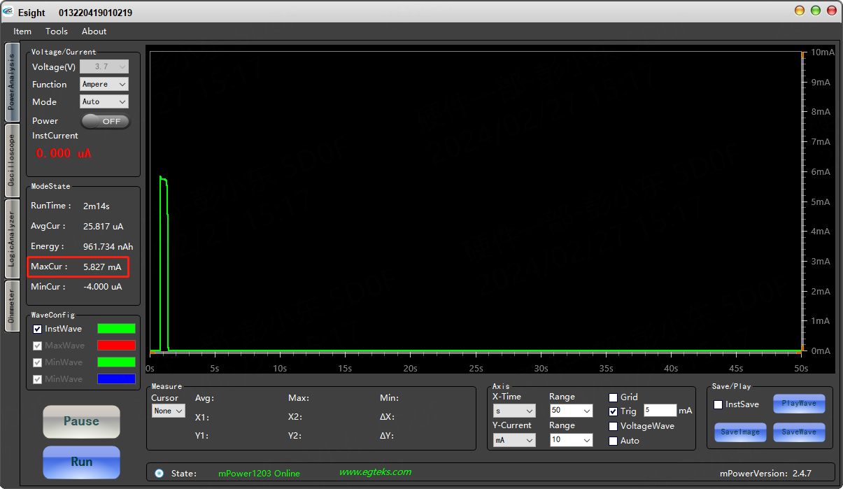
Figure 1 (MaxCur consumed is 5.827mA)
- In the general design, we give priority to ensure that the small system is powered on, and then supply power to the peripheral circuit. So how do we design a circuit like this?

