At the moment we are using the LMK04616 part in our design and we are driving the CLKInX with a LVDS driver (ZL40213). According the

Datasheet it should be possible to drive the part with LVDS:

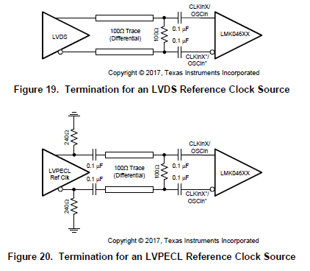

When we look to the LMK04616 specification of the CLKInX inputs it looks like this:

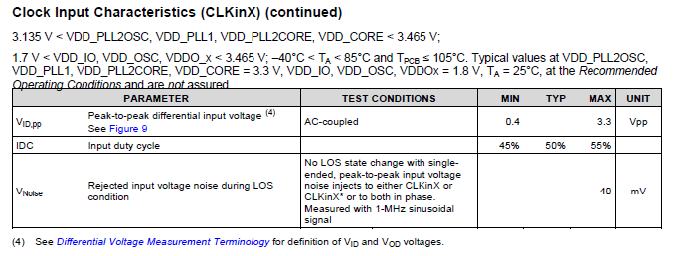

Here is stated that the VID must be at least 0.4V and what we see in the ZL40213 specification the output swing of the chip is between

0.25V and 0.4V (see below). This seems to be very critical (0.25V is out of spec…).

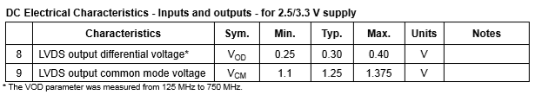

According to me the typical swing on LVDS signals is 350mV. We tried it on the LMK04616_EvalBoard and there we see when the CLKInx is too low the

first PLL (PLL1) won’t lock.

So how can we drive the LMK04616 with LVDS without becoming critical on the design?