Part Number: LMK05028
Development Board: LMK05028EVM
Issue Description: The LMK05028EVM features an on-board TCXO. By configuring the CH Mux on output port OUT0, the TCXO signal can be output. Under the same configuration file, when using the on-board TCXO, OUT0 outputs no signal; however, when an external input signal is connected via port J12, OUT0 outputs a signal.
Could you please help us verify whether this is due to an issue with our development board’s configuration or if the TCXO on this development board is not functioning properly?

Below is our configuration information:
TICS PRO Configuration:
Main: Start Page: Configure CH0's CH Mux to Ref Bypass.
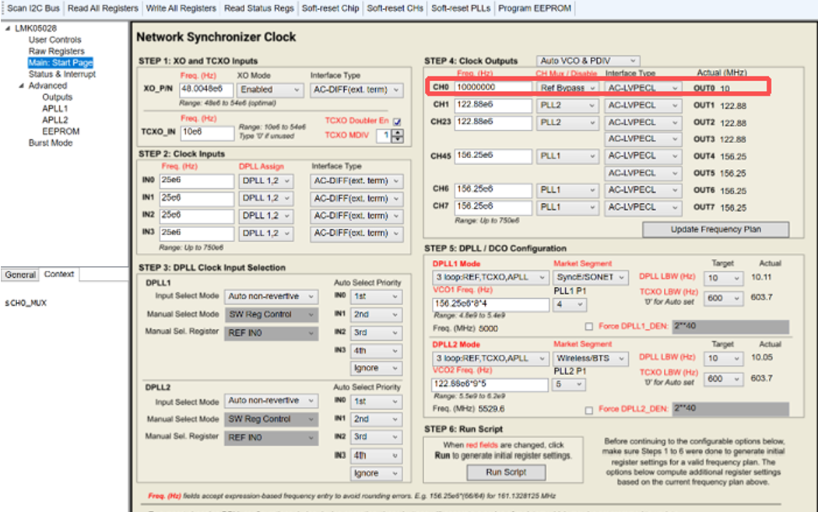
According to the LMK05028 register manual, configure R89 to 0x005900. This selects the TCXO as the Ref Bypass input source.

Board jumper settings:
JP4: Connect pins 1 – 2,power the on-board TCXO;
JP26: Disconnect,enable the on-board TCXO.
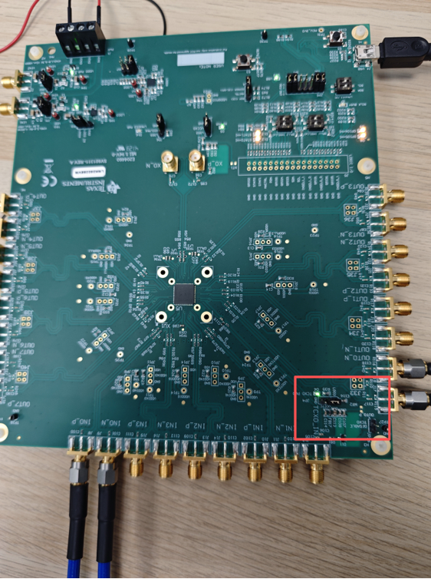
OUT0 Output Signal Waveform:
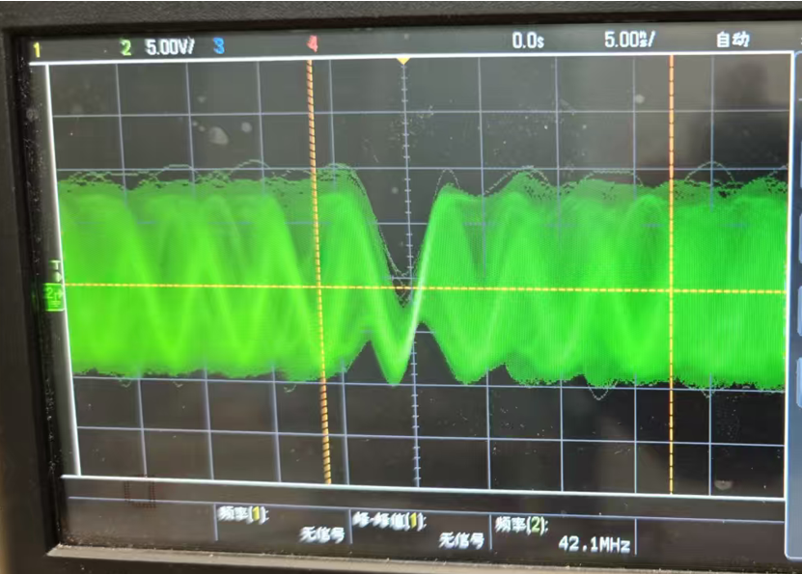

With the same configuration, connect an external 10 MHz sine wave signal to the J12 port.
Board jumper settings:
JP4: Connect pins 2 - 3, disable power the on-board TCXO;
JP26: Connect , disable the on-board TCXO.
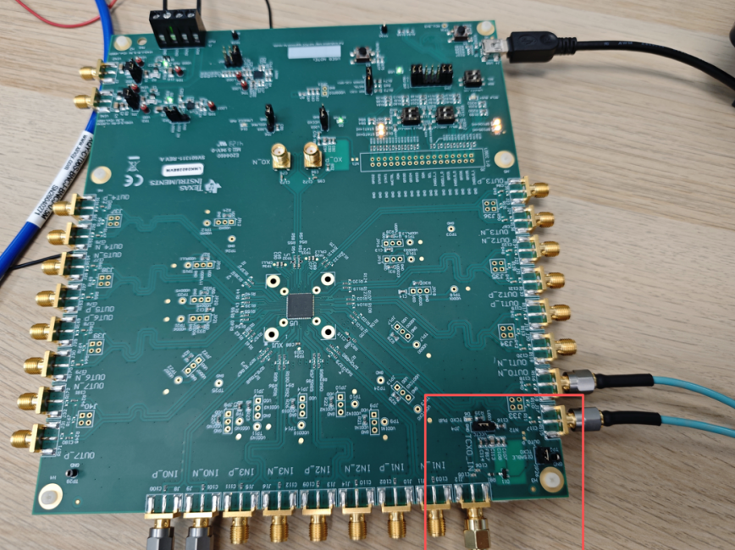
OUT0 Output Signal Waveform:
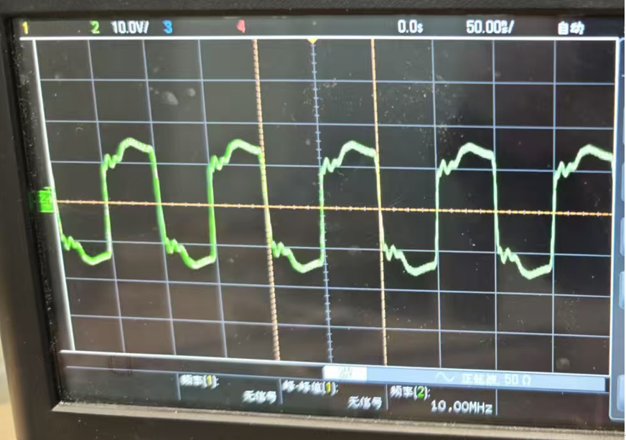

Attached is our configuration file and Register map txt file.
Since the system does not support uploading TCS files, I converted the TCS file to a TXT file and uploaded it.

