1) we are not getting correct output when external clock input was 100MHz.
We are giving 100MHz as Single ended input clock to CLKin1 and configuration as shown in figures.
Output ports of LMK04828EVM are DCLKout0, DCLKout2 and DCLKout10 should give 100MHz output when Clock divider was 1 but we are getting as 3.13MHz, If we changed clock divider value then we are getting correct frequency output based on clock divider value.
The output signals are not synchronizing there will 1500ps delay getting, after changing Analog Delay and Digital Delay then also signals are not changed and not synchronized.
You can see my output screenshot in below.
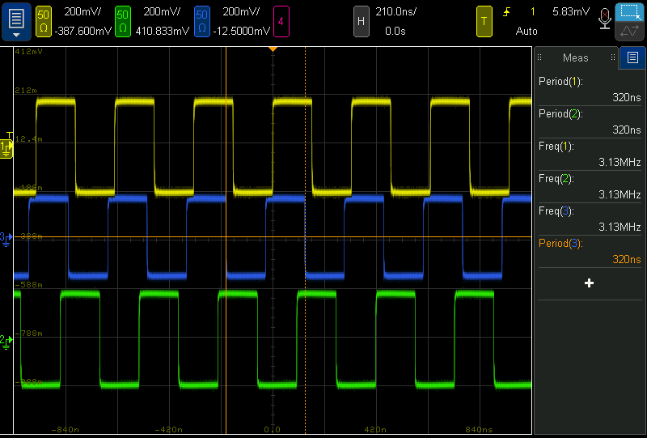
2) we are getting distorted output of LMK (DCLKout0, DCLKout2 and DCLKout10) and they are not synchronized.
We are giving 200MHz as Single handed input clock to CLKin1 and configuration as shown in figures.
In this case we are getting correct frequency output but that output was distorted and non-synchronized output.
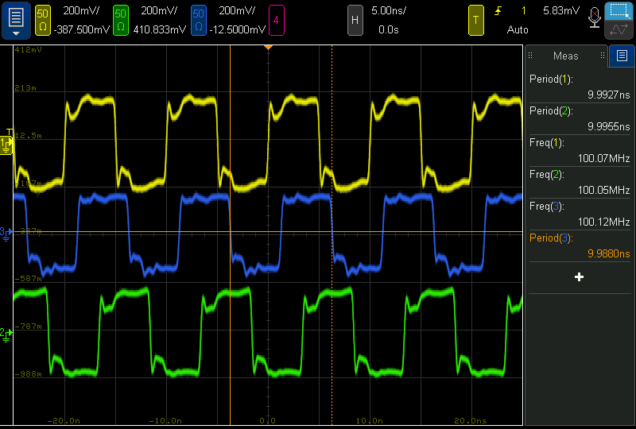
OUR REQUIREMENT: According to our requirement input is 100MHz and we need Synchronized 100MHz output in all(DCLKoutX) output ports, give me help for this.

