LMX2594
Output frequency: fast jump between 14G and 14.2G
The configuration of VCO is as follows: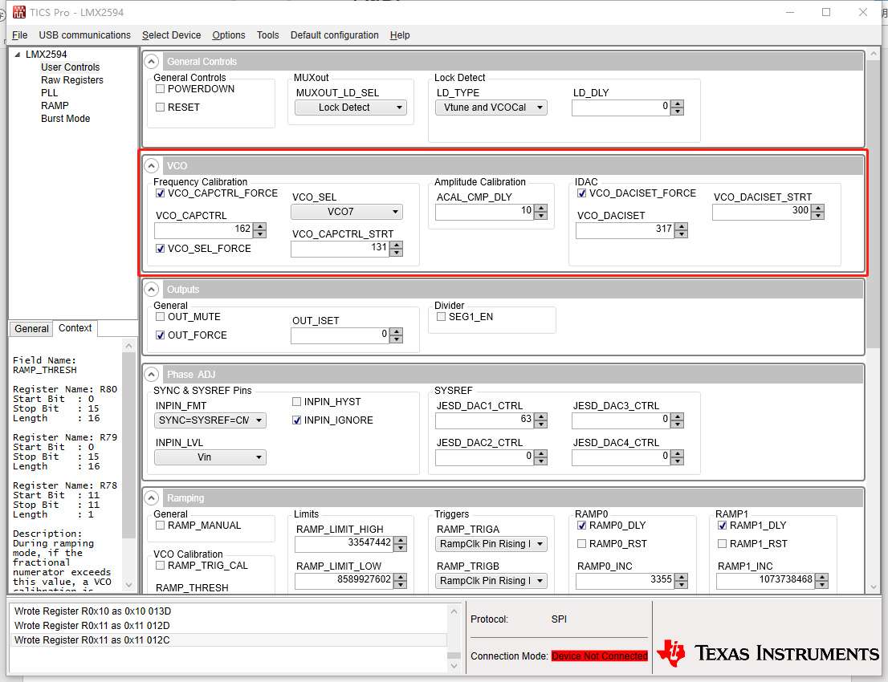
However, it is displayed on the signal source analyzer as: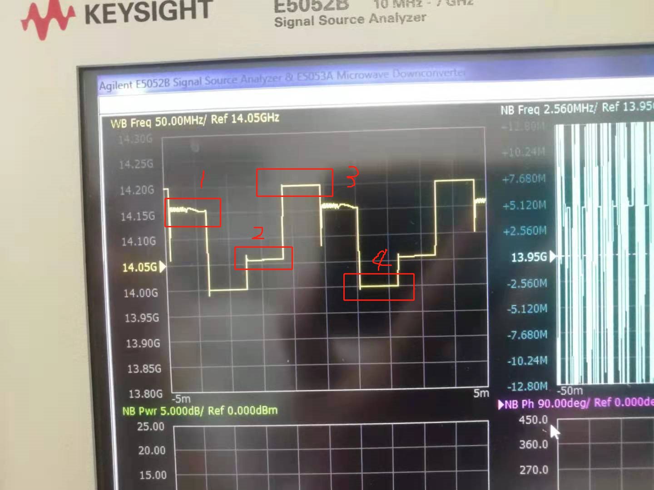
As shown in the figure: the frequency of 3 is 14.2G, and the frequency of 4 is 14G, but the frequency of 1 point and 2 points should not appear.
1 Is this output normal?
2 If not, what is the correct configuration order?
3 It is better to use TICS-Pro parameter configuration or program sample code.

Thanks.

