LMX2595 Chirp Mode Frequencies
6/27/18

I referred to your answer saying that Fpd should be changed to 100MHz, but the chirp could not be received in length of 125MHz, and also, the results were less good than running on Fpd of 200MHz.

At this point, a result of 95MHz was obtained for chirp length when Fpd is run at 200MHz.

What is the role of the “Threshold” field in the “VCO Calibration window” that belongs to the “TICS Pro” application?

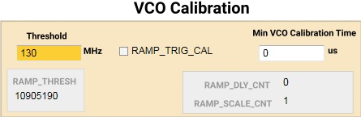

How to set the “chirp length time” through the “TICS Pro” application in manual mode ?

