From LMK03318 datasheet, page 13:

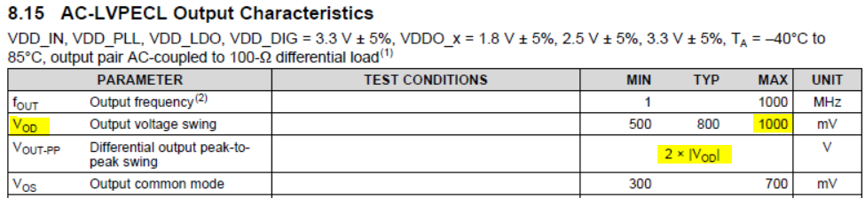

From TMS320C6678 datasheet, page 116, Absolute Maximum Ratings:

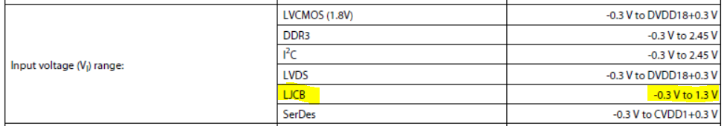

From Clocking Design Guide for Keystone Devices SPRABI4, page 48 500mV p-p:

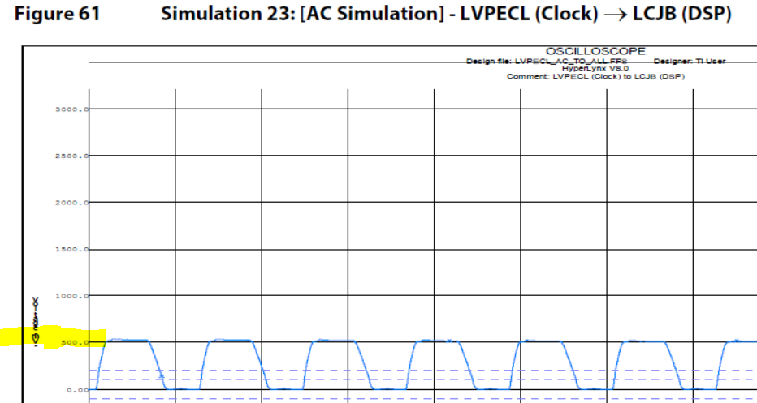

The Hardware Design Guide SPRABI2D did not appear to offer guidance on the exact voltage levels.

The Application Report on AC-Coupling Between LVPECL… and CML SCAA059C on the bottom of page 4, top of page 5:

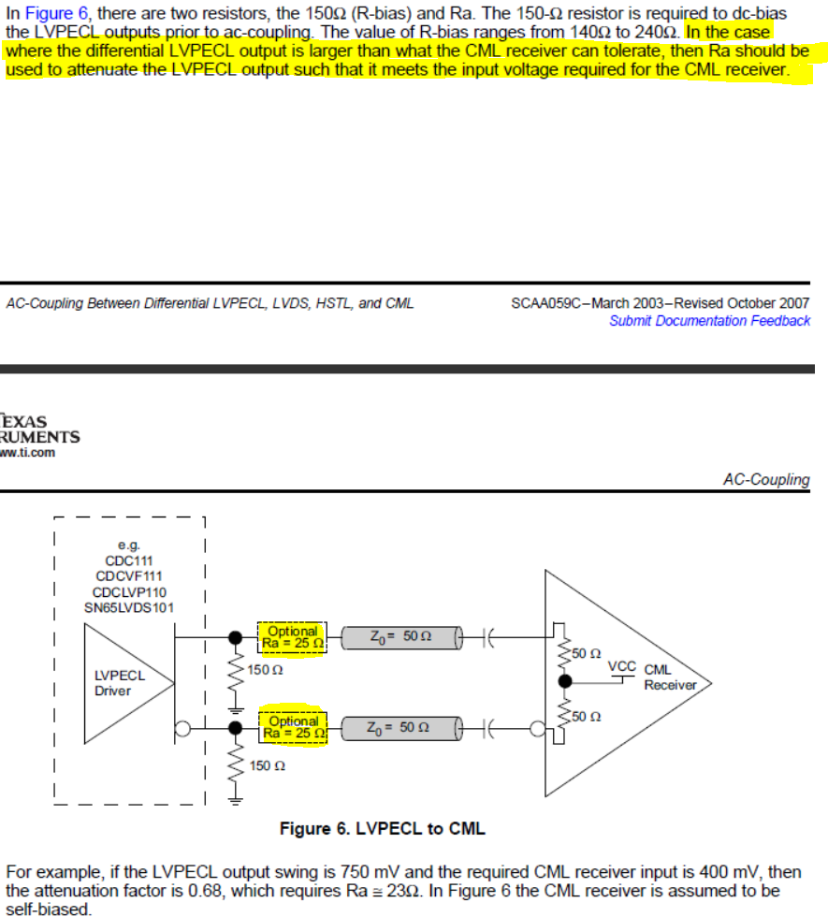

- An Ra of 50Ω would cut the voltage in half from the LMK03318 output to the TMS320C6678 input.
- Is this the best value to use for Ra?

