Hello,

Here are few questions regarding LMK04821.

1. Following WEBENCH designer results, sometimes I need external VCXO and sometimes no (see below picture). Why?

According the device functional modes that mention in datasheet, we always need external VCXO or Tunable Crystal.

Can you explain when I need to add external VCXO? (if I don’t need the VCXO , can I connected directly the CPout1 to Loop filter circuit and then to OSCin?)

[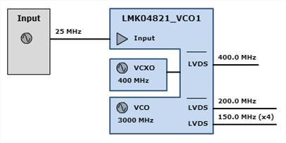](https://e2e.ti.com/cfs-file/__key/communityserver-components-multipleuploadfilemanager/d6f5c717_2D00_08d0_2D00_42da_2D00_95e8_2D00_51d9e9ef935e-268569-complete/Q1_5F00_1.jpg)  [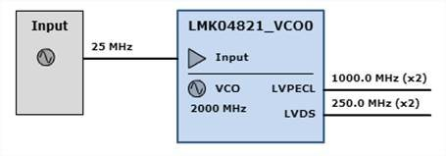](https://e2e.ti.com/cfs-file/__key/communityserver-components-multipleuploadfilemanager/d6f5c717_2D00_08d0_2D00_42da_2D00_95e8_2D00_51d9e9ef935e-268569-complete/Q1_5F00_2.jpg)  [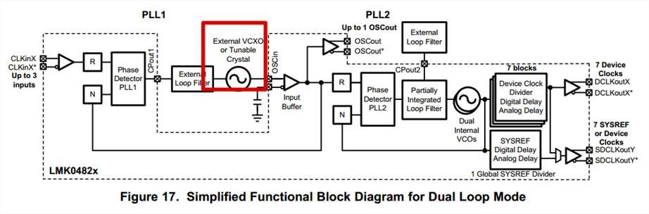](https://e2e.ti.com/cfs-file/__key/communityserver-components-multipleuploadfilemanager/d6f5c717_2D00_08d0_2D00_42da_2D00_95e8_2D00_51d9e9ef935e-268569-complete/Q1_5F00_3.jpg)

2. What is this circuit mean? Is that required for each design?

[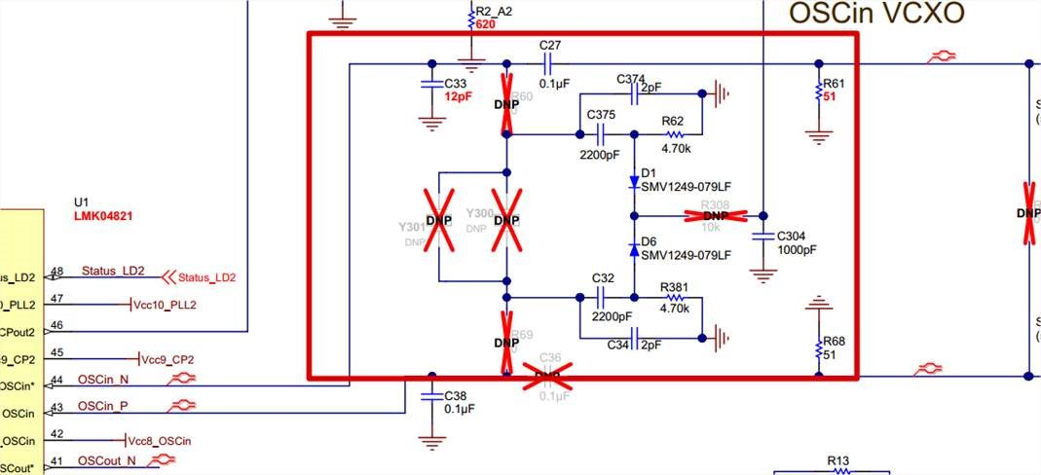](https://e2e.ti.com/cfs-file/__key/communityserver-components-multipleuploadfilemanager/d6f5c717_2D00_08d0_2D00_42da_2D00_95e8_2D00_51d9e9ef935e-268569-complete/Q2_5F00_1.jpg)

   3. According to datasheet, I need to connect the OSCINN to GND via capacitor. In the EVM pin OSCIN connected to GND via capacitor instead of OSCINN. Please advise.

[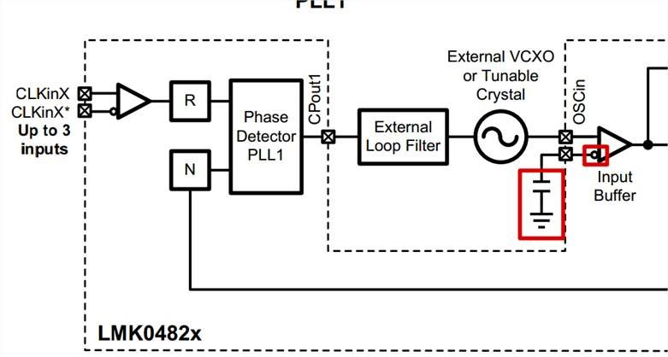](https://e2e.ti.com/cfs-file/__key/communityserver-components-multipleuploadfilemanager/d6f5c717_2D00_08d0_2D00_42da_2D00_95e8_2D00_51d9e9ef935e-268569-complete/Q3_5F00_1.jpg)

[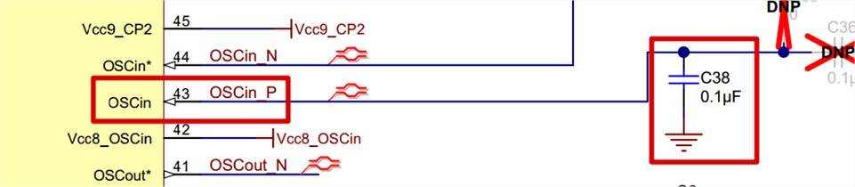](https://e2e.ti.com/cfs-file/__key/communityserver-components-multipleuploadfilemanager/d6f5c717_2D00_08d0_2D00_42da_2D00_95e8_2D00_51d9e9ef935e-268569-complete/Q3_5F00_2.jpg)

    4. On LOOPFILTER1 - The WEBENCH calculated that VCO frequency is 100MHz. Is the external VCO that I need to add to my design? If yes, do you have an application note how to select the right VCO/VCXO?

[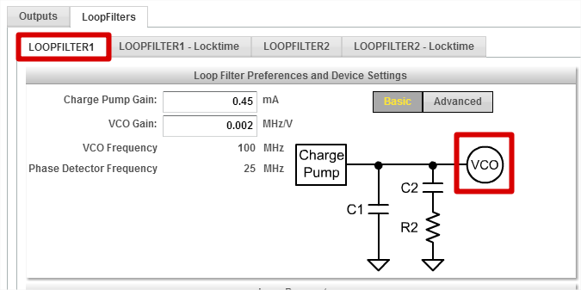](https://e2e.ti.com/cfs-file/__key/communityserver-components-multipleuploadfilemanager/d6f5c717_2D00_08d0_2D00_42da_2D00_95e8_2D00_51d9e9ef935e-268569-complete/Q4_5F00_1.png)

 5. On LOOPFILTER2 - The WEBENCH calculated that VCO frequency is 3000MHz. This is an internal VCO. I need to add only the EXT Loopfilter component, Right?

[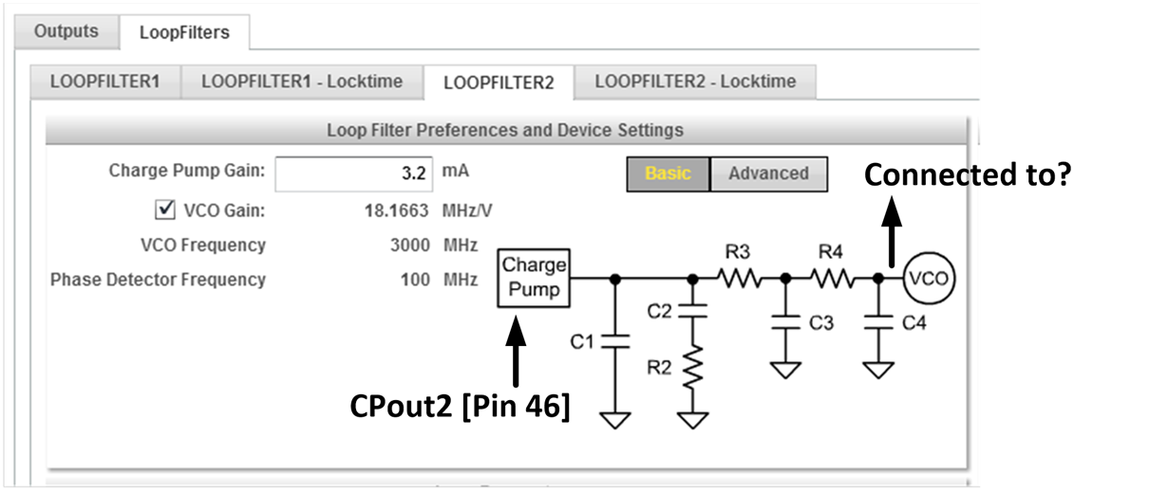](https://e2e.ti.com/cfs-file/__key/communityserver-components-multipleuploadfilemanager/d6f5c717_2D00_08d0_2D00_42da_2D00_95e8_2D00_51d9e9ef935e-268569-complete/Q5_5F00_1.png)

 6. What is CLK input requirements? PPM?

7. What is the requirement for RESET pin? Is there a minimum reset pulse? Is Pull down resistor required? Can I make reset to LMK04821 by SW (via SPI interface)?

1. Regarding the SYNC pin, what is the requirement if SYNC is required or not? (our design include two LMK04821, In one of them the SYNC is required and the second not)
2. How can I change the output standard in Clock Design Tool?

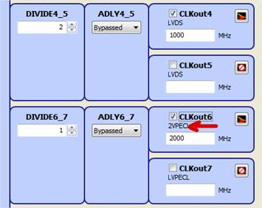

Thanks,