Texas Instruments
EVM Test Procedure

CDCI6214EVM Test Procedure

Rev. A
Date 10/16/2017

GENERAL

  - PURPOSE

    - To provide detailed instructions for testing EVM Modules

  - SCOPE

    - Covers complete instructions for testing SV601290A-001 (CDCI6214EVM)

  - REFERENCE DOCUMENTATION

    - Schematic
    - PCB assembly drawing
    - Users Guide

  - DEFINITIONS

    - UUT is reference to Unit under Test
    - EVM is reference to Evaluation Module assembly, in this case the UUT
    - DUT is reference for the Device Under Test which is the TI unit U1 on the EVM

- SAFETY

  - Safety Glasses are to be worn.

  - This test must be performed by qualified personnel trained in electronics theory and understand the risks and hazards of the assembly to be tested.

  - ESD precautions must be followed while handling electronic assemblies while performing this test.

  - Precautions should be observed to avoid touching areas of the assembly that may get hot or present a shock hazard during testing.

- QUALITY

  - Test data or reports shall be made available upon request by Texas Instruments.

- APPAREL

  - Electrostatic smock
  - Electrostatic Gloves or finger cots
  - Safety Glasses
  - Ground ESD wrist strap
- EQUIPMENT

  - Hardware

Item | Equipment | Requirement | Purpose
1 | USB Cable | USB A Male to Micro B Male | data connection to computer and power supply; e.g. 3025013-06
2 | SMA Cables | 1 pc of 50Ω cable | connect to UUT output to scope
3 | Frequency counter | Capable of measuring up to 200MHz (Agilent HP 53131A or equivalent) | measure UUT output frequency  (must have 50Ω DC connected input)
4 | Windows PC | Win Vista or newer | to install GUI and driver and verify USB connectivity

  - Software

Item | Software | Requirement | Purpose
1 | TICS Pro | ≥1.6.4.x | modular GUI to program the part

- EQUIPMENT SETUP

  - Connection Diagram

  - Initial Jumper Configuration (outlined in red below)
UUT at the beginning of the test procedure:
- Set J16 to 2-3
- Set J31, J32 to 2-3
- Set J23, J29, J30
- Set J24, J25, J26, J27 to 1-2
- Set all switches in S2 to off (side of Pin 1)
- Set S2 3-6 to on (opposite side of Pin 1, connected to R66)

- PROCEDURE

  - Visual Inspection, Assembly SV601290A-001

    - Verify that all jumpers and switches are set according to the Initial Jumper Configuration (section 6.3, above).

  - Computer Software Install Procedure

One time per computer and user. Omit 7.2. when software is already installed.

    - TICS Pro
- Go to http://www.ti.com/tool/ticspro-sw and download TICS Pro
- the zip file snac072%CHAR%.zip contains an installer. %CHAR% will be a character from the alphabet.
- unzip the installer and follow the instructions to install the software.
- a re-boot of the PC may be required
  - Firmware Install/USB Connectivity Test

    - Remove jumper J23 (to be re-placed after testing)
    - Connect EVM to computer using the USB cable.
    - PC: Launch TICS Pro application from the desktop or start menu.
    - If a prompt to update firmware appears, click ‘OK’ to continue to auto-update firmware.

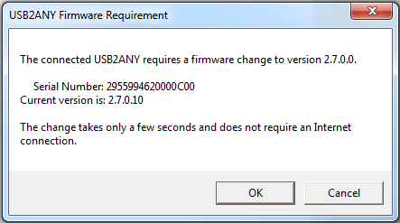
    - Click “Update Firmware”
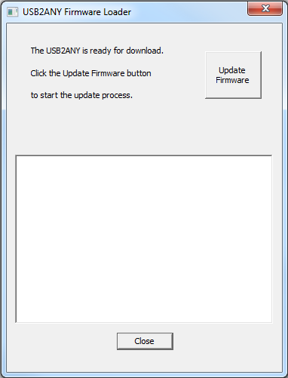
    - If firmware update is completed successfully, click “Close”. If the firmware is not successful or aborted, then re-try by unplugging the USB cable and repeat from step 7.3.
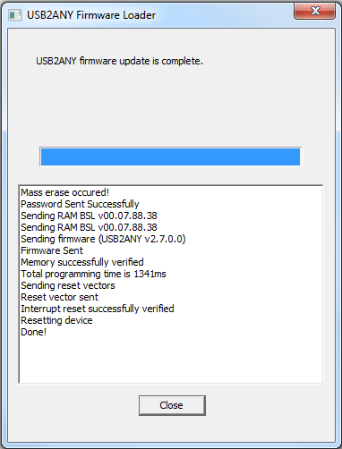
    - EVM: disconnect.
    - Set J23 and reconnect USB cable to USB header J15.
    - PC: Launch TICS Pro application from desktop or start menu. Check application window name- if it is not ‘TICS Pro – CDCI6214’, click ‘Select Device’ > ‘Clock Generator/Jitter Cleaner (Single Loop)’ > ‘CDCI6214’.
    - Click ‘Block Diagram’ tab under CDCI6214 (top left of window).
      - Ensure that Connection Mode is ‘USB2ANY’ (bottom center of window).
      - Ensure that DUT Power button reads ‘PWR off’, else click it to set it to ‘PWR off’
      - Ensure that RESETN/SYNC button reads ‘High’, else click it to set it to ‘High’
      - Ensure that EEPROMSEL reads ‘On’ ‘High’. If it reads HiZ, click it to set it to ‘On’. If it reads ‘Low’, click it to set it to ‘High’.
      - Ensure that REFSEL reads ‘On’ ‘Low’. If it reads HiZ, click it to set it to ‘On’. If it reads ‘High’, click it to set it to ‘Low’.

      - Click DUT Power to set it to ‘PWR on’. Verify that the status box in the lower left of the window reads ‘Device found at 0x76. Address will be updated.’ If this step fails, repeat 7.3.

  - Device Test
    - Connect SMA cable to connector Y1P of the EVM and to CH1 of the frequency counter. Set frequency counter input to “DC” and “50 Ohm” input. Verify frequency is 100MHz.
    - Remove SMA cable from connector Y1P. Connect SMA cable to connector Y1N of the EVM. Verify frequency is 100MHz.
    - Disconnect SMA and USB cables from EVM.
    - Done with testing UUT. Repeat procedure until all UUTs have been tested.
      - If any step in the procedure fails, rerun the test from beginning.

  - Final Steps

- Mark the two labels on the EVM like the following:

- MATERIAL DISPOSITION & TRANSFER

  - CONFORMING MATERIAL

On the ESD bag, in text clearly visible and readable to the naked eye, add
For evaluation only; not FCC approved for resale.
This can be included on the label below or added as a separate label.

Units that have passed this test procedure shall be packaged into anti-static ESD approved bags, labeled per table below and shipped per the P.O.

Label 1  Assembly Number + Dash Number  (if Applicable) | Label 2  IC Number
SV601290A-001 | CDCI6214EVM

  - NON-CONFORMING MATERIAL

If yield loss is 2% or less, scrap non-conforming units and adjust P.O. to reflect total amount shipped. If yield loss approaches, or exceeds 5%, contact EVM coordinator for assistance.

Change History:
Date | Changes | Reason | By
4/9/2015 | Original
5/8/2017 | start cdce6214evm from template |  | Kammermayer, Patrick
5/10/2017 | 1st version for quote |  | Kammermayer, Patrick
5/15/2017 | initial version for 1st build |  | Kammermayer, Patrick
6/15/2017 | variant number and vcc voltages | APL updates for CDCE6214i | Kammermayer, Patrick
6/22/2017 | descriptions of steps and software | APL updates for CDCE6214i | Kammermayer, Patrick
6/28/2017 | CDCE2614I became CDCI6214  (screenshots still show old name) | renamed to align with orderable part number | Kammermayer, Patrick
9/22/2017 | Steps simplified | Edited for RTM | Li, Tim Chao
9/23/2017 | Revised | 5.1 added 50 Ohm requirement (freq counter) | Kammermayer, Patrick
9/23/2017 | Revised | 6.2 J31,J32 now 2-3 default | Kammermayer, Patrick
9/23/2017 | Revised | S2 3-6 set to on | Kammermayer, Patrick
9/23/2017 | Revised | 7.1 assembly nr | Kammermayer, Patrick
9/23/2017 | Revised | 7.3.1 J16->J23 | Kammermayer, Patrick
9/23/2017 | Revised | 7.3.7 J1->J15 | Kammermayer, Patrick
9/23/2017 | Revised | Split 7.37 into 7.37 + 7.38, added “Set J23” | Kammermayer, Patrick
9/23/2017 | Revised | 7.3.10 added REFSEL step; 0x74->-x76 | Kammermayer, Patrick
9/23/2017 | Revised | 7.4.1 frequency counter must be DC coupled with 50 Ohm input. | Kammermayer, Patrick
9/23/2017 | Revised | 7.4.3 removed j16 action | Kammermayer, Patrick
10/16/2017 | Board Illustrations updated | shunts J24..27 shown in wrong location in images | Kammermayer, Patrick
10/16/2017 | Board Illustrations updated | silkscreen color and highlights corrected | Kammermayer, Patrick

