FT232H EEPROM programming sequence:
- Scan
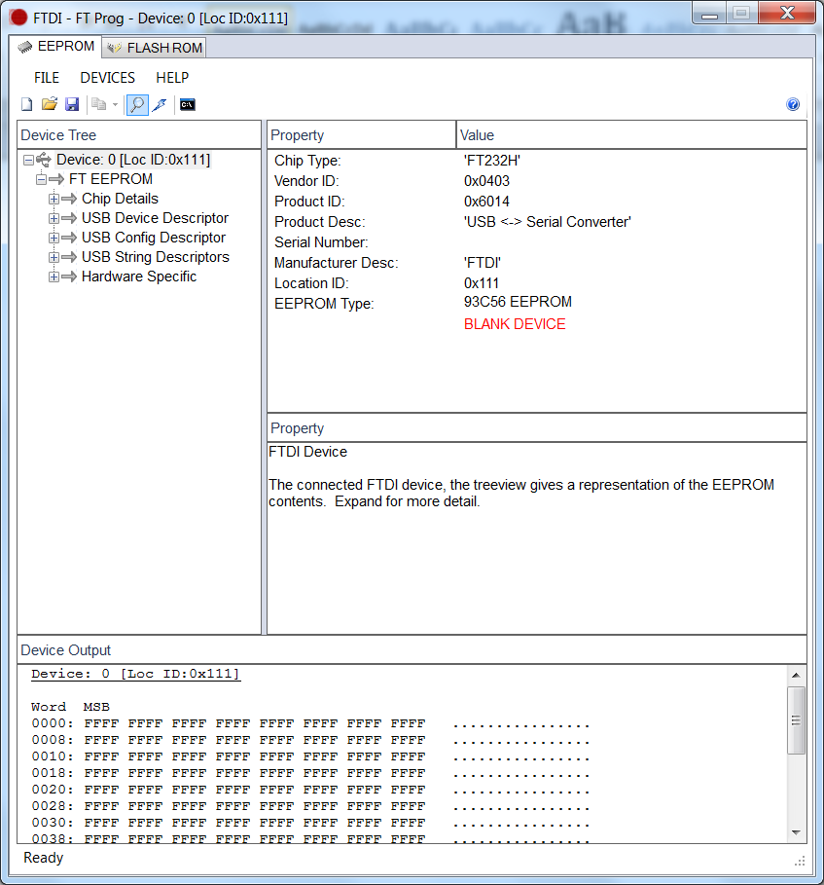

- Write the product description “TIDA1021_28”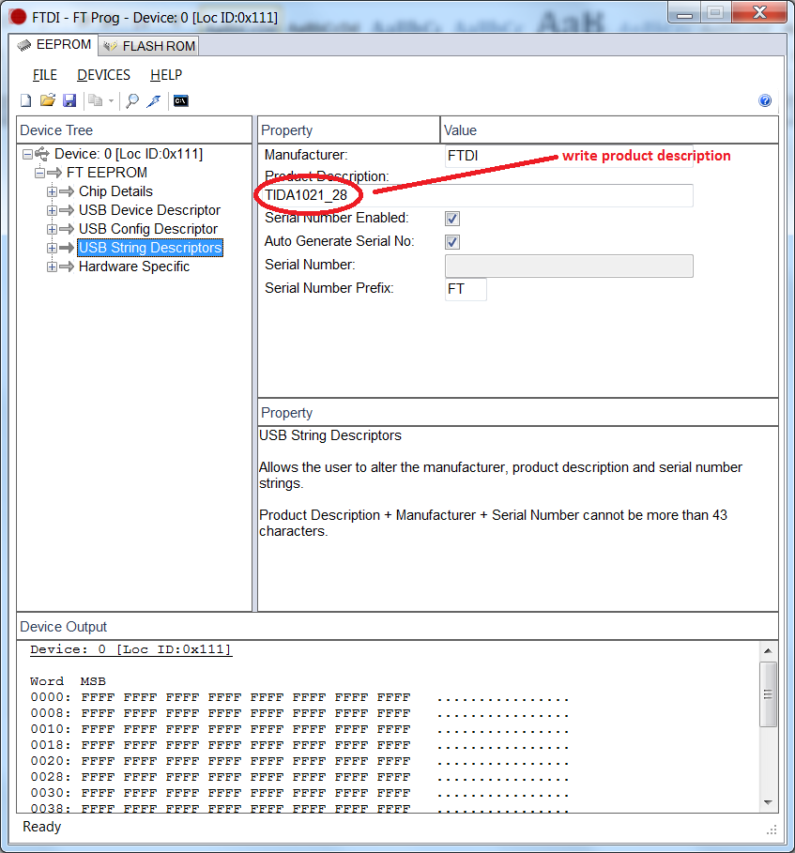
- Program
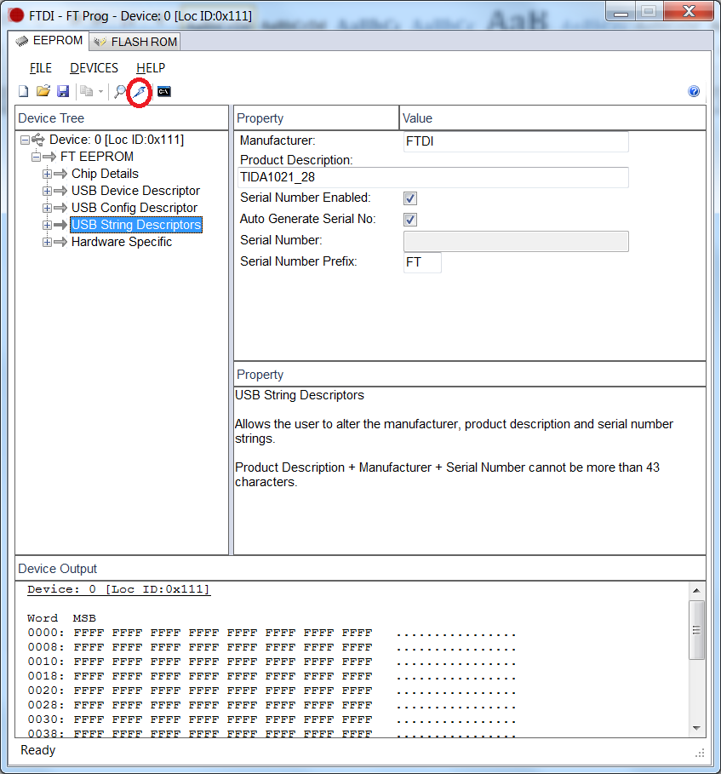
- Again scan and will get the written product description
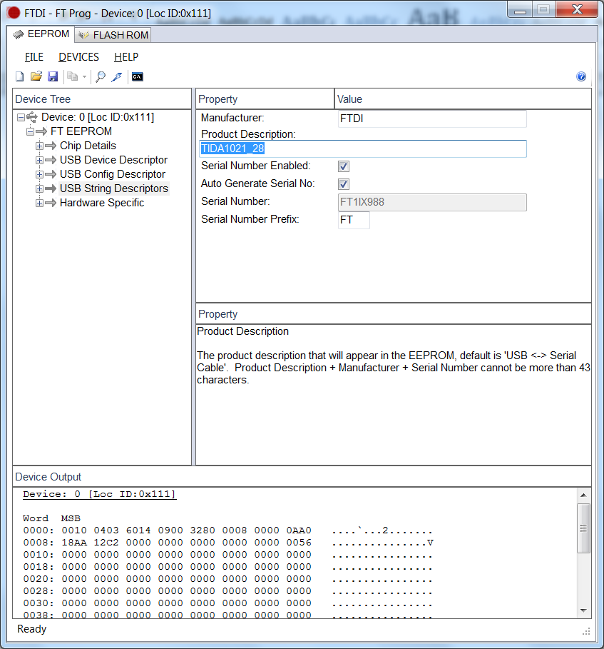
- Now Open the HSDC TID GUI, which will identify the board and connect to the GUI.

