TPS3899 tD reset time delay confirm.

1. The picture below is taken from page 8 of the [TPS3899 datasheet (Rev. C)](https://www.ti.com/lit/gpn/tps3899)

一張含有 文字, 螢幕擷取畫面, 數字, 字型 的圖片

AI 產生的內容可能不正確。

1. The picture below is taken from page 2 of the [TPS3899 Application note](https://www.ti.com/lit/pdf/slvaey7).

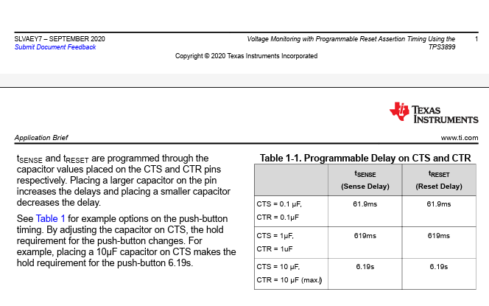

1. The picture below is taken from page 10 of the [TPS3899EVM Voltage Supervisor User's Guide](https://www.ti.com/lit/pdf/SLVUBZ3)

