* Here is the Header which you told to me

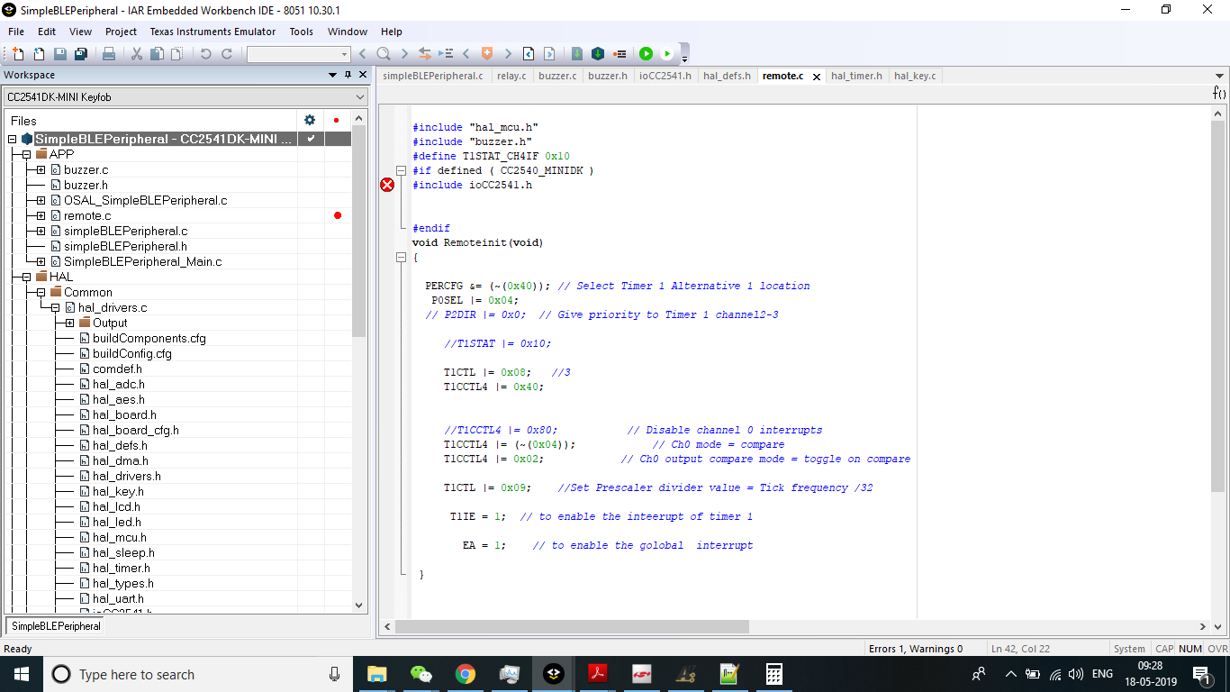

* Here is the screen shot for the ERROR which is displayed on the screen.

