1、Same firmware, different hardware test:
I got the customer's actual vehicle boards. I fully erased the chip, flashed the same firmware to my debug board (same as the customer's board, maybe different batch) and the TI development board. My board does not lose pairing after connection, no problems at all. The customer's board loses pairing after disconnecting and reconnecting, requiring re-pairing.

2、Verify official demo:
I downloaded the official demo to the customer's board. After connecting and pairing, then disconnecting, then connecting again, there were no problems at all.

3、Compare project configurations:
I compared my project with the demo project and found that the parameters in syscfg are different.
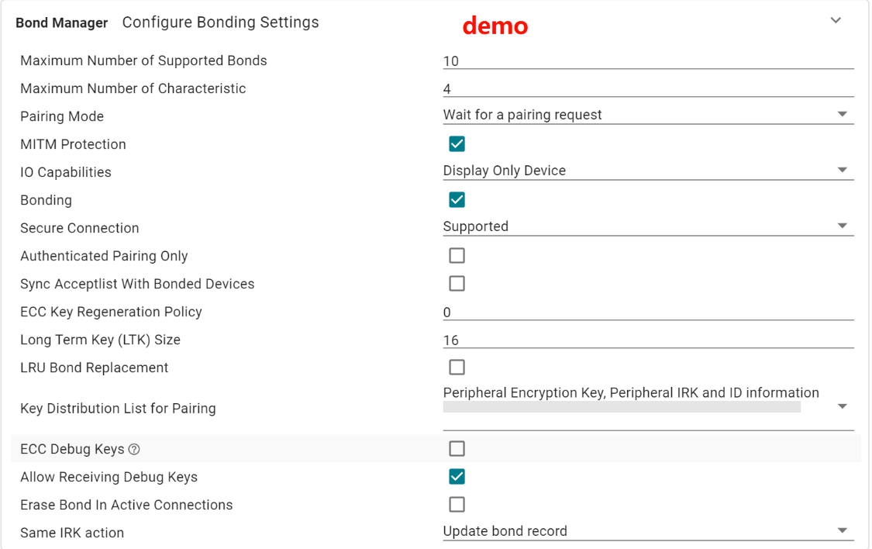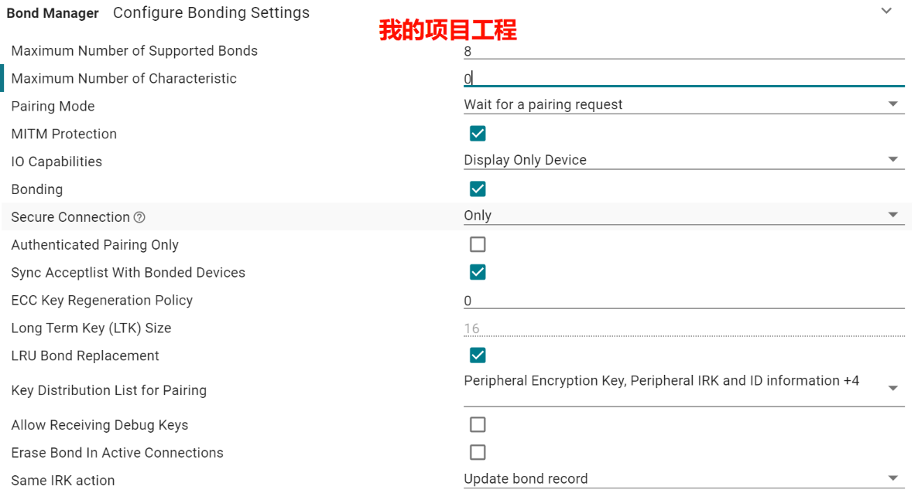

4、Modified my project configuration for testing:
Modified my project configuration for testing:
I found that when I changed the "Maximum Number of Characteristic" value to 4 (non-zero), the customer's board returned to normal. I thought the issue was resolved, but I discovered that after changing the "Maximum Number of Characteristic" value to 4, after connecting and pairing, the next connection will first send a notify, then enter the connection callback, and then send notify again.
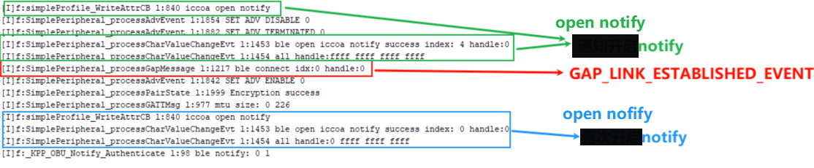
The GAP_LINK_ESTABLISHED_EVENT event calls SimplePeripheral_addConn. If notify is enabled before the GAP_LINK_ESTABLISHED_EVENT event, the index obtained through SimplePeripheral_getConnIndex is invalid.I would like to ask how to remove the notify before the GAP_LINK_ESTABLISHED_EVENT here?

The problem we are worried about: We have encountered a situation in a previous project where some mobile phones consider notify successful when it is enabled for the first time and will not enable notify for the second time. This results in the inability to receive notify after the physical connection GAP_LINK_ESTABLISHED_EVENT, and the process cannot proceed. I would like to ask how to remove the notify before the GAP_LINK_ESTABLISHED_EVENT here?

Even if I delete the pairing of my phone and then connect it with the same phone without pairing, it will still start notify first and then call back to notify the connection .

question：
（1）Can the cause of the pairing loss problem be analyzed based on my discovery?
（2）If I modify the parameters here in syscfg Bond Manager, will it affect the data structure of nv? Will it have an impact on the existing devices in the ota market?

