Hi Rachel,
Please review our project configuration as listed below and try to help us on how to resolve the peer device address.

Initial Setup
--------------------------------------------------------------------------------
- Our project uses Central + Broadcaster configuration.
- As a Central, the part is setup to scan for each 1.5 sec and try to connect to a device which we are interested in.
- As a Broadcaster, the part is setup to broadcast ibeacon for every 100 milli seconds.

Test Steps to reproduce the issue
- Start the device.
- Connect with a Phone which is advertising a UUID known to device.
- Initiate Pairing Process
- Disconnect the device after pairing is successful (once after receiving GAP_BOND_SAVED).
- Try to reconnect the Phone .
Problem Description
- When a device is connected and bonding process is started, we don’t see the device being added to the HCI_LE_AddDeviceToResolvingListCmd by GapBondMgr. Below is the screen shot we took while debugging.

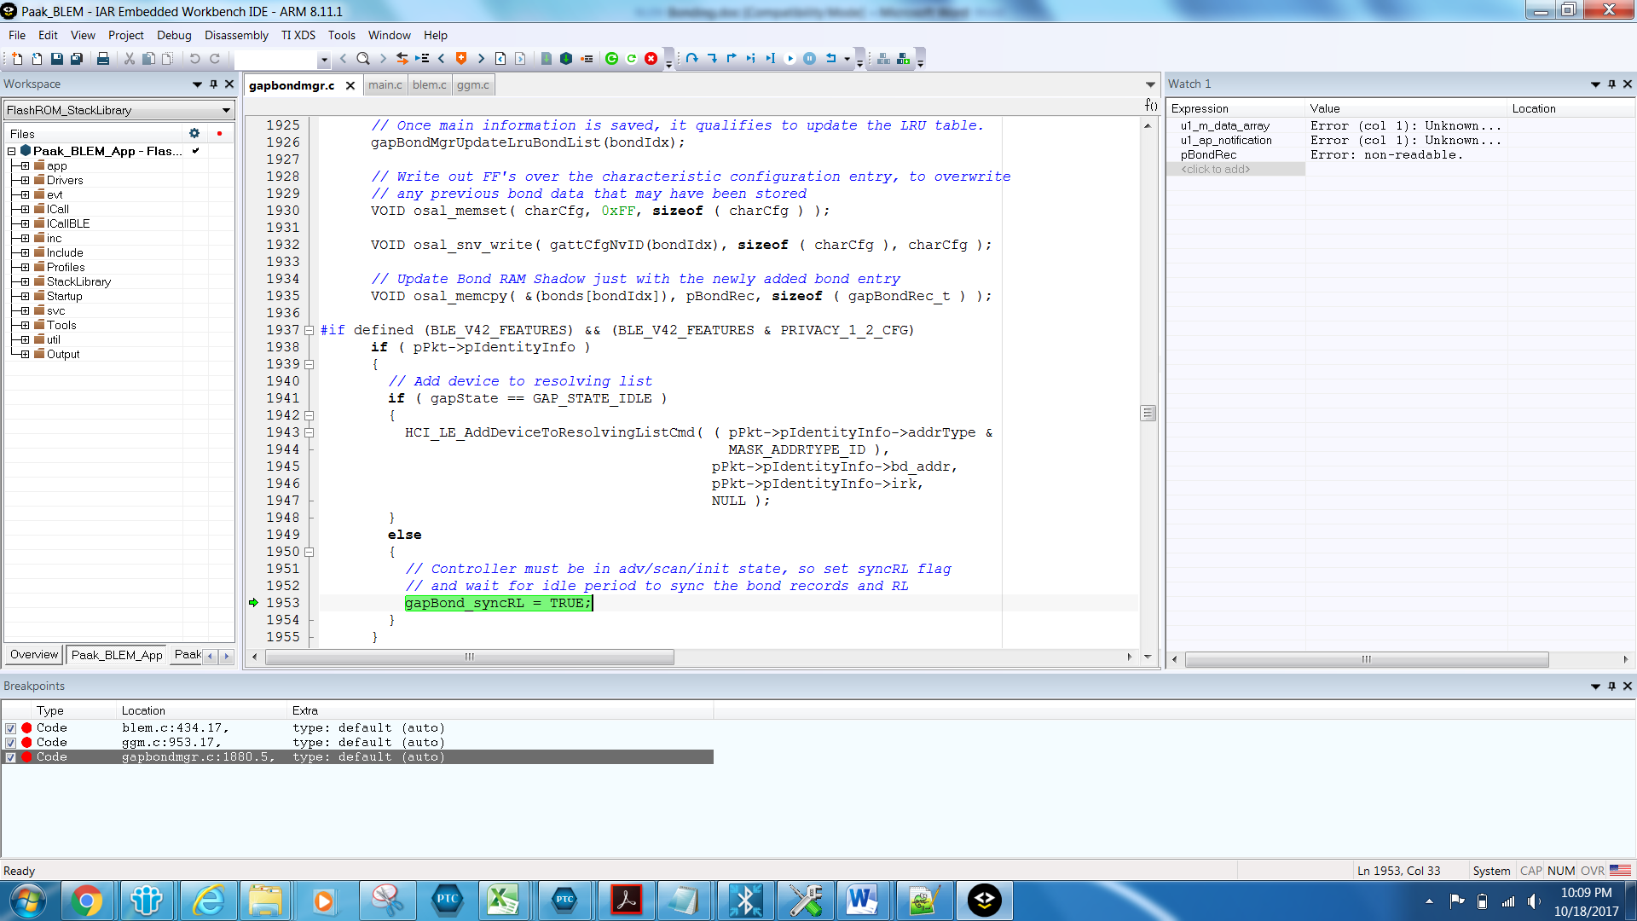

- When we checked the value of gapstate in gapBondMgrAddBond function, the value shows 0x04000001. We are assuming the state means device is advertising.
- In the above scenario, when the controller will store device’s IRK values? Looks like, controller never stores IRK as gapstate is not Idle.

