1. **If the default uuid is changed, the issue of blocking after disconnecting the Bluetooth connection will occur**

Use custom UUID;

#define TI_BASE_UUID_128( uuid ) 0xfb, 0x34, 0x9b, 0x5f, 0x80, 0x00, 0x00, 0x80, \

0x00, 0x10, 0x00, 0x00, LO_UINT16( uuid ), HI_UINT16( uuid ), 0x00, 0x00

Normally connected to Bluetooth, can also be used normally.However, after the Bluetooth is disconnected, the CC2340-R5 will have problems as shown in the following figure:

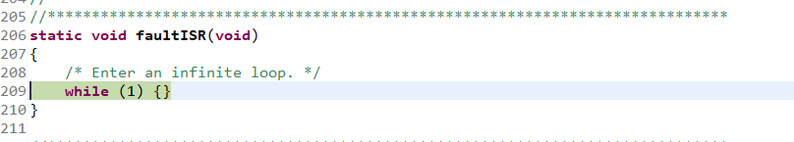

Error Entering faultISR

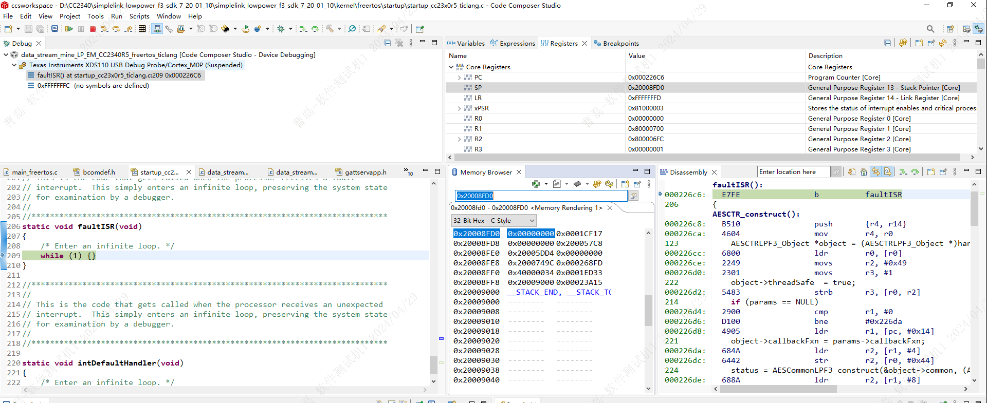

1. **The customer's own board burns the project in the SDK, can not search for Bluetooth, EVM board can burn**

