CC2640R2F chip to do MCU lock motherboard after the electrostatic test

Actual test results:

The pressure gauge is set to 5.2kv (electrostatic contact is required to reach 8KV, air discharge is required to reach 15KV). In the process of contacting the lock body shell with the high-pressure gun, the lock motherboard will be restarted.The phenomenon is that every time the high pressure gun contact lock shell or temporary other metal generated static, the lock motherboard will restart.

I hope you can help solve the problem of weak anti-high voltage and anti-static ability. What improvements should we make in hardware or software?Thank you very much!

Waveforms in the high voltage test process of oscilloscope test:

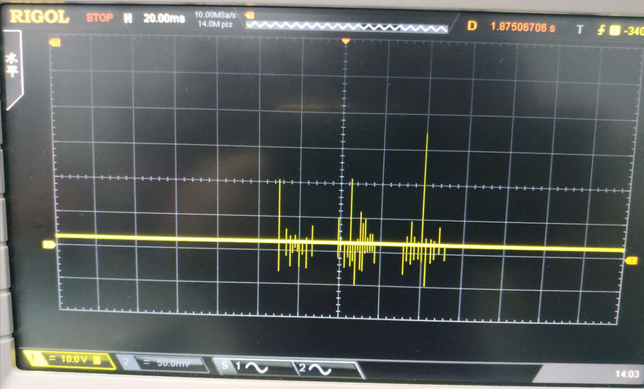

Figure 1: MCU chip RESET pin waveform of the lock motherboard

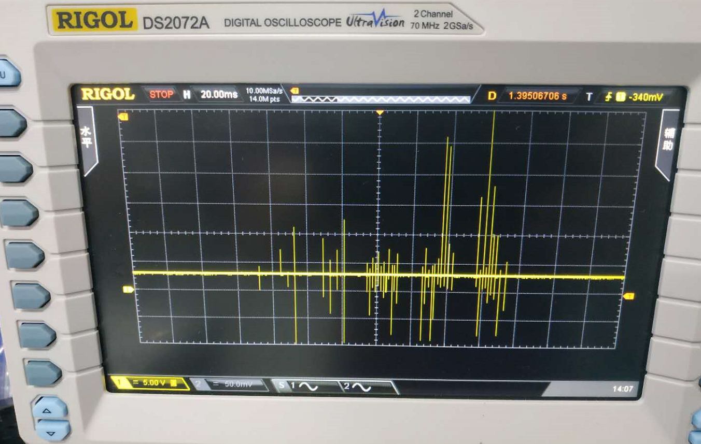

Figure 2: MCU power supply (3.3v) waveform of the lock motherboard

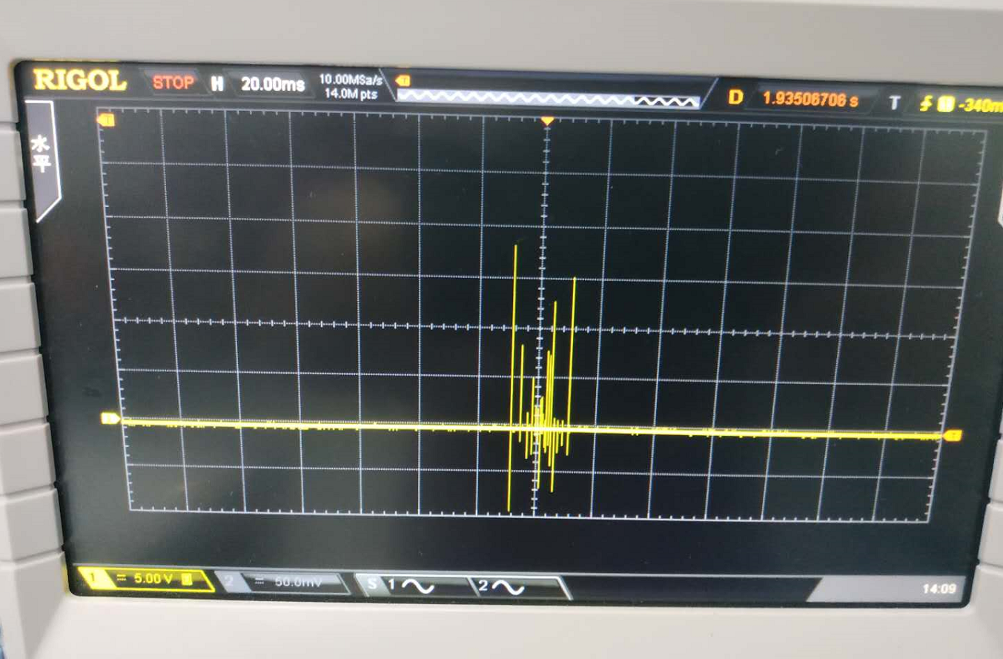

Figure 3: lock the main board of the ground waveform

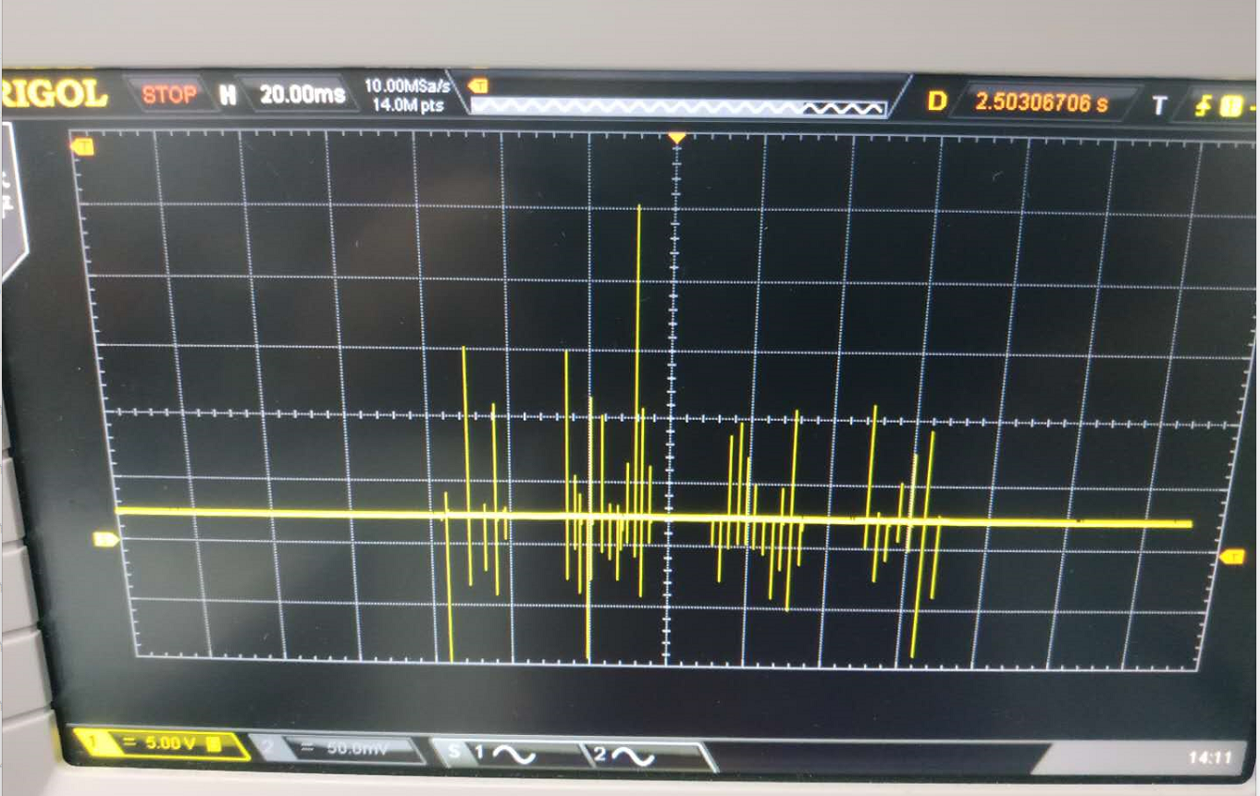

Figure 4: lock motherboard IO input of a pin waveform

Schematic 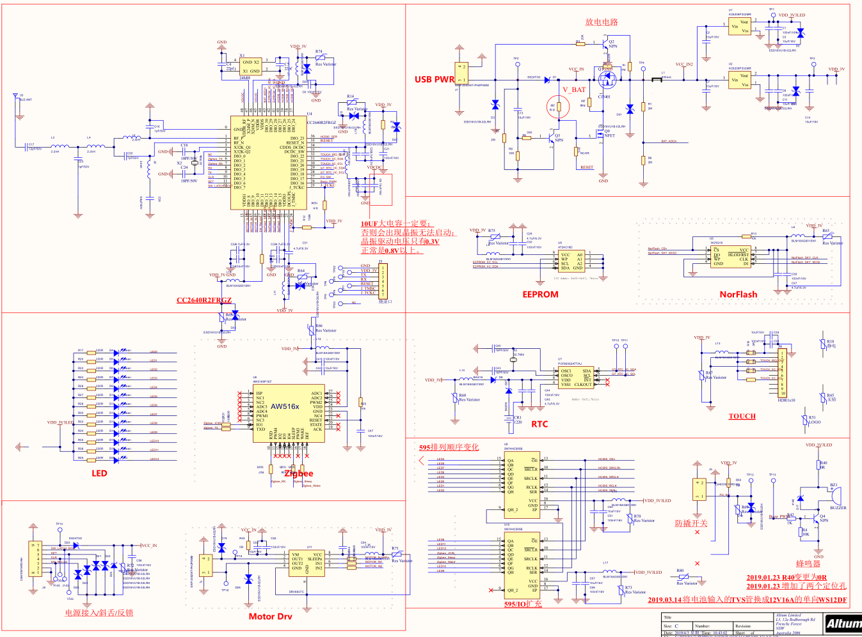

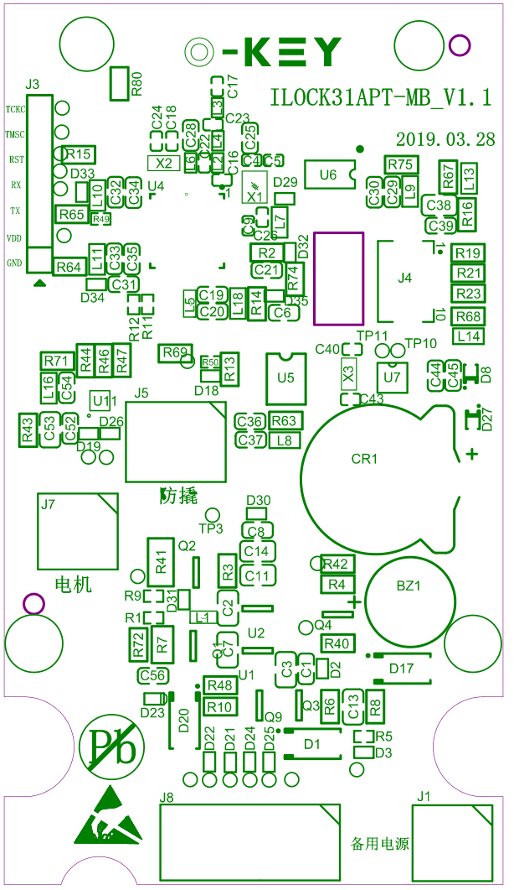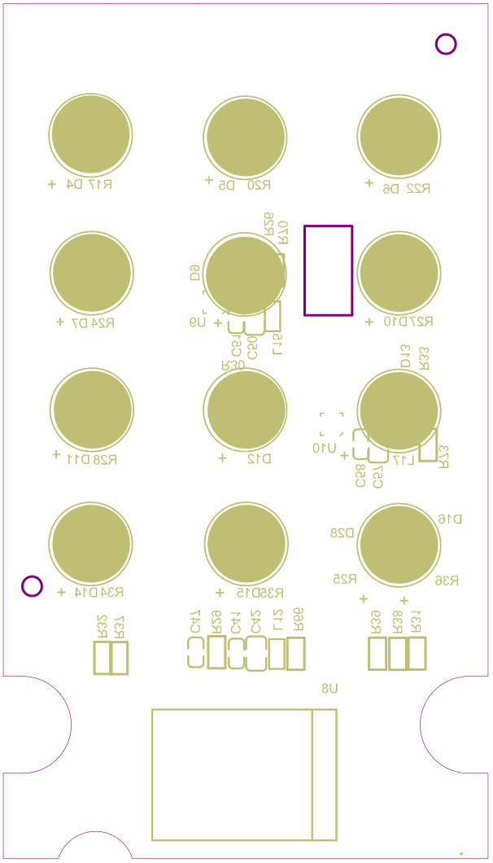

Lock motherboard 3D drawing: