AUX_DDI0_OSC.STAT0 = 0 (SCLK_HF_SRC) but expected a 1 for the CC2652RB
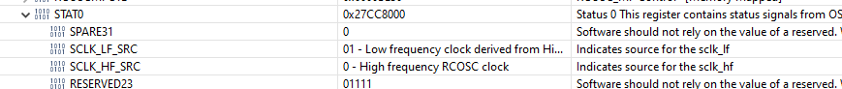

Why is HPOSC_COMP_P3 .HPOSC_COMP_P3 =0x11111111? Is it trimmed?
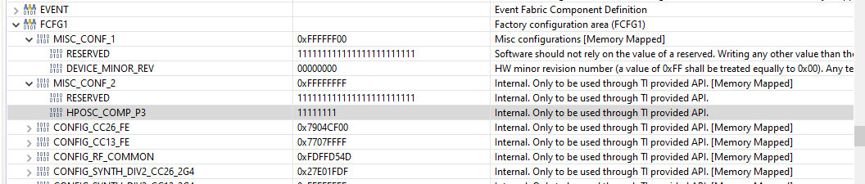

Why are HPOSC_MEAS_n registers are not shown in CCS register view: 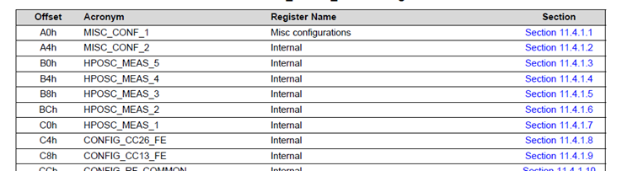

The OSC_CONF.HPOSC_OPTION = 0 but 1 is expected.
