In Healthy condition, my device when goes to sleep it consume less than 1uA current.

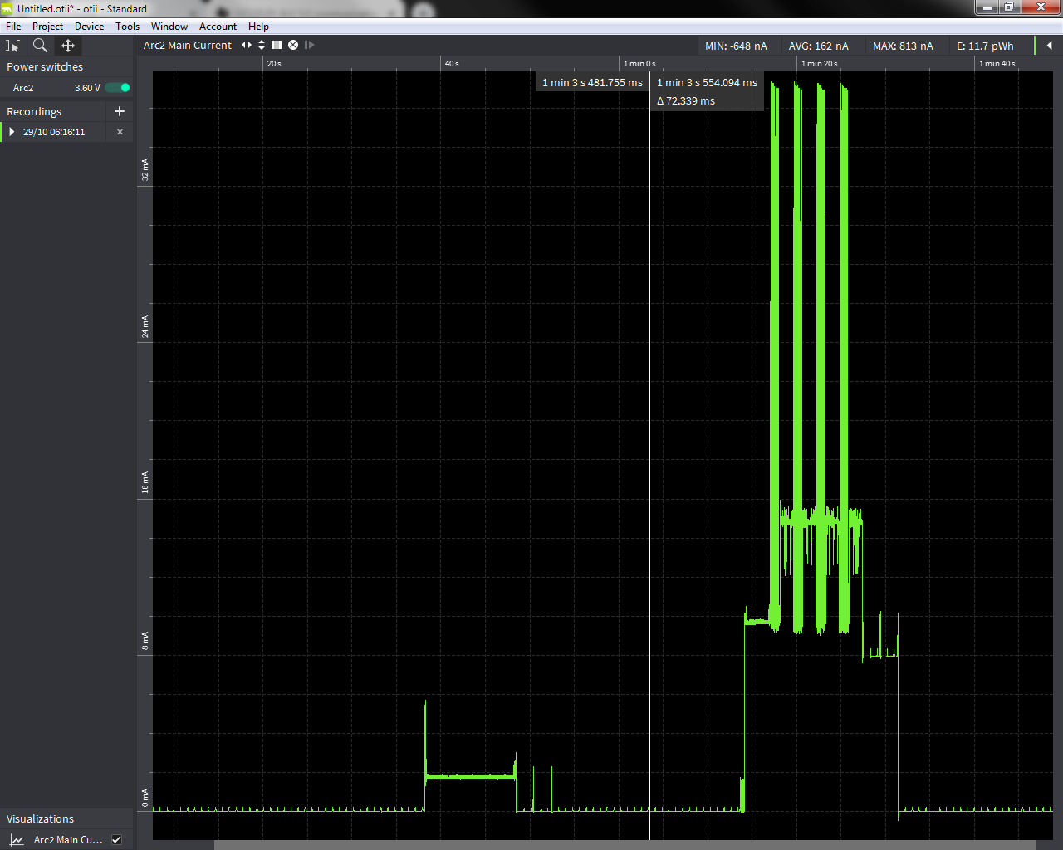

Detailing of sleep current. You can see in blow screen shot that the average sleep current is less than 1uA.

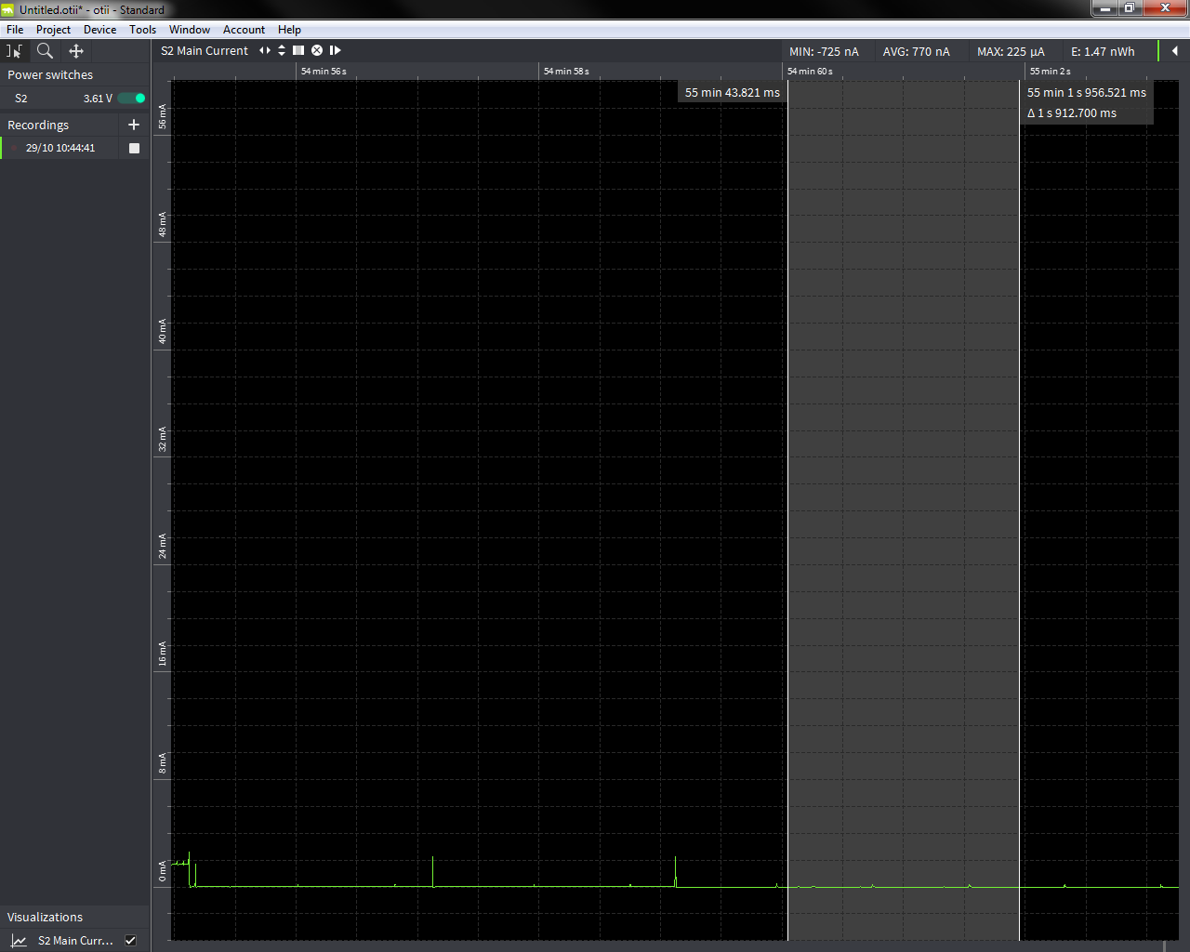

We do periodic and during transmission module consume 32mA, but then after it come back to 1uA, have a look of below screen shot.

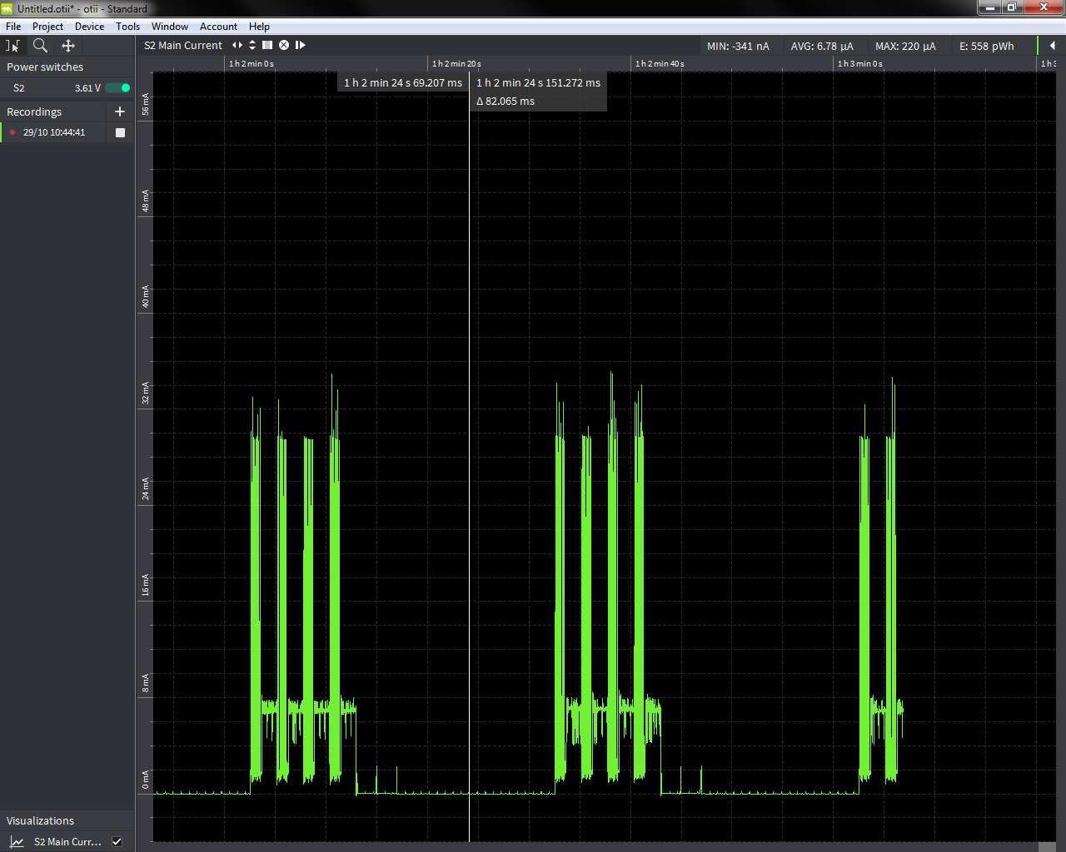

Problematic situation, in this device is did not goes to sleep, and taking ~2mA current continuously, but my sleep method is getting executed “PTD_ReadyForSleep_g” (please refer source code sent earlier) as my other activity that I performed before going to sleep is executing.

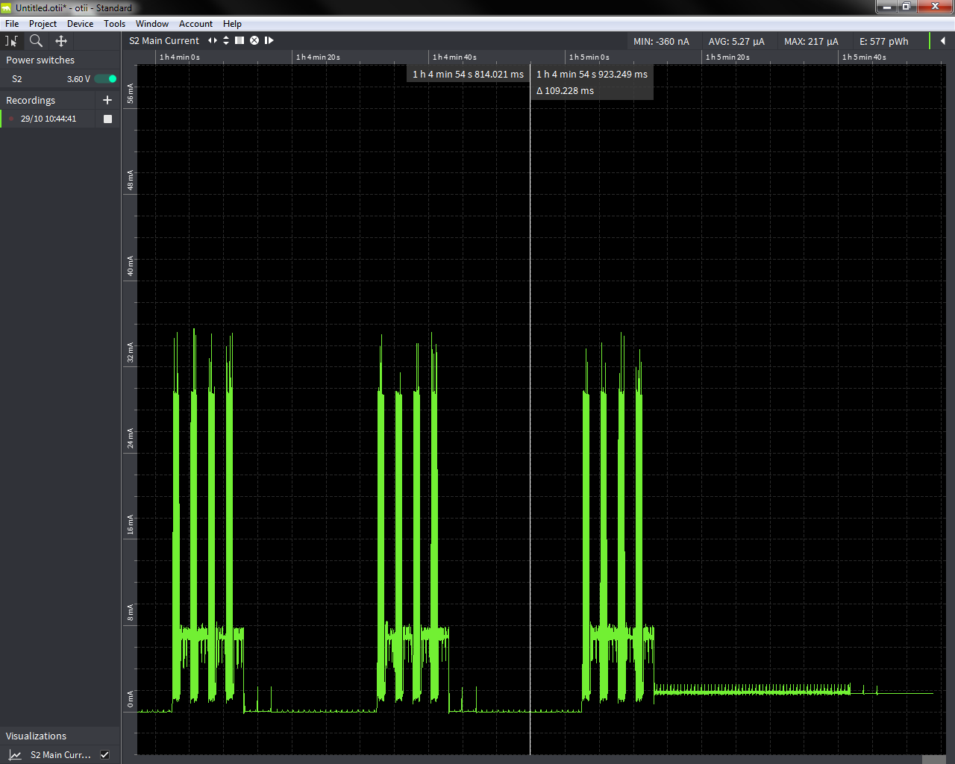

Once this problem is simulated my device does not goes to deep sleep and its keep on consuming 2mA, while it goes to sleep.

