Copy HOGP-BLE-HID-EXAMPLE-main
https://github.com/TexasInstruments/HOGP-BLE-HID-EXAMPLE/tree/main/source/ti/ble5stack/profiles/hid
hidkbdservice.c 、hidkbdservice.h、hiddev.h to BasicBle project , do the following modifications:

- In hidkbdservice.c ,Left-hand side is original source code, change to right-hand side
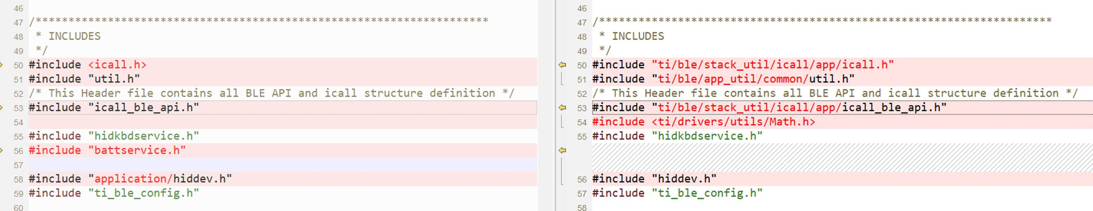

- In hidkbdservice.c, change all the “CONST” to “const”

- Copy HidDev_ReadAttrCB() /hiddev.c to hidkbdservice.c. Comment out the following “if block”:
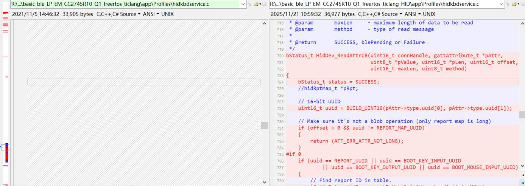

- Comment out the callback below:
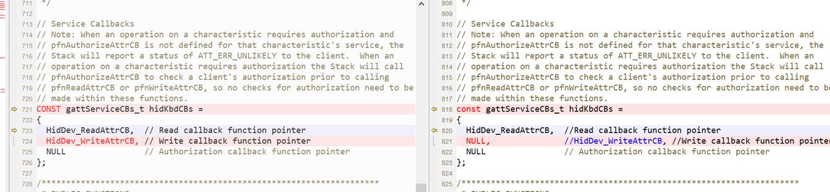

- Comment out the following code in bStatus_t HidKbd_AddService(void)
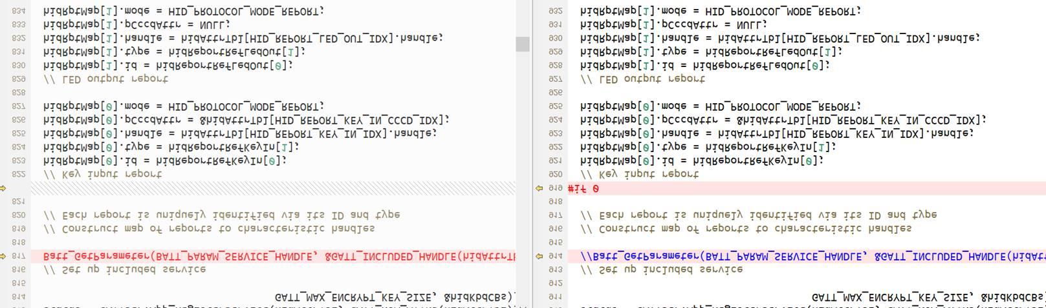
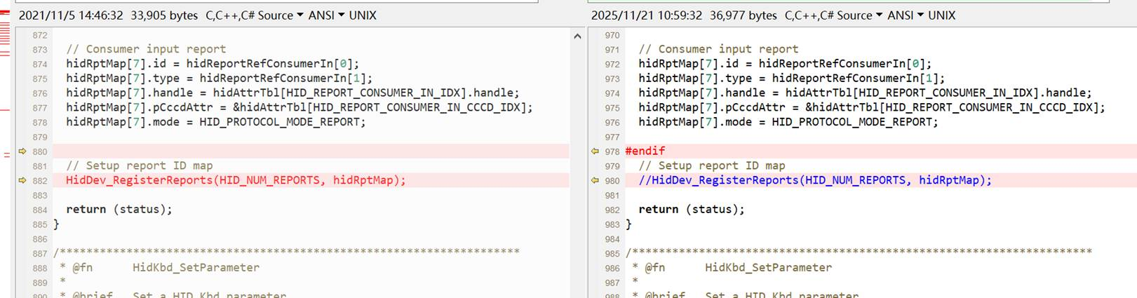

- Modify hiddev.h
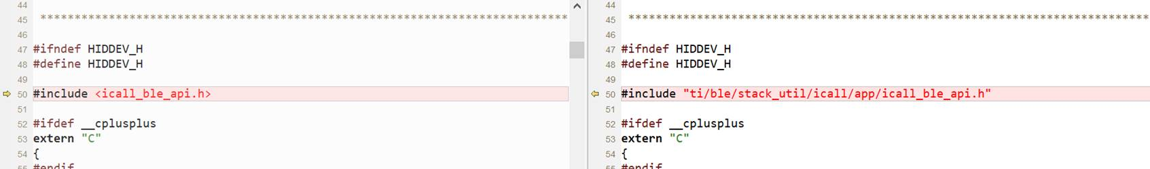

- Modify Sysconfig pairing mode as “initiate a pairing request”

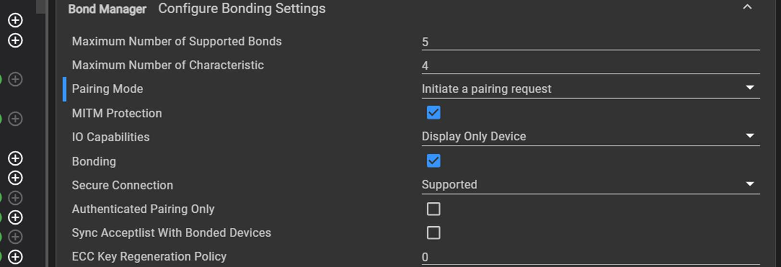

- Add HidKbd_AddService() in app_main.c
status = HidKbd_AddService();
if(status != SUCCESS)
{
// TODO: Call Error Handler
}

