This document explains how to measure RSSI on a TI Launch Pad utilizing Smart RF Studio 8.
Necessary HW:
- TI Connectivity Launchpad of choice, e.g. https://www.ti.com/tool/LP-EM-CC2745R10-Q1
- Debug connector, e.g. https://www.ti.com/tool/LP-XDS110?keyMatch=xds110&tisearch=universal_search&usecase=partmatches
Necessary SW:
- Smart RF Studio https://www.ti.com/tool/SMARTRFTM-STUDIO (v8 is used for newer parts)
There are three ways to measure RSSI. One method requires 1 launch pad and the second requires 2 launch pads. For both methods, the hardware is the same, connect the connectivity LP to the debug connector, and plug the debug connector into the computer via the provided USB-C Cable. This will both power the device and give you debug access. If using x2 boards, do this for both boards.
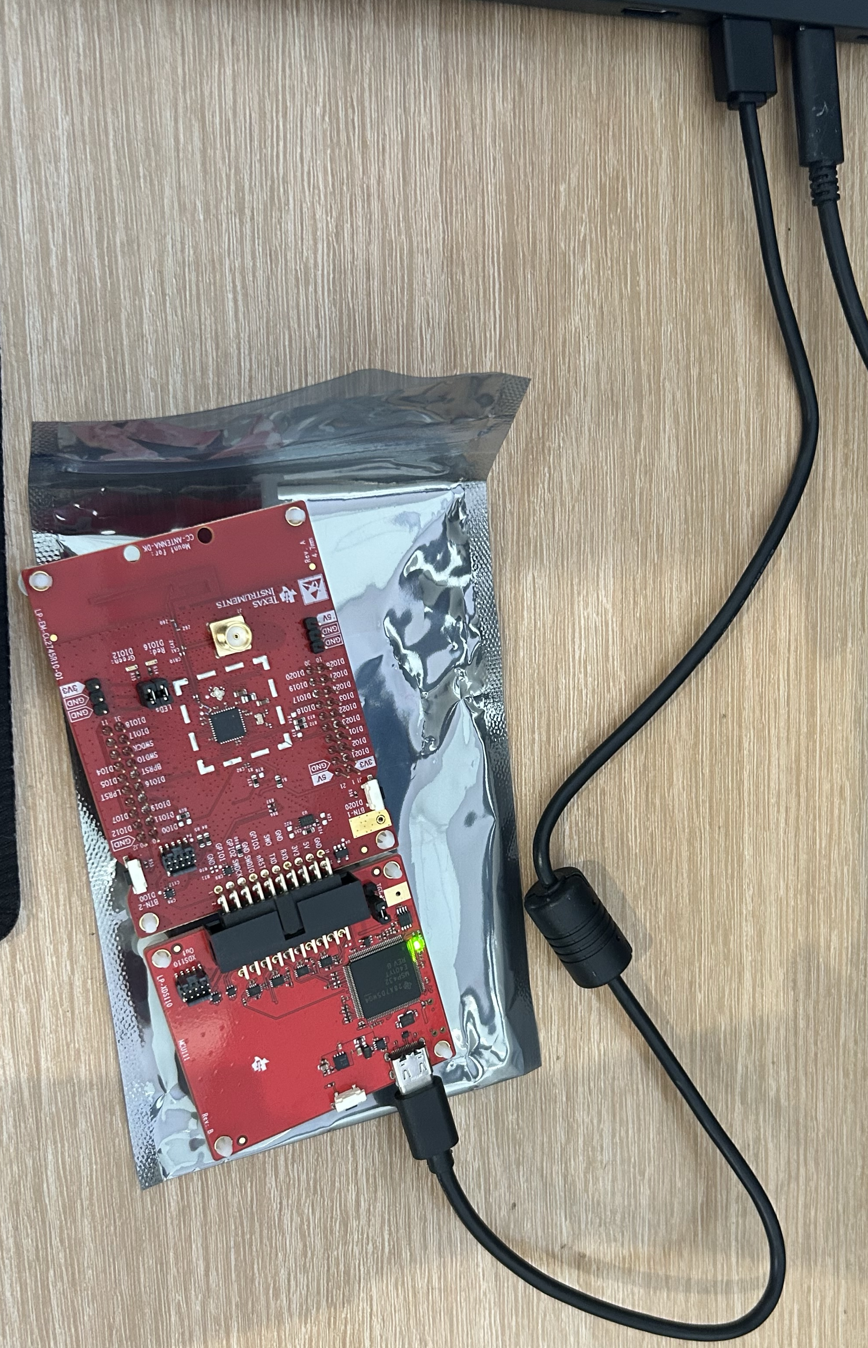
Method #1: Measuring RSSI using 1 Launch Pad with continuous RX
Method #2: Measuring RSSI using 2 Launch Pads with continuous RX/ continuous TX
Method #3: Measuring RSSI using 2 Launch Pads with Packet RX/ continuous TX
See Bluetooth 5, LE and IEEE 802.15.4 settings here:
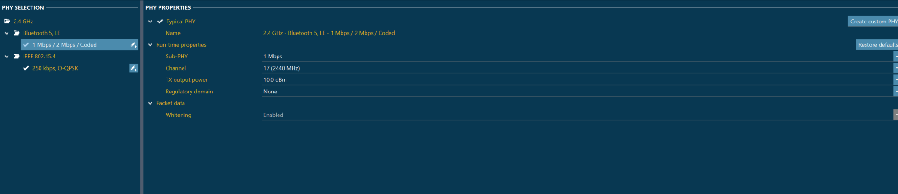
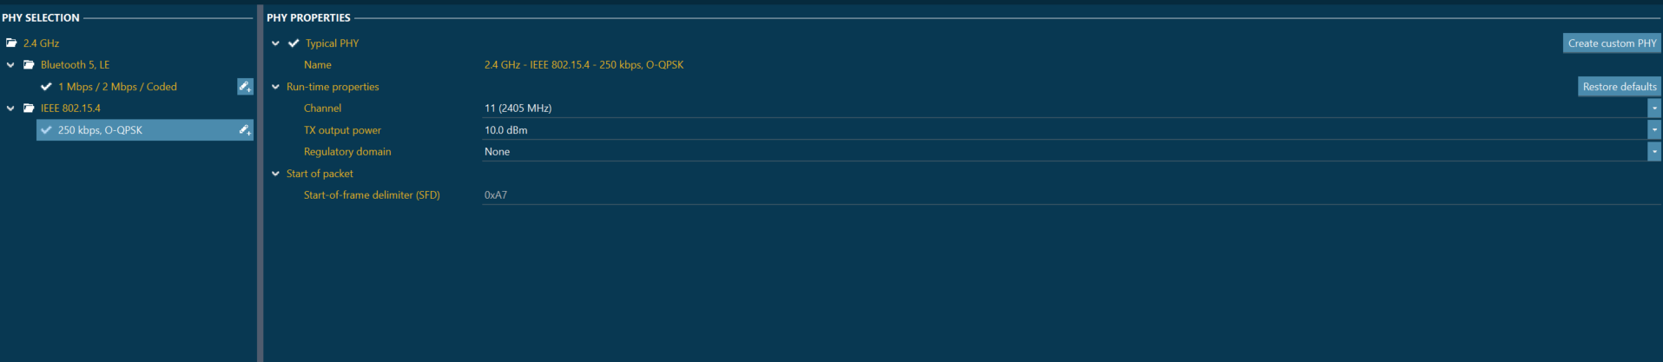
Increase the output power for optimal RSSI measurement.
Method #1: This method allows you to measure RSSI using a single LP and enables continuous monitoring of the RSSI.
RF Test #1, Continuous RX Tab, run test to see RSSI live
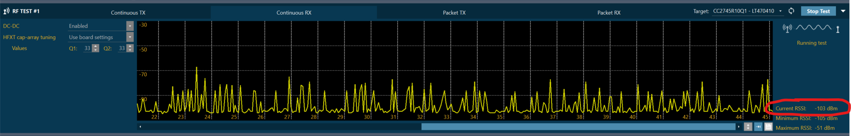
For Methods #2 and #3 put the launch pads closer for optimal RSSI measurement.
Method #2: This method allows you to measure RSSI using two LP and enables continuous monitoring of the RSSI.
- RF Test #1, Continuous TX Tab, run this test first
- RF Test #2, Continuous RX Tab, run test to see RSSI live in this tab

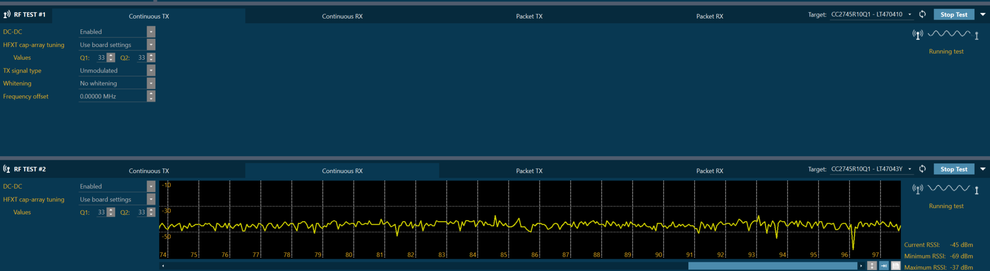

Method #3: This method allows you to measure RSSI using two LP and enables capturing RSSI from a specific Packet TX device. These tests can be ran multiple times since this test runs with a fixed number of packets.
- RF Test #1, Packet TX Tab, run this test first
- RF Test #2, Packet RX Tab, run test to see RSSI for each transmitted packet in this tab.
