Sniffer setup Steps

1. Download SW from this link (<https://www.ti.com/tool/PACKET-SNIFFER>)

Select the highlighted version for downloading:

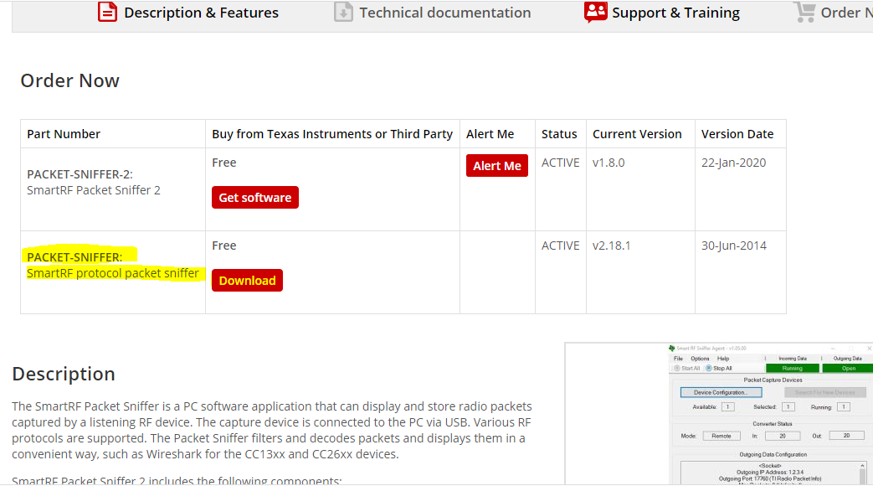

1. Open the SW
2. Select the entry like in below image

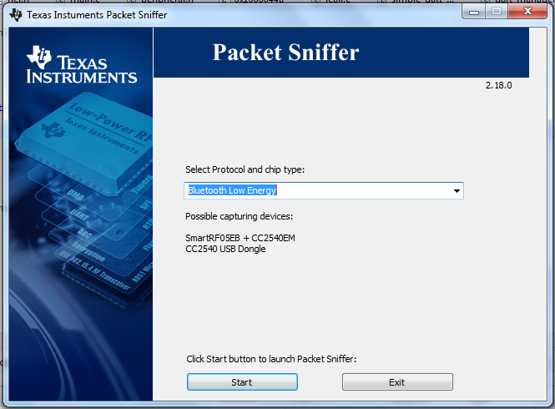

1. Hit Start button
2. If the sniffer device is connected that it should be shown like highlighted section in the below image:

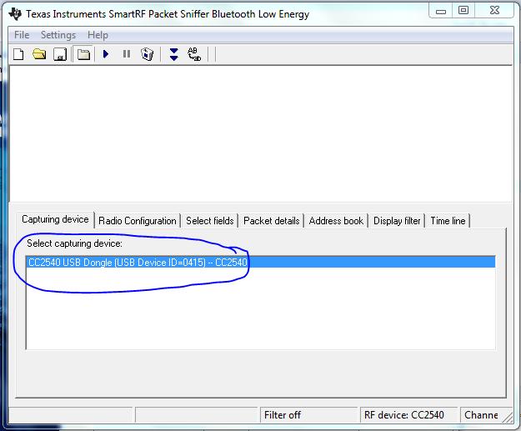

1. Click on file and then hit Reset on that drop down to avoid error.
2. Hit Play button, now the packets should displayed on the display section.

Below is the frame snapshot when the phone is connected with BLE and sending 0x33 packet from App to BLE side.

