Reproducing UART Malformed Data Produced by TI-CC2640r2

UART settings
uartParams.writeDataMode = UART_DATA_TEXT ;
uartParams.readDataMode = UART_DATA_TEXT;
uartParams.readMode = UART_MODE_BLOCKING; ;
uartParams.readReturnMode = UART_RETURN_FULL;
uartParams.readEcho = UART_ECHO_OFF;
uartParams.baudRate = 921600;

Project settings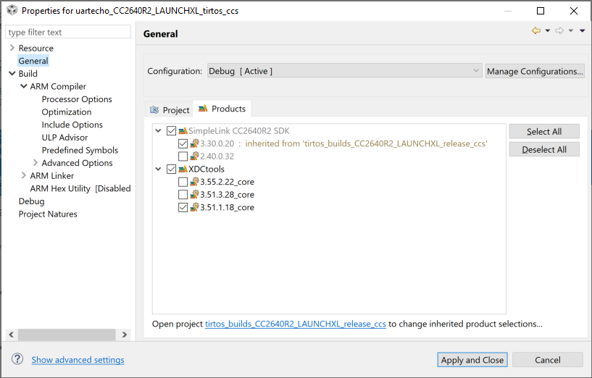
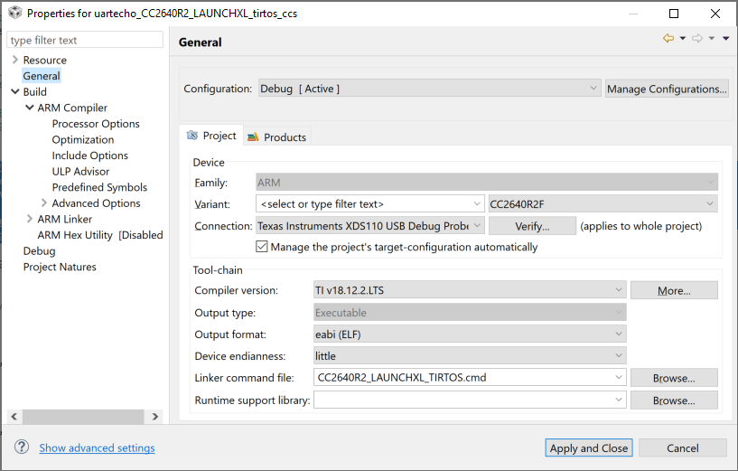

Example of Malformed data

