TI-RTOS Object Viewer (ROV) Issue
Contents
ROV unavailable when STACK is built as a library 1
ROV available in Split Image Configuration (STACK is a separate image) 2

ROV unavailable when STACK is built as a library
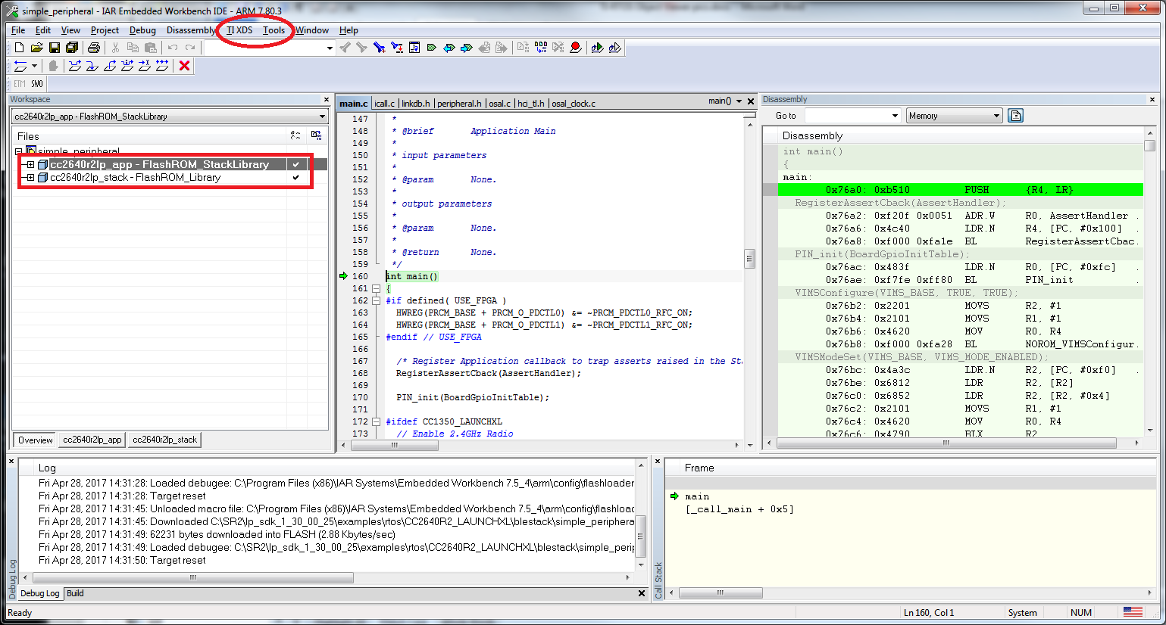

ROV available in Split Image Configuration (STACK is a separate image)
