1.持续发报及温度跳变原因分析Analysis of the Causes of Continuous Telegraphy and Temperature Jump
如下图，红框字段为数据包序号字段。正常情况下，在发报时，每更新一次数据，该序号自动增一。As shown in the figure below, the field in the red box is the data packet sequence number field. Under normal circumstances, during telegraphy, this sequence number automatically increments by 1 each time the data is updated. However, in the figure, after the sequence number increases to 0x28, it suddenly changes to 0x00 and then continues to increment. This indicates that the system has experienced a reset
温度跳变原因：系统发生复位后，温度、电压等buffer的值还未来得及更新，最初发报的数据是随机值。这与温度发生跳变只发生在数据包序号0或1相印证。其它数据包的温度值都正常。Causes of Temperature Jump: After the system resets, the values in buffers (such as those for temperature and voltage) do not have time to update. The data transmitted in the initial telegraphy is random values. This is consistent with the fact that temperature jumps only occur when the data packet sequence number is 0 or 1. The temperature values of other data packets are all normal
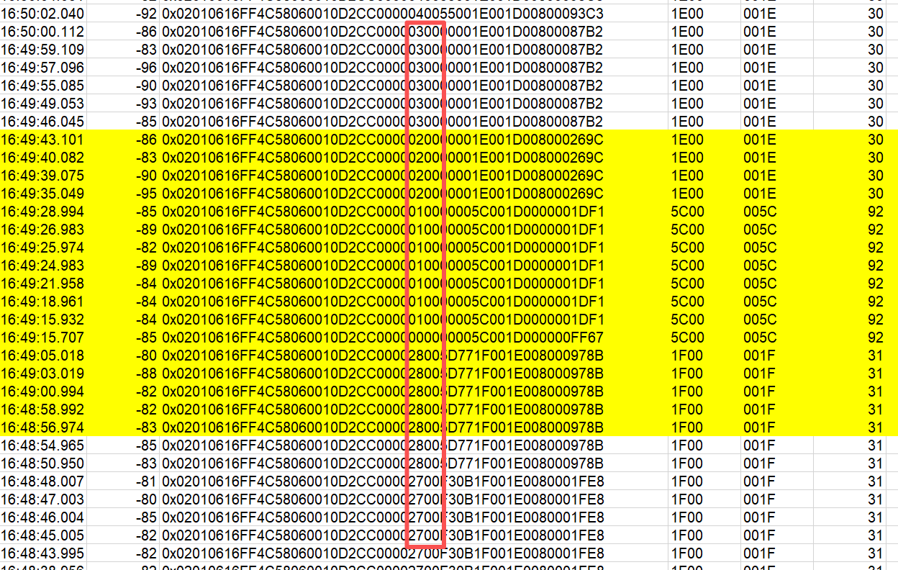
结论：持续发报原因是系统发生了异常复位。温度跳变是数据还未来得及更新导致，与温度采集部分无关。
Conclusion: The cause of continuous telegraphy is an abnormal reset of the system. Temperature jumps result from data failing to update in time and have no connection to the temperature acquisition component.
Explanation of Core Logic

2.飞线连接仿真器查看系统运行情况Connect the emulator via flying leads to monitor the system operation
如下图，通过飞线，将故障件连接仿真器进行系统运行情况查看。跟踪程序运行，查看相关变量，未发现运行异常的情况。As shown in the figure below, the faulty unit is connected to the emulator via flying leads to monitor the system operation. During the process, the program execution was tracked and relevant variables were checked, with no abnormal operation detected
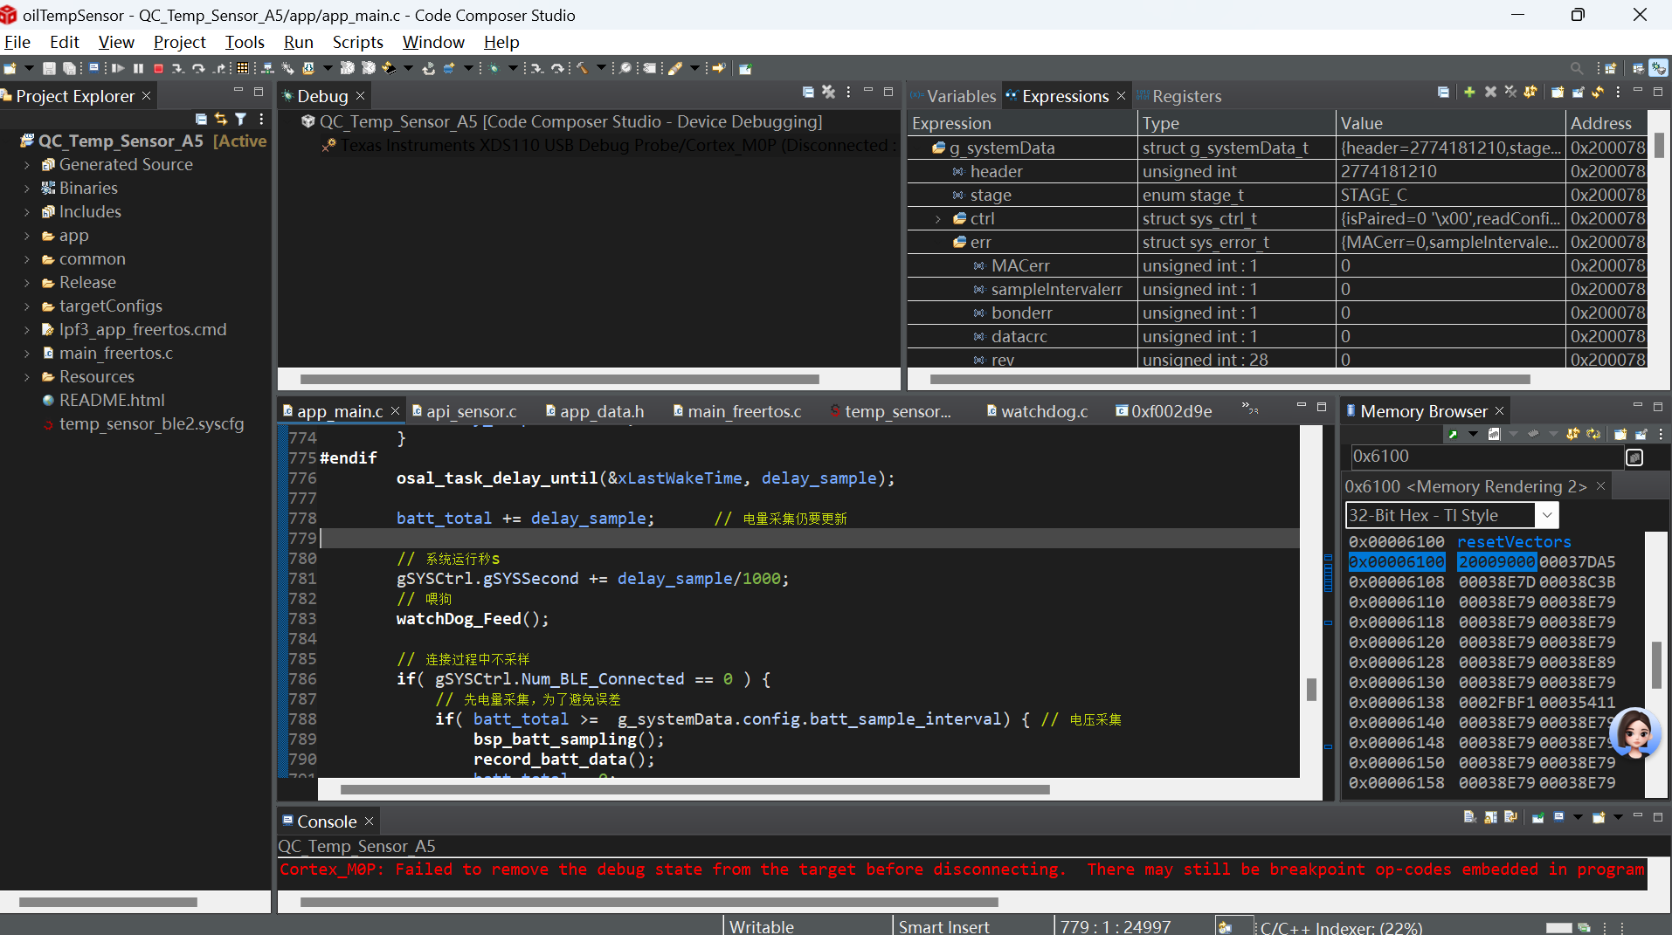
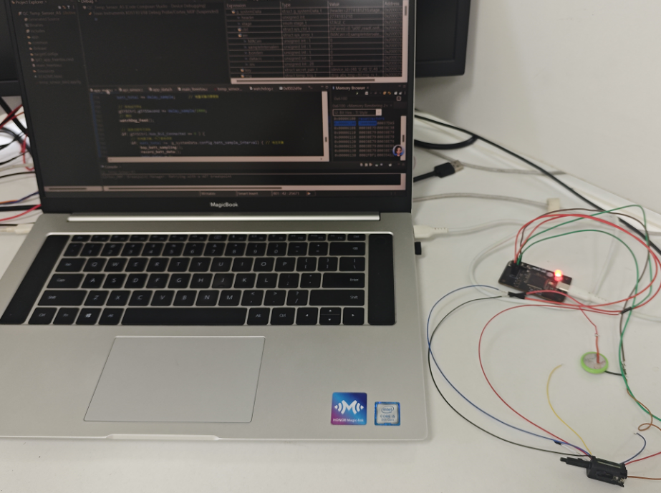

3.将故障件软件全部擦除，重新刷新代码，查看故障情况Erase all software from the faulty unit, reflash the code, and then check for the occurrence of faults
如下图，红框字段为数据包序号字段，正常情况下，在发报时，每更新一次数据，该序号自动增一。重新刷写代码后，同样出现序号突然变为0x00，说明系统发生了复位，故障依旧。
As shown in the figure below, the field in the red box is the data packet sequence number field. Under normal circumstances, during telegraphy, this sequence number automatically increments by 1 each time the data is updated. After reflashing the code, the sequence number still suddenly resets to 0x00. This indicates the system has experienced a reset, and the fault persists
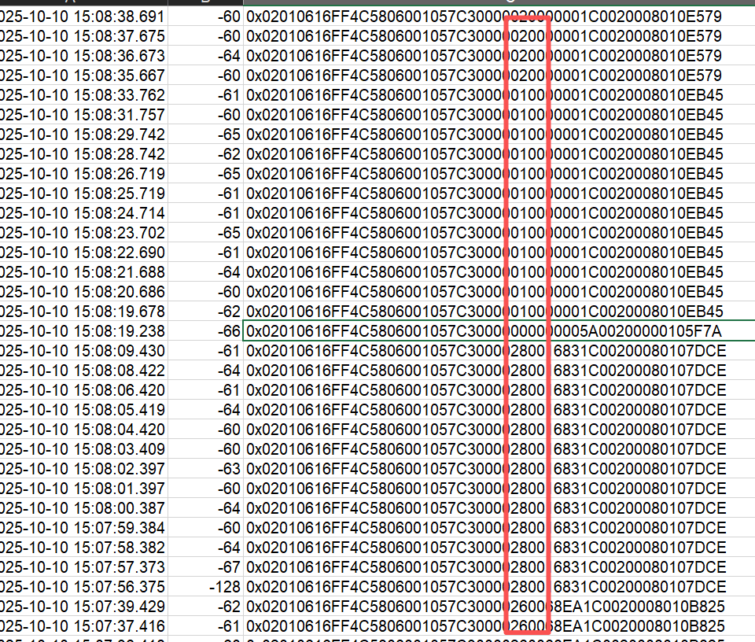
结论：刷新代码后，故障依旧。初步判断该故障与硬件电路相关，下一步将打开射频屏蔽盖，进一步排查复位电路、时钟震荡电路等。
Conclusion: After reflashing the code, the fault still persists. It is initially determined that the fault is related to the hardware circuit. For the next step, the RF shield cover will be opened to further inspect the reset circuit, clock oscillation circuit, and other relevant components

4.更换晶振及C4、C5电容Replace the crystal oscillator and the capacitors C4 and C5
如下图，更换32.768k晶振及C4、C5电容，用示波器测试其输出震荡信号，波形及频率正常。检测蓝牙广播信息，复位现象依旧。As shown in the figure below, the 32.768kHz crystal oscillator and capacitors C4/C5 were replaced. The output oscillation signal was tested with an oscilloscope, and both the waveform and frequency were normal. However, when detecting the Bluetooth broadcast information, the reset phenomenon still persisted.
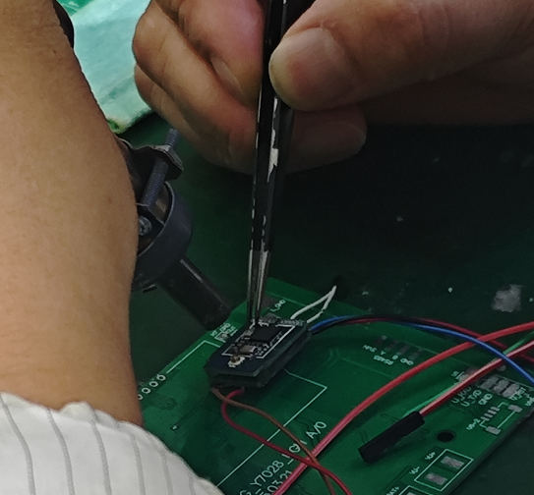
更换晶振及电容Replace the crystal oscillator and capacitors
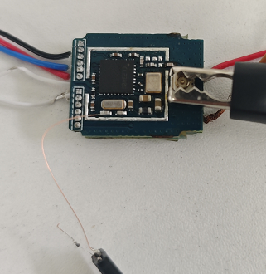
接示波器检测晶振信号Connect an oscilloscope to detect the crystal oscillator signal.
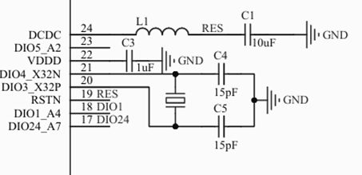
32.768k时钟电路原理图Schematic Diagram of 32.768kHz Clock Circuit
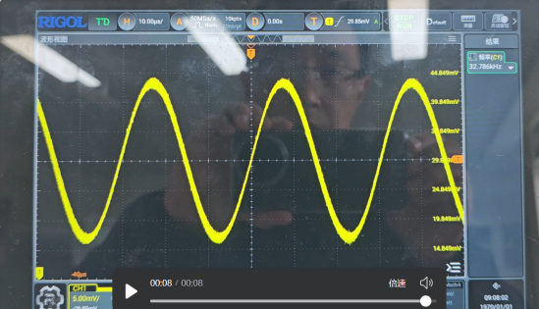
输出信号波形The output signal waveform
结论：32.768k时钟震荡电路无异常。
Conclusion: The 32.768kHz clock oscillation circuit is free of abnormalities

5.检测复位信号Detect the reset signal.
如下图，用示波器监测复位信号，信号输出无异常。As shown in the figure below, the reset signal was monitored with an oscilloscope, and the signal output showed no abnormalities.
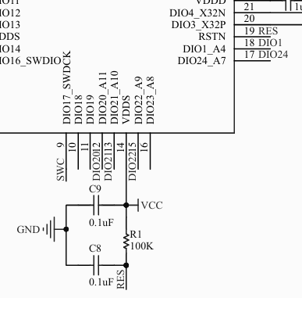
复位电路原理图Schematic Diagram of the Reset Circuit
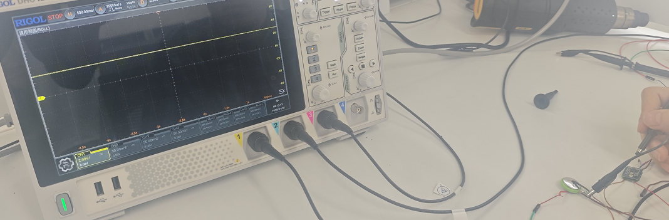
用示波器监测复位信号Monitor the reset signal with an oscilloscope
结论：复位电路工作无异常
Conclusion: The reset circuit is functioning without abnormalities

- 与一个工作正常的件，做MCU的ABA互换测试.Conduct an ABA swap test of the MCU with a normally functioning unit
如下图，将问题件和一个正常件做MCU的互换，互换后测试，问题MCU的那个件复位问题依旧存在，另一个件工作正常，即问题随MCU走。As shown in the figure below, the MCUs of the faulty unit and a normally functioning unit were swapped. After the swap test, the unit with the original faulty MCU still had the reset issue, while the other unit (now with the normal MCU) operated normally. This confirms the fault follows the MCU
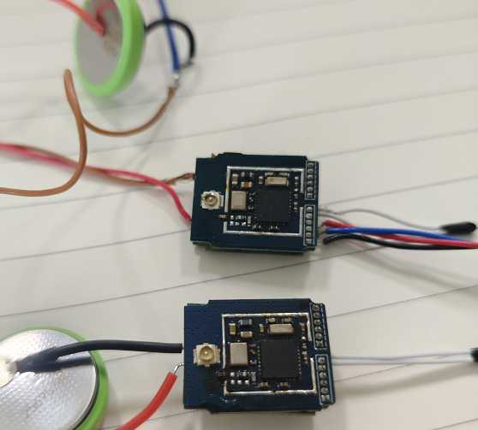

MCU互换MCU swap
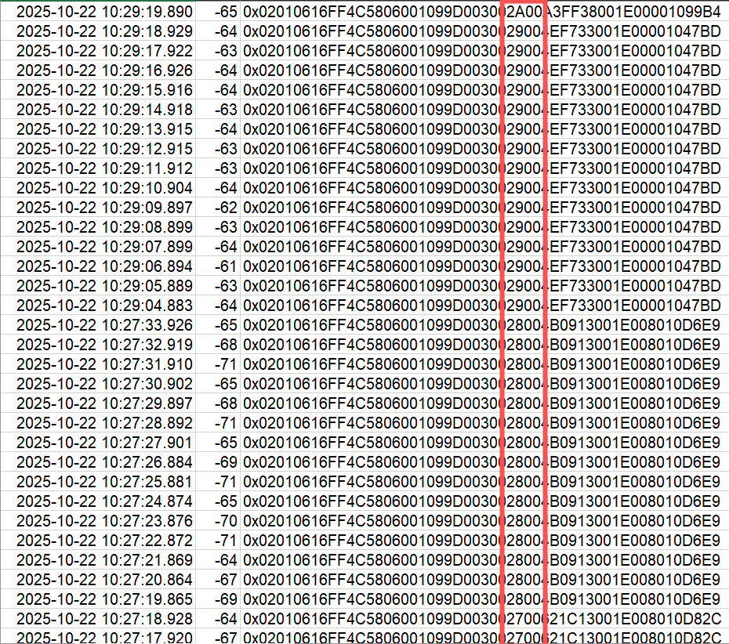
正常MCU件包序号递增The unit with the normal MCU shows a continuous increment of the packet sequence number
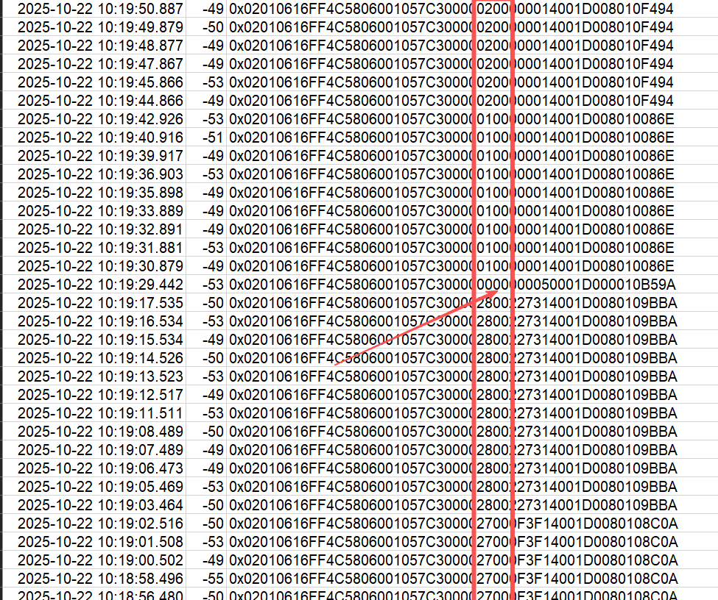
异常MCU件发生了复位包序号回零The unit with the abnormal MCU experiences a reset, causing the packet sequence number to return to zero.
结论：
a.复位现象由MCU导致，该片MCU为异常件。
b.到目前为止，该复位问题为发现的唯一一例。
Conclusion:
The reset phenomenon is caused by the MCU, and this specific MCU is identified as an abnormal unit.
So far, this reset issue has been found in only one unit (no other cases have been detected).

