1.Before array is defined, we can see .cinit = 5732.

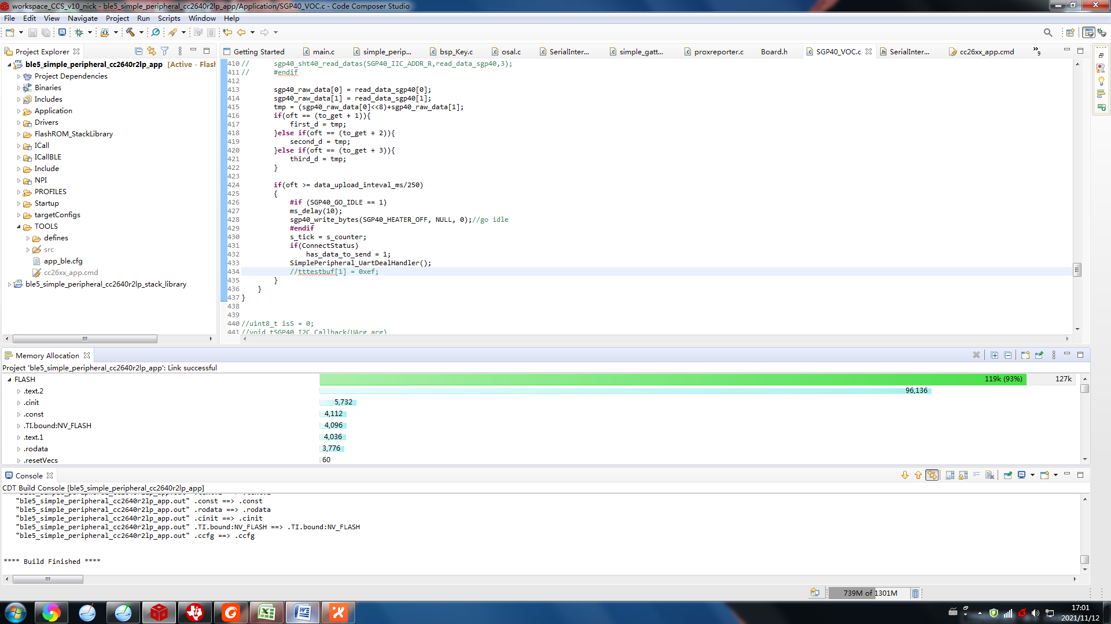

2.Define an array.

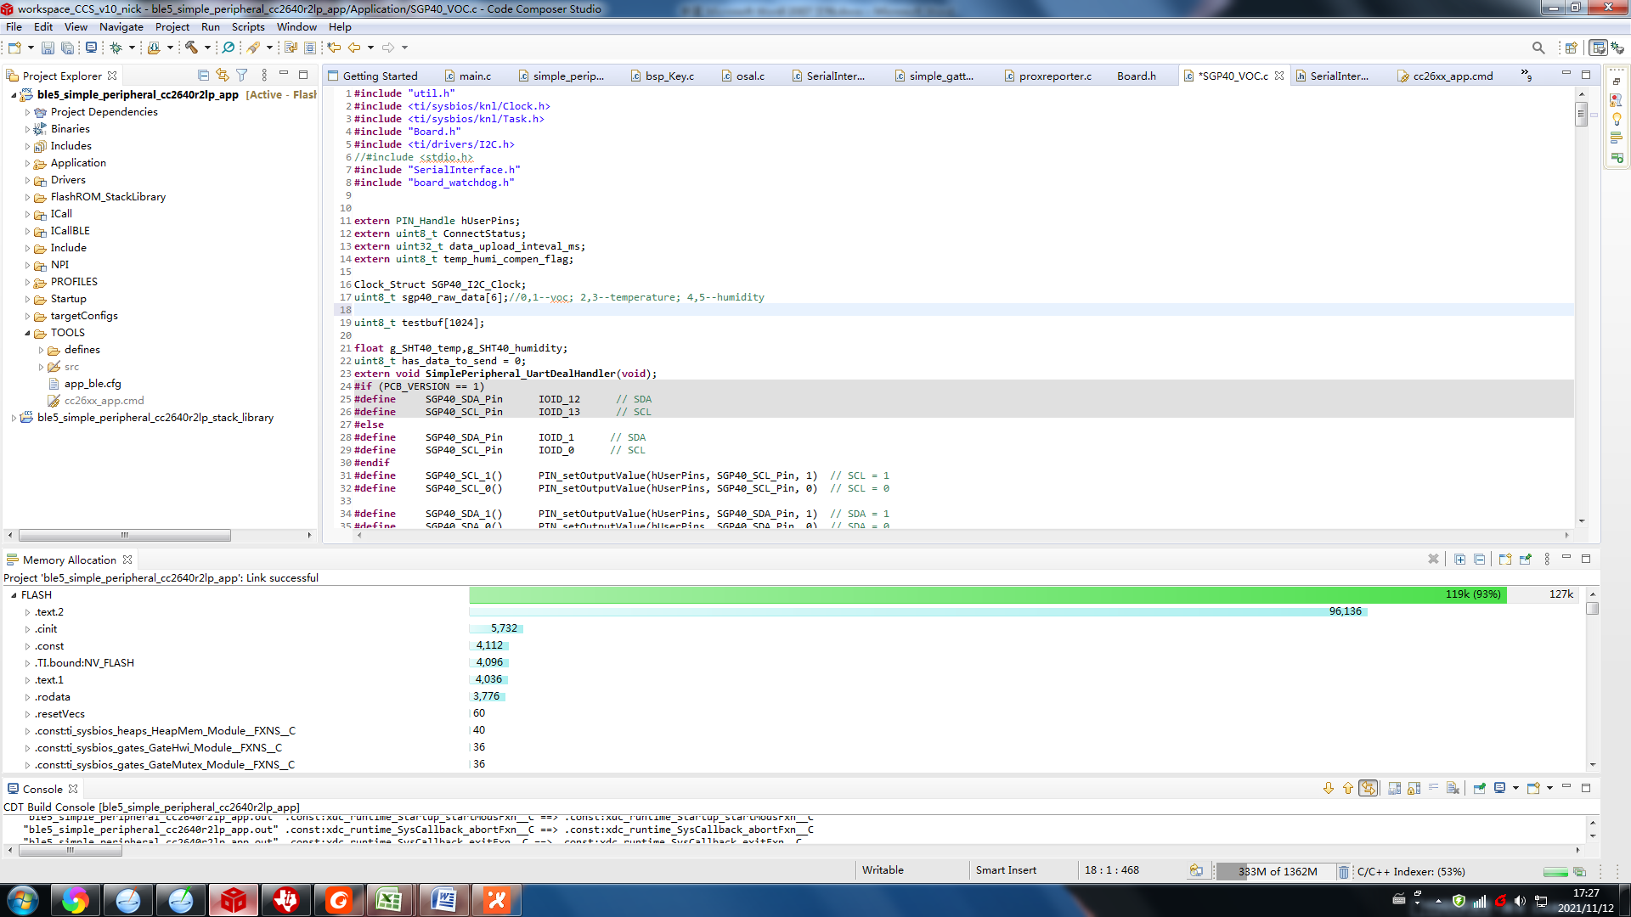

3.Use it anywhere in the code.

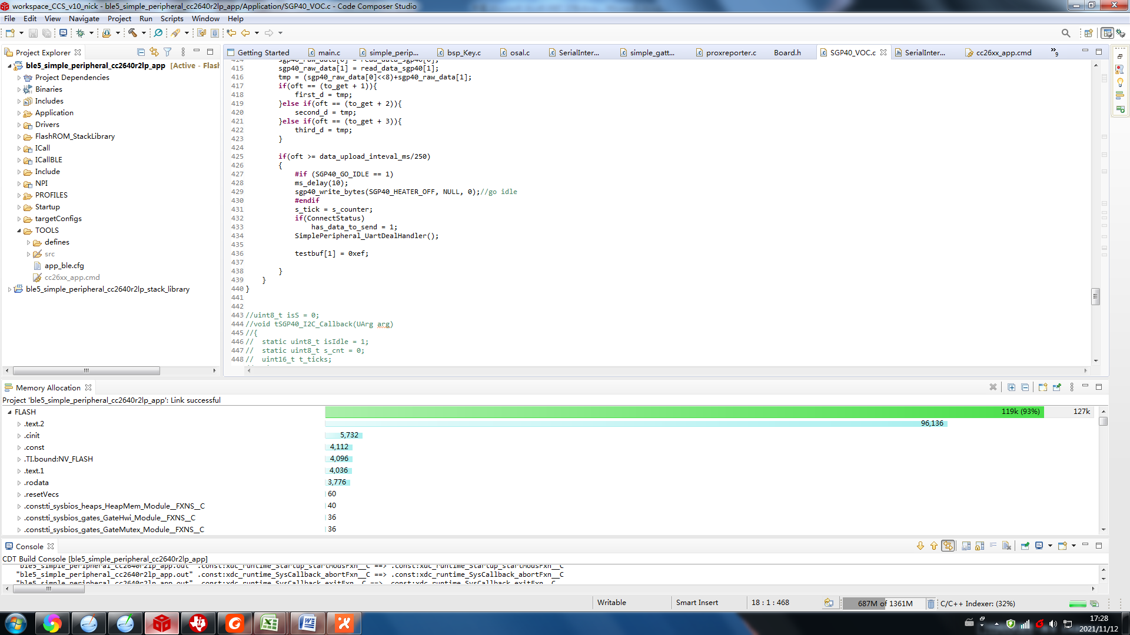

4.After compiling, it can be seen that .cinit is now 6756, which increases by 1024 bytes

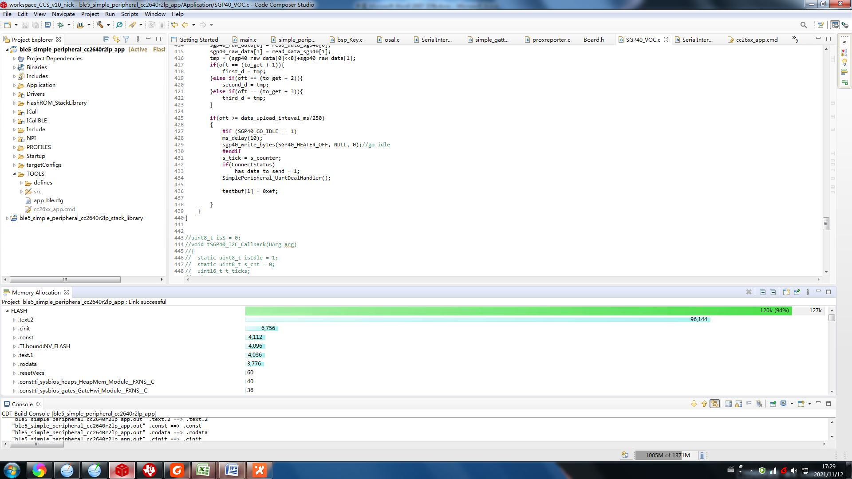

1. I’m using the CCS 10.1.1 and compiler version is TI v18.1.8.LTS. Use official routine “SimplePeripheral”.

